**SnapShot: Influenza by the Numbers  
Information and Discussion of the Sources Used**

**Dimensions: The Size and Amount of Key Proteins** **3**

Size, Mass, and Number of HA and NA 3

Crystal Structures of HA and NA 14

Number of Fabs that can Simultaneously Bind 15

Number of IgGs that can Simultaneously Bind 17

Number of HA Trimers Required to Initiate Fusion 21

Size and Mass of an Influenza Virion (Spherical vs Filamentous) 23

Size of Epithelial Cells (Target Cells of Influenza) 33

Antigenic Sites on HA and NA 36

H1N1 HA Epitopes: Sa, Sb, Ca1, Ca2, Cb 36

H3N2 HA Epitopes: A, B, C, D, E 37

HA Stem Epitopes 37

The NA Epitopes 38

**Antibody Response** **40**

Quantifying the IgG, IgA, and IgM Antibody Response 40

Targets of Antibody-Secreting B Cells 49

The Binding EC50 and Neutralization IC50 of Potent Antibodies 53

Binding (ELISA) 54

Evolutionary Rates 56

Evolutionary Rates of HA 57

Evolutionary Rates of NA 58

Genome Mutation Rate per Replication Cycle 59

Virus Escape Frequencies 62

**Infection Dynamics** **63**

Typical Infection Time Course 63

Number of Epithelial Cells 71

Viral Life Cycle 72

Viral Burst Size 75

Fraction of Virus that is Infectious 79

Minimal Infectious Dose 85

End of Infection Statistics 90

Function of Glycans and Glycan Clock Theory 91

**Quantification: Experimental Assays** **95**

Total Virus: Hemagglutination Assay (HA) 96

Number of Virions in 1 HAU 100

Number of Red Blood Cells in Turkey (Meleagris gallopavo) 104

Number of Red Blood Cells in Chicken (Gallus gallus domesticus) 105

Infectious Virus 106

Infectious Unit (IFU)/Plaque Forming Unit (PFU)/Infectious Virus Particles (IVP) 106

50% Tissue culture Infective Dose (TCID50) 107

Antibody Potency 109

Hemagglutination Inhibition (HI or HAI) Assay 109

Influenza Nomenclature 113

Neutralization Assay 114

Mechanisms of Antibody Neutralization 114

Number of Antibodies Required to Neutralize Virus 118

# Dimensions: The Size and Amount of Key Proteins

## Size, Mass, and Number of HA and NA

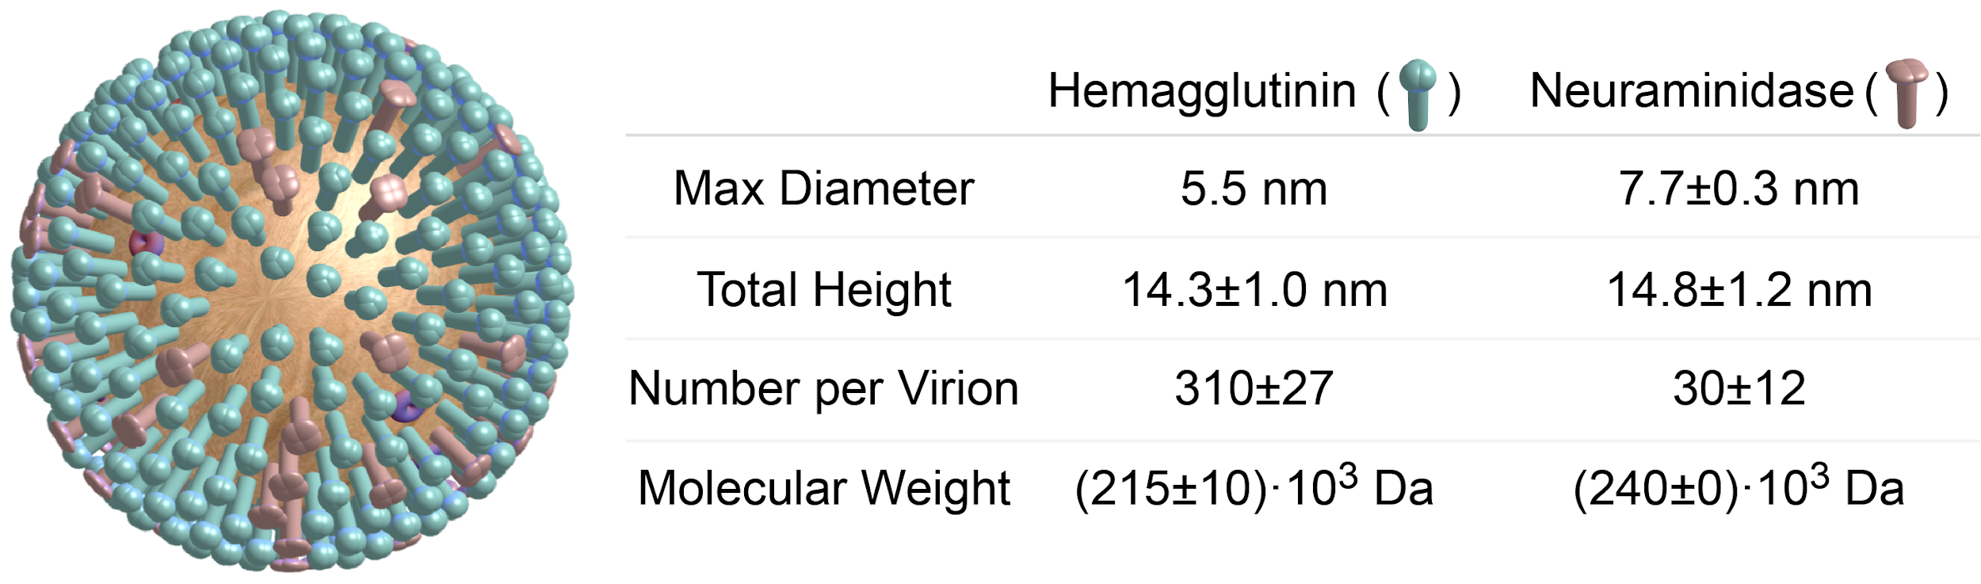

On the virion, the green surface protein represents hemagglutinin, the red surface protein neuraminidase, and the purple transmembrane protein M2. Note that while these summary statistics average over multiple influenza strains, the HA and NA dimensions presented on the front of the SnapShot represent the A/California/04/2009 strain whose crystal structure is shown in the top-left quadrant.

|  |  |  |  |  |
| --- | --- | --- | --- | --- |
| **Max Diameter of HA**  **(Viral Strain)** | **Source** |  | **Max Diameter of NA**  **(Viral Strain)** | **Source** |
| 5.5 nm (A/Hong Kong/1968) | [Wilson 1981](https://doi.org/10.1038/289366a0) |  | 7.7±0.3 nm (B/Lee) | [Wrigley 1973](https://doi.org/10.1016/0042-6822(73)90457-1) |
| **5.5±0 nm** | **Average Value** |  | **7.7±0.3 nm** | **Average Value** |

|  |  |  |  |  |
| --- | --- | --- | --- | --- |
| **Total Height of HA**  **(Viral Strain)** | **Source** |  | **Total Height of NA**  **(Viral Strain)** | **Source** |
| 15.4 nm (A/California/04/2009) | [Broecker 2019](https://doi.org/10.1128/JVI.00840-19) |  | 14.9 nm (A/California/04/2009) | [Broecker 2019](https://doi.org/10.1128/JVI.00840-19) |
| 14 nm (X31) | [Harris 2006](https://doi.org/10.1073/pnas.0607614103) |  | 13.1 nm (A/Puerto Rico/8/1934) | [Broecker 2019](https://doi.org/10.1128/JVI.00840-19) |
| 13.5 nm (A/Hong Kong/1968) | [Wilson 1981](https://doi.org/10.1038/289366a0) |  | 16 nm (X31) | [Harris 2006](https://doi.org/10.1073/pnas.0607614103) |
| **14.3±1.0 nm** | **Average Value** |  | 15.0 nm (X-7F1) | [Laver 1969](https://doi.org/10.1016/0042-6822(69)90132-9) |
|  |  |  | **14.8±1.2 nm** | **Average Value** |

|  |  |  |  |  |
| --- | --- | --- | --- | --- |
| **Number of HA/virion**  **(Viral Strain)** | **Source** |  | **Number of NA/virion**  **(Viral Strain)** | **Source** |
| 340  (A/WSN/1933) | [Vahey 2019](https://doi.org/10.1016/j.cell.2018.10.056) |  | 24 (A/WSN/1933) | [Vahey 2019](https://doi.org/10.1016/j.cell.2018.10.056) |
| 294±23 (A/WSN/1933) | [Hutchinson 2014](https://doi.org/10.1038/ncomms5816) |  | 23±6 (A/WSN/1933) | [Hutchinson 2014](https://doi.org/10.1038/ncomms5816) |
| 296±8 (X31) | [Harris 2006](https://doi.org/10.1073/pnas.0607614103) |  | 44±8 (X31) | [Harris 2006](https://doi.org/10.1073/pnas.0607614103) |
| **310±27** | **Average Value** |  | **30±12** | **Average Value** |

|  |  |  |  |  |
| --- | --- | --- | --- | --- |
| **HA Molecular Weight**  **(Viral Strain)** | **Source** |  | **NA Molecular Weight**  **(Viral Strain)** | **Source** |
| 220·103 Da (A/Netherlands/219/2003) | [McCraw 2016](https://doi.org/10.1128/CVI.00085-16) |  | 188·103 Da (A/NWS/33HA-A/tern/Australia/G70C/75NA) | [Jackson 1991](https://doi.org/10.1007/BF01319230) |
| 220·103 Da (A/Anhui/1/1013) | [McCraw 2016](https://doi.org/10.1128/CVI.00085-16) |  | 196·103 Da (A/NWSH-Tokyo/67N) | [Jackson 1983](https://www.ncbi.nlm.nih.gov/pubmed/6822736) |
| 200·103 Da (A/Puerto Rico/8/34) | [Magadan 2013](https://doi.org/10.1128/JVI.00471-13) |  | 240·103 Da (B/Lee) | [Wrigley 1973](https://doi.org/10.1016/0042-6822(73)90457-1) |
| 210·103 Da (A/Aichi/2/68) | [Weldon 2010](https://doi.org/10.1371/journal.pone.0012466) |  | **(208±28)·103 Da** | **Average Value** |
| 240·103 Da (A/Memphis/1/71) | [Jackson 1991](https://doi.org/10.1007/BF01319230) |  |  |  |
| 224.6·103 Da (A/Hong Kong/1968) | [Wilson 1981](https://doi.org/10.1038/289366a0) |  |  |  |
| **(219±14)·103 Da** | **Average Value** |  |  |  |

**Sources:**

* [Vahey 2019](https://doi.org/10.1016/j.cell.2018.10.056) (Cell): Low-Fidelity Assembly of Influenza A Virus Promotes Escape from Host Cells
  + Analyzed a viral strain expressing M1 from H3N2 A/Udorn/1972 in an H1N1 A/WSN/1933 background
  + “For a spherical particle 120 nm in diameter, [the median amount of HA and NA] corresponds to 340 HA trimers and 24 NA tetramers. There values are comparable to those previously reported by mass spectrometry (98 HA trimers, 6 NA tetramers; [Hutchinson 2014](https://doi.org/10.1038/ncomms5816)) and by direct counting of proteins on two viruses imaged using cryoelectron tomography (290-301 HA trimers, 38-50 NA tetramers; [Harris 2006](https://doi.org/10.1073/pnas.0607614103))”
  + “Longer virions more enriched in HA relative to NA than shorter virions”
* [McAuley 2019](https://doi.org/10.3389/fmicb.2019.00039) (Frontiers in Microbiology): Influenza Virus Neuraminidase Structure and Functions
  + Not a direct measurement, but they cite previous literature values as “40–50 NA spikes and 300–400 HA spikes on an average sized virion of 120 nm [[Varghese 1983](https://doi.org/10.1038/303035a0); [Ward 1983](https://doi.org/10.1016/0014-5793(83)80113-6); [Moules 2010](https://doi.org/10.1016/j.virol.2010.04.030)]”
* [Broecker 2019](https://doi.org/10.1128/JVI.00840-19) (Journal of Virology): Extending the Stalk Enhances Immunogenicity of the Influenza Virus Neuraminidase
  + “Compared to circulating H1N1 strains (pre- and post-pandemic), the NA of the PR8 virus has a 15-amino-acid deletion in the stalk domain (44). It has been estimated by molecular dynamics calculations that the NA protein of the H1N1pdm09 A/California/ 04/2009 (Cal09) virus extends from the membrane by 14.9 nm, which is slightly less than the estimated height of the HA protein (15.4 nm) (45) (Fig. 1A). It was also calculated that each amino acid in the stalk domain contributes to ~0.12 nm of the total height of the NA protein (45). Consequently, the NA of PR8 virus has an estimated height of 13.1 nm. Adding 15 amino acids to the PR8 NA would increase its height to that of the Cal09 NA (14.9 nm), and inserting 30 amino acids would raise the height to 16.7 nm.”

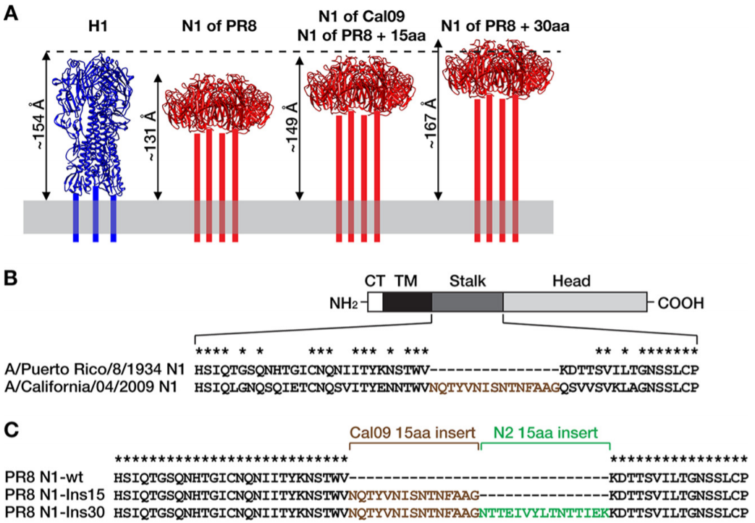

**Figure 1. Design and rescue of influenza viruses with extended N1 neuraminidase stalk domains.** (A) Estimated lengths of the ectodomains of N1 proteins with different stalk lengths (red) compared with the ectodomain of H1 hemagglutinin (blue). The structure of the NA stalk has not been determined and is indicated by four bars. The lengths of the ectodomains are estimates from molecular dynamics simulations, as reported before (45). The depiction of H1 is based on the crystal structure of the PR8 HA (PDB number 1RU7 [62]), and the depictions of N1 are based on the crystal structure of the NA of A/California/04/2009 (Cal09) virus (PDB number 3TI3 [63]). The structures are not to scale and were visualized with UCSF Chimera (64). aa, amino acids. (B) The four domains of the NA protein are indicated (CT, cytoplasmic tail; TM, transmembrane domain). The diagram is not to scale. The amino acid sequences comprising the stalk region are defined as previously described (42). Asterisks denote conserved amino acids. A 15-amino acid region of the Cal09 NA stalk that is not present in the PR8 NA is shown with brown letters. (C) Alignment of the three NA proteins with different stalk lengths. The 15-amino-acid N2 insertion is derived from the NA stalk domain of the A/New York/61/2012 (H3N2) virus. wt, wild type.

* + “Truncations of various lengths in the hypervariable stalk have been identified in the NAs of subtypes N1 to N3 and N5 to N7, mostly in those from avian influenza viruses (40). In contrast, there is currently no evidence for variation in the NA stalk length in influenza viruses circulating in humans (40).”
* [Angeletti 2018](https://www.ncbi.nlm.nih.gov/pmc/articles/PMC6028072/) (Cold Spring Harbor Perspectives in Biology): Is It Possible to Develop a "Universal" Influenza Virus Vaccine? Outflanking Antibody Immunodominance on the Road to Universal Influenza Vaccination
  + Not a direct measurement, but their Figure 2 reports that there are approximately 500 HA and 50 NA per virion
  + They also state that there are 10 M2 transmembrane channels per virion
* [Peng 2017](https://www.cell.com/cell-host-microbe/fulltext/S1931-3128%2816%2930479-6) (Cell Host and Microbe): Recent H3N2 Viruses Have Evolved Specificity for Extended, Branched Human-type Receptors, Conferring Potential for Increased Avidity
  + Each HA trimer has three receptor binding sites that are 4.5nm apart. “Receptor sites on two protomers within the same HA trimer are ∼4.5 nm apart”
* [McCraw 2016](https://doi.org/10.1128/CVI.00085-16) (Clinical and Vaccine Immunology): Characterization of Influenza Vaccine Hemagglutinin Complexes by Cryo-Electron Microscopy and Image Analyses Reveals Structural Polymorphisms
  + Analyzed the A/Netherlands/219/2003 (H7N7) and A/Anhui/1/1013 (H7N9) strains
  + For both strains, “the lower three bands of HA [thought to correspond to monomeric, dimeric, and trimeric subunits,] had approximate molecular masses of 70 kDa, 120 kDa, and 220 kDa, respectively.” Hence, trimeric HA should have a molecular weight of 220 kDa
* [Hutchinson 2014](https://doi.org/10.1038/ncomms5816) (Nature Communications): Conserved and host-specific features of influenza virion architecture
  + Used mass spectrometry to quantify the levels of viral protein. To get the absolute protein counts (shown in the *Relative to Pol* column of Table 2), they normalized the amount of protein in the heterotrimeric polymerase subunits (PA, PB1, and PB2) to be 8 per virion

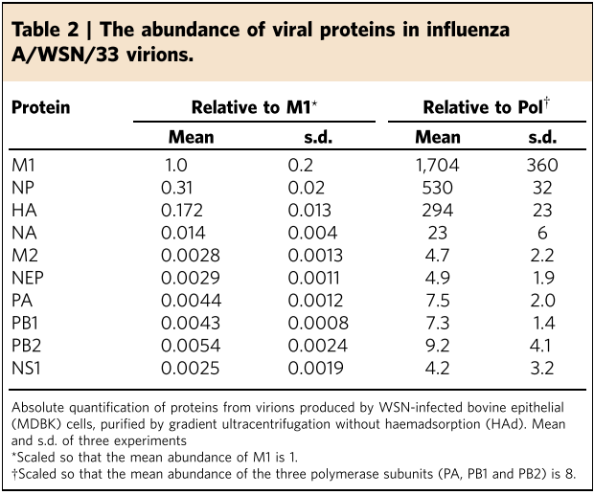

* [Harris 2013](https://doi.org/10.1073/pnas.1214913110) (PNAS): Structure and accessibility of HA trimers on intact 2009 H1N1 pandemic influenza virus to stem region-specific neutralizing antibodies
  + Figure S8 shows multiple HA stem epitopes (shown in yellow and green in Panel D, together with the epitope that the teal Fabs bind). Figure 5B of this paper suggests that three antibodies can bind to the stem without their Fc and other Fab sterically clashing, but additional stem-binding antibodies may not be able to simultaneously bind to this same HA trimer (or even nearby trimers)

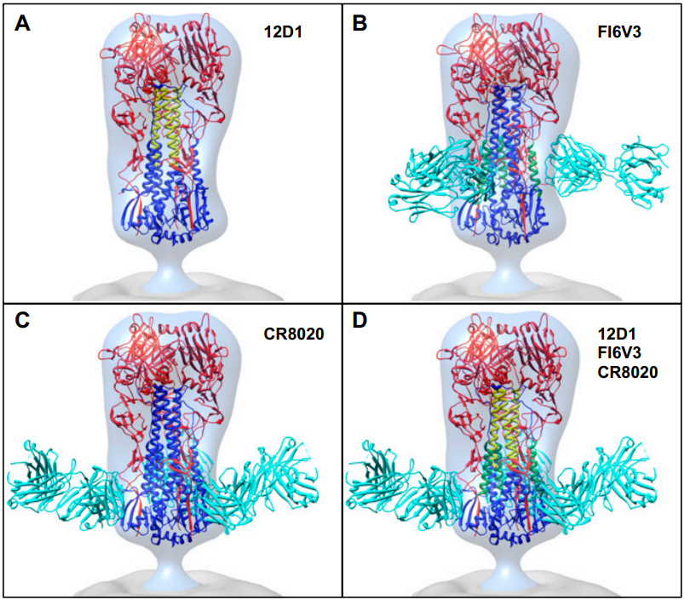

**Figure S8. Comparison of different types of stem epitopes on viral H3 HA.** (A–C) Front views of structures with the 12D1 epitope and complexes of Fab fragments with trimeric HAs placed into the experimentally obtained 3D density map for the H3 HA from H3N2 influenza virus. Structures shown include (A) the HA2 epitope for antibody 12D1, shown in yellow (1) on docked H3 (PDB ID code: 3SDY) (2); (B) H3 HA bound to FI6V3 Fab fragment (PDB ID code: 3ZTJ) (3) with helix A of HA2 within the epitope footprint, in green; and (C) H3 HA bound to CR8020 (PDB ID code: 3SDY). (D) Composite comparison showing the relative location of 12D1, FI6V3, and CR8020 epitopes on H3 HA. HA1 is in red; HA2 is in blue; selected epitope regions for 12D1 and FI6V3 are in yellow and green, respectively; and Fabs are in cyan. The 3D map of H3 is shown as a transparent surface rendering, with the viral membrane region in gray.

* + They report an average influenza spacing of 14 nm (“HA trimers are much more densely packed, with an average spacing of ∼14 nm”), yet this value seems too large for the following reasons
    - As an upper bound for the nearest-neighbor separation between two HA trimers, consider uniformly distributing 350 points (the number of HA trimers) on a sphere with a 60 nm radius (the average size of an influenza virion). It is straightforward to compute the nearest-neighbor distance, as shown by the following single line of Mathematica code. (The first term represents the 60nm radius of the virus and the second term finds the minimal Euclidean distance between all pairs of points.) This calculation instead suggests that a virion would need to have 200 spikes before this upper bound would drop to 14 nm

**Input:** Quantity[60, "Nanometers"] Min[EuclideanDistance@@@Subsets[SpherePoints[350], {2}]]

**Output:** 10.5 nm

* + - As a reference point, the maximum center-to-center separation between the antigen-binding sites of both Fabs in an IgG is ~15 nm [[Klein 2010](https://doi.org/10.1371/journal.ppat.1000908)], and hence a 14 nm HA separation would be near the limit of bivalent binding (although still possible). It is known that some IgGs can bind bivalently since there is a 1000x increase in the binding affinity or the minimum neutralizing concentration between an IgG and its corresponding Fab counterpart [[Lee 2012](https://www.pnas.org/content/109/42/17040), [Schofield 1997](https://doi.org/10.1099/0022-1317-78-10-2431)]
* [Magadan 2013](https://doi.org/10.1128/JVI.00471-13) (Journal of Virology): Influenza A Virus Hemagglutinin Trimerization Completes Monomer Folding and Antigenicity
  + Analyzed the A/Puerto Rico/8/34 (PR8) viral strain
  + “Trimerized recHA3 proteins (∼200 kDa) sedimented as discrete peaks...”
* [Moules 2010](https://doi.org/10.1016/j.virol.2010.04.030) (Virology): In vitro characterization of naturally occurring influenza H3NA− viruses lacking the NA gene segment: Toward a new mechanism of viral resistance?
  + Analyzed the H3N2 strain A/California/07/04. Note that they also analyzed two viral strains lacking NA, but here we exclusively focus on the wild type H3N2 strain
  + Estimated the density of glycoprotein spikes (both HA and NA) to be 695 on a virion with 100 nm diameter. Since their measured virus diameter was 88.5±9.3 nm, that would translate to 695·(4π·(88.5±9.3 nm)2)/(4π·(100 nm)2)=544±114 total spikes. Although we cannot separate the number of HA and NA spikes from this measurement, it will nevertheless be on the high end of the range of estimates seen in other manuscripts
  + They noted the following observation, which allows us to crudely estimate that on a spherical virion there will be 454±95 HA and 91±19 NA spikes. “Most authors agree that the NA/HA ratio at the surface of influenza A viruses is about 1/5 [[Harris 2006](https://doi.org/10.1073/pnas.0607614103); [Fujiyoshi 1994](https://doi.org/10.1002/j.1460-2075.1994.tb06264.x)]”
* [Weldon 2010](https://doi.org/10.1371/journal.pone.0012466) (PLoS One): Enhanced Immunogenicity of Stabilized Trimeric Soluble Influenza Hemagglutinin
  + Analyzed H3N2 virus A/Aichi/2/68, modified at the C-terminus with a GCN4pII trimerization repeat to stabilize the native trimeric structure of HA
  + “Separation of reaction products on gradient SDS-PAGE and Western blot analysis indicates that the sHA is observed as a mixture of trimeric (∼210 kDa), dimeric (∼140 kDa), and monomeric proteins (∼70 kDa)”
* [Gamblin 2010](https://doi.org/10.1074/jbc.R110.129809) (Journal of Biological Chemistry): Influenza Hemagglutinin and Neuraminidase Membrane Glycoproteins
  + “NA is a mushroom-shaped tetramer of identical subunits, with the head of the mushroom suspended from the virus membrane on a thin ~6-nm-long stalk, a length that is variable between virus strains”
* [Shtyrya 2009](https://www.ncbi.nlm.nih.gov/pmc/articles/PMC3347517/) (Acta Naturae): Influenza Virus Neuraminidase: Structure and Function
  + “NA resembles a homotetramer of a mushroom shape: head of 8×8×4 nm on the thin stem, 1.5 nm wide and from 6-10 nm long [[Colman 1989, book](https://books.google.com/books/about/The_Influenza_Viruses.html?id=8JXhBwAAQBAJ)].” This implies that the total length of NA ranges from 10-14 nm.
    - *Note*: It is unclear how they determined the length range of 6-10 nm for the NA stem, since page 178 of the Colman book their refer to only states that the stalk length may be “up to 10 nm [[Laver 1969](https://doi.org/10.1016/0042-6822(69)90132-9), [Wrigley 1973](https://doi.org/10.1016/0042-6822(73)90457-1)],” and of these two references only the former gives a total length of NA at 15 nm (while the latter looks at NA with the stem proteolytically digested)
  + “Notwithstanding that NA types A and B homology cover only 30%, their three-dimensional structures are virtually identical [6].“
  + The neuraminidase active site is “located 3.2 nm from the tetragonal axis,” and therefore the distance between active sites is (3.2 nm)·21/2 = 4.5 nm
  + “The molecular mass of the [neuraminidase] monomer is ≈ 60 kDa, and ≈ 240 kDa for the tetramer [[Varghese 1991](https://doi.org/10.1016/0022-2836(91)80068-6)].”
* [Ndifon 2009](https://doi.org/10.1073/pnas.0903427106) (PNAS): Differential neutralization efficiency of hemagglutinin epitopes, antibody interference, and the design of influenza vaccines
  + An HA trimer has a length of 13.5 nm and a diameter of 5.5 nm [[Wilson 1981](https://doi.org/10.1038/289366a0)]. Because a Fab has dimensions of 8nm×5nm×4nm [[Poljak 1973](https://doi.org/10.1073/pnas.70.12.3305)], the area of the end face of HA (where it binds to sialic acid) approximately equals to the width of the 4nm×5nm binding surface of a Fab. This suggests that only a single antibody can bind to the top of each HA trimer, so steric occlusion may plan an important role in mediating sera
  + In the Supporting Information: ≈345 HA trimers per virus [[Taylor 1994](https://doi.org/10.1006/viro.1994.1653)]
* [Yamaguchi 2008](https://doi.org/10.1016/j.jsb.2008.01.009) (Journal of Structural Biology): Zernike phase contrast electron microscopy of ice-embedded influenza A virus
  + Analyzed H1N1 A/New Caledonia/20/99
  + "About 450 [HA and NA] glycoprotein spikes were present on the surface of 120 nm diameter virions, whose surface area (4π*r*2) was 45,216 nm2. This number well matched the previous mass analysis estimates of 400–500 spikes per virion [[Ruigrok 1984](https://doi.org/10.1099/0022-1317-65-4-799)]." Note that they did not separately measure HA and NA spikes
* [Harris 2006](https://doi.org/10.1073/pnas.0607614103) (PNAS): Influenza Virus Pleiomorphy Characterized by Cryoelectron Tomography
  + Analyzed the viral strain X31 (a recombinant strain expressing A/PR/8/34 (H1N1) internal proteins and A/Aichi/2/68 (H3N2) glycoproteins). Note that A/Aichi/2/68 is a specific strain of the A/Hong Kong/1/1968 virus [[Kilbourne 1969](https://www.ncbi.nlm.nih.gov/pmc/articles/PMC2427719/)]
  + Found there are ≈300 HA and 45 NA spikes per virion
    - “The packing density of spikes was assessed by counting them within typical well resolved patches; on average, an area of 40×40 nm was found to contain 13 spikes. No difference in this respect was observed between spherical and elongated virions. Thus a spherical virion of average diameter (120 nm) should have ≈375 [HA and NA] spikes.”
    - “This figure was confirmed by counting all of the spikes on two virions of average diameter whose entire surfaces were visualized clearly enough for this to be possible, yielding 351 (301 HA plus 50 NA) and 328 (290 HA plus 38 NA) spikes per virion. Allowing for a few bare patches (such patches were observed on ≈40% of spherical virions, e.g., Figure 4b–d), these quantitations are consistent.”
    - ”They are also in reasonable agreement with prior biochemical estimates of 340–400 HA trimers per virion [[Inglis 1976](https://doi.org/10.1016/0042-6822(76)90355-X)].“
  + “Glycoproteins are packed closely but irregularly, with an average center-to-center spacing of ≈11 nm.”
  + Figure 3 shows the distribution of spikes on a representative virion
    - “When the HA ectodomain is docked into tomographic densities for HA spikes, its outer tip is ~14 nm from the membrane surface (i.e., there is a 2-nm stem), whereas for NA spikes, this spacing is ~16 nm (i.e., a 10-nm stem).”

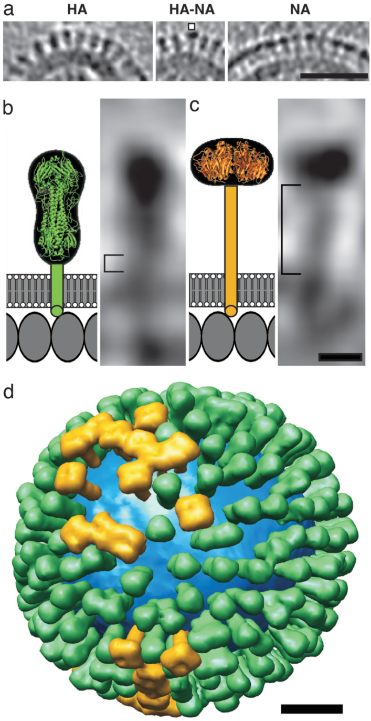

**Figure 3. Distributions and shape-based differentiation of HA and NA spikes.** (a) HA cluster (Left); single NA (marked) in a cluster of HAs (Center); and cluster of mainly NA spikes (Right). (Scale bar, 50 nm.) (b and c) The stem lengths of HA and NA (square brackets in b and c, respectively) were measured as described in Materials and Methods. The structures of the stems, transmembrane segments, and endodomain tails are not known, and they are shown schematically. Molecules in the matrix layer are inferred to be packed in a monolayer with a spacing of 4 nm (our unpublished results). (Scale bar, 5 nm.) (d) Model of the distribution of glycoprotein HA (green) and NA (gold) on a single influenza virion. The lipid bilayer is blue. (Scale bar, 20 nm.)

* [Jackson 1991](https://doi.org/10.1007/BF01319230) (Archives of Virology): Three antibody molecules can bind simultaneously to each monomer of the tetramer of influenza virus neuraminidase and the trimer of influenza virus hemagglutinin
  + Analyzed hemagglutinin from A/Memphis/1/71 (Mem 71) and neuraminidase from the H1N9 avian virus strain A/NWS/33HA-A/tern/Australia/G70C/75NA
  + The mass of NA obtained by two different methods. "The values of 188 kDa obtained for pronase released NA and 48 kDa obtained for Fab' are in good agreement with the values of 196 kDa and 48.2 kDa respectively obtained by a sedimentation equilibrium method [[Jackson 1983](https://www.ncbi.nlm.nih.gov/pubmed/6822736)].”
  + Table 2 shows their measured value of 240 kDa for the molecular weight of hemagglutinin
* [Jackson 1983](https://www.ncbi.nlm.nih.gov/pubmed/6822736) (Journal of Immunology): The equilibrium constant for the interaction between a monoclonal Fag fragment and influenza virus neuraminidase
  + Analyzed the viral strain A/NWSH-Tokyo/67N, which is a reassortant containing hemagglutinin from H1N1 A/NWS/33 and neuraminidase from H2N2 A/Tokyo/3/67
  + “The sedimentation equilibrium distribution obtained with 125I-neuraminidase is presented in Figure 1b. The slope of the line drawn through the data yields a value of 196,000 Da for the molecular weight of the enzyme“
* [Colman 1983](https://doi.org/10.1038/303041a0) (Nature): Structure of the catalytic and antigenic sites in influenza virus neuraminidase
  + Each NA tetramer has four catalytic sites that are 4.2 nm apart. “The distance between the active centres across the subunit interface is 4.2 nm.”
* [Varghese 1983](https://doi.org/10.1038/303035a0) (Nature): Structure of the influenza virus glycoprotein antigen neuraminidase at 2.9 Å resolution
  + “The influenza virus neuraminidase glycoprotein is a tetramer with a box-shaped head, 100×100×60 Å, attached to a slender stalk.”
* [Wilson 1981](https://doi.org/10.1038/289366a0) (Nature): Structure of the haemagglutinin membrane glycoprotein of influenza virus at 3 Å resolution
  + Analyzed H3N2 A/Hong Kong/1968
  + “The haemagglutinin (HA) of the A/Hong Kong/1968 virus is a trimer of 224,640 molecular weight (MW).”
  + “The haemagglutinin trimer is an elongated cylinder, 13.5 nm long, with a triangular cross-section varying in radius from 1.5 nm to 4 nm.” Thus, the max diameter of the HA head would be 1.5 nm + 4 nm = 5.5 nm
* [Wrigley 1973](https://doi.org/10.1016/0042-6822(73)90457-1) (Virology): The size and shape of influenza virus neuraminidase
  + Analyzed the B/Lee viral strain
  + Each NA monomer was found to be 60,000 Da. Therefore, “the total molecular weight of the protein is approximately 240,000 Da.“
  + The head of neuraminidase “appears to consist of four coplanar subunits each 4nm×4nm×4nm.” Therefore, the entire neuraminidase head has an 8 nm diameter
  + Figure 3B shows the length profiles of different NA molecules. Digitizing the length distribution (i.e. the sizes greater than 60 Angstroms) gives a max diameter for neuraminidase of 7.7±0.3 nm

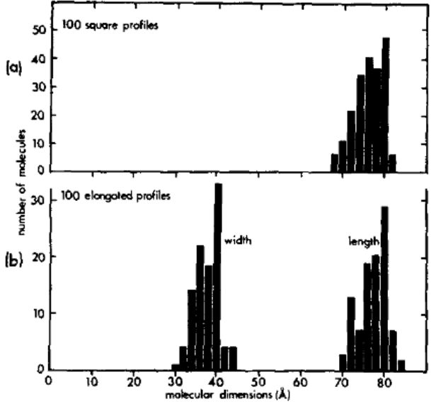

**Figure 3.** Histograms showing distribution of (a) side-to-side measurements of 100 square profiles (two perpendicular measurements per profile), and (b) width and length measurements of 100 elongated profiles.

* [Laver 1969](https://doi.org/10.1016/0042-6822(69)90132-9) (Virology): Morphology of the isolated hemagglutinin and neuraminidase subunits of influenza virus
  + Analyzed the A0-A2 recombinant X-7F1 viral strain
  + “In the presence of SDS, [neuraminidase molecules] were seen as oblong structures about 8.5 nm long and 5.0 nm wide with a centrally attached fibre 10.0 nm long.“ Since neuraminidase is mushroom-shaped, with a head that is approximately (8.5 nm long)×(8.5 nm wide)×(5.0 nm high), the total length of neuraminidase is 5.0 nm + 10.0 nm = 15.0 nm

### 

### Crystal Structures of HA and NA

The front of this Cell Snapshot shows the crystal structure of the pandemic H1N1 A/California/04/2009 influenza virus hemagglutinin [[PDB 3LZG](https://doi.org/10.1126/science.1186430)] with the surrounding ectodomain copied from [Harris 2013](https://doi.org/10.1073/pnas.1214913110). Note that the cytoplasmic domain is not crystallizable and must be inferred.

Less information is known about the structure of neuraminidase, since its stem and cytoplasmic tail have not yet been crystallized. The crystal structure on the front of the SnapShot shows the head of the pandemic H1N1 A/California/04/2009 neuraminidase [[PDB 4B7M](https://doi.org/10.2210/pdb4B7M/pdb)] together with a best-guess of the stem and ectodomain.

Of the four types of influenza (A-D), only influenza A and B cause seasonal epidemics. Currently, H1N1 and H3N2 constitute the dominant subtypes of influenza A while Victoria and Yamagata represent the most prevalent lineages of influenza B. Together, they comprise the four components of the annual influenza vaccine.

Note that while influenza A and B contain both HA and NA spikes, influenza C is unique in that it contains a single spike HEF that serves to bind, initiate fusion, and ultimately sever glycans to enable the egress of viral progeny [[Wang 2016](https://doi.org/10.1007/s13238-015-0193-x)]. Since influenza C typically causes mild disease, it has been studied far less extensively than influenza A or B.

### 

### Number of Fabs that can Simultaneously Bind

When multiple antibodies attempt to simultaneously bind to antigenic sites that are too close to each other, the antibodies may sterically occlude one another and inhibit binding (e.g. Figure S1 of [Angeletti 2017](https://doi.org/10.1038/ni.3680) shows that a Fab binding to any of the five canonical antigenic sites on the head of HA will partially inhibit binding to the other sites). However, if polyclonal serum can target every antigenic site on HA, then this surface protein can, in principle, be completely covered in antibodies. The studies below demonstrate that antibodies do indeed target sites everywhere along HA, and that the maximum number of Fabs that can simultaneously bind to HA essentially equal the theoretical upper bound (based on the surface area of HA and the Fab binding surface).

**Sources:**

* [Taylor 1994](https://doi.org/10.1006/viro.1994.1653) (Virology): Competitive Binding of Neutralizing Monoclonal and Polyclonal IgG to the HA of Influenza A Virions in Solution: Only One IgG Molecule Is Bound per HA Trimer Regardless of the Specificity of the Competitor
  + There is sufficient surface area for ~10 Fabs to bind to an HA trimer, ignoring steric hindrance between these antibodies. “Assuming a diameter of 5.5 nm [[Wilson 1981](https://doi.org/10.1038/289366a0)] and that the sides and top which are available to interact with antibody paratopes represent 75% of the total surface area, this could accommodate nearly ten nonoverlapping antibody footprints of 7.5 nm2 [[Amit 1986](https://doi.org/10.1126/science.2426778), [Colman 1987](https://doi.org/10.1038/326358a0)].”
* [Jackson 1991](https://doi.org/10.1007/BF01319230) (Archives of Virology): Three antibody molecules can bind simultaneously to each monomer of the tetramer of influenza virus neuraminidase and the trimer of influenza virus hemagglutinin
  + 9 Fabs from polyclonal rabbit serum were able to simultaneously bind to HA, while 13 Fabs could simultaneously bind to NA. This stoichiometry was determined by measuring the molecular weight of the Fab+antigen complex. “Trimeric hemagglutinin and tetrameric neuraminidase molecules isolated from influenza virus bind an average of 9 and 13 molecules respectively of monovalent antibody fragments prepared from IgG isolated from polyclonal sera.”
  + "The entire surface of a protein antigen is generally considered to be an antigenic continuum [6]. From this it follows that a very large number of individual epitopes can exist on the surface of a single antigen molecule. In fact there is now clear evidence, from experiments making use of mAbs, naturally occurring field strains of virus and mAb-selected escape mutants, that numerous overlapping and non-overlapping epitopes exist on the surface of NA [2, 23, 35, 36, 37] and HA [9, 16, 31, 32, 39]. The results of the present study indicate that even under saturating conditions no more than three or four antibodies derived from a polyclonal antiserum, which contains distinct antibodies with specificity for a number of epitopes, bind to each monomer. In vivo, where intact IgG, IgM, and IgA antibody molecules bind to intact virions, steric constraints will be even greater and fewer numbers of antibodies will bind."
  + "The 'footprint' of the paratope of an Fab fragment has an area of between 6 and 8.5 nm2 [3, 10, 11, 27, 30]. The total exposed surface area on a monomer of NA is about 125 nm2 and that of an HA monomer is some 180 nm2. Theoretically, therefore, these two proteins could accommodate the footprint areas of up to 15-21 and 20-30 monovalent antibody fragments respectively."

### Number of IgGs that can Simultaneously Bind

Full IgGs are far larger than Fabs and hence can sterically inhibit one another’s binding much more than Fabs. The sources below discuss how many IgGs can simultaneously bind to an HA trimer.

**Sources:**

* [Taylor 1994](https://doi.org/10.1006/viro.1994.1653) (Virology): Competitive Binding of Neutralizing Monoclonal and Polyclonal IgG to the HA of Influenza A Virions in Solution: Only One IgG Molecule Is Bound per HA Trimer Regardless of the Specificity of the Competitor
  + Analyzed the H7N1 viral strain A/FPV/Rostock/34
  + Allege that only one IgG can bind per HA spike in whole virus, whereas multiple IgGs can bind to a soluble HA. "These demonstrated that the binding of one molecule of IgG mAb per HA trimer prevented the binding of mAbs directed against other antigenic sites on the HA (site A, site B, or site D), even though these are topographically separate and antigenically independent. Furthermore the same procedures showed that one molecule of mAb per trimer prevented the binding of polyclonal HA-specific IgG obtained from the serum of rabbits immunized with whole virus. This restricted binding is clearly a property of the intact virion, since others using purified HA have shown that up to four IgG molecules of different specificities can bind per trimer.”
* [Taylor 1987](https://doi.org/10.1016/0042-6822(87)90466-1) (Virology): Quantitative relationships between an influenza virus and neutralizing antibody
  + Analyzed the H7N1 viral strain A/FPV/Rostock/34
  + They determined that even at saturating concentrations of Ab or polyclonal sera, only one IgG is bound per HA trimer. However, if the virus is adsorbed onto a plastic microtitre plates or if binding to purified HA is conducted, then 3 IgG can bind per HA trimer. This suggests that viral adsorption for assays such as ELISA may disrupt the viral structure and allow multiple antibodies to simultaneously bind to each trimer, even though such binding may not happen for whole, intact virus.
    - “Using radiolabeled immunoglobulins approximately one IgG molecule, whether of monoclonal or polyclonal origin, binds per HA spike under conditions of antibody saturation.”
    - "Binding of neutralizing IgG obtained from two different rabbits, WR26 and WR45, that had been inoculated with FPV/D (H7N7) and one rabbit WR69 that had been inoculated with V31 (H7N2) which has an HA derived from FPV/R (H7N1) was similar (Fig. 2)"

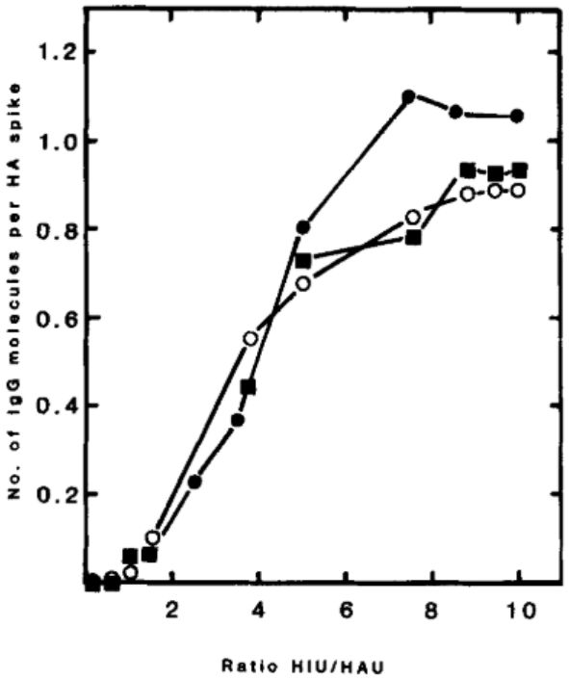

**Figure 2. Number of polyclonal IgG molecules binding to HA spikes of FPV/R particles in suspension.** 20 HAU FPV/R (7.96·108 particles) was incubated with 125I-labelled purified IgG derived from hyperimmune sera WR45 (◼️), WR26 (𐩒), and WR69 (⬤). WR45 and WR26 were produced by inoculation of rabbits with FPV/D (H7N7) and WR69 with the FPV/R reassortant V31 (H7N2). Their specific activities were 7.68·104, 1.25·105, and 4.2·104 cpm/μg, respectively. The number of IgG molecules was calculated as described in Table 1. At a ratio of 10 HIU:1 HAU neutralization exceeded 99.95%.

* + - “Binding of IgG in solid-phase radioimmunoassay. FPV/R particles and BHA (HA enzymatically removed from FPV/R particles), both at the equivalent of 5 HAU, were adsorbed to the wells of plastic micro- titre plates. Essentially the same curves for HC2 and HClO were seen whether FPV/R particles or BHA mol- ecules were used as the solid-phase binding substrate (Fig. 4). Data show that the use of a solid-phase RIA resulted in an increase in binding of IgG molecules from one per HA spike observed with FPV/R particles free in solution to approximately three per HA spike.”

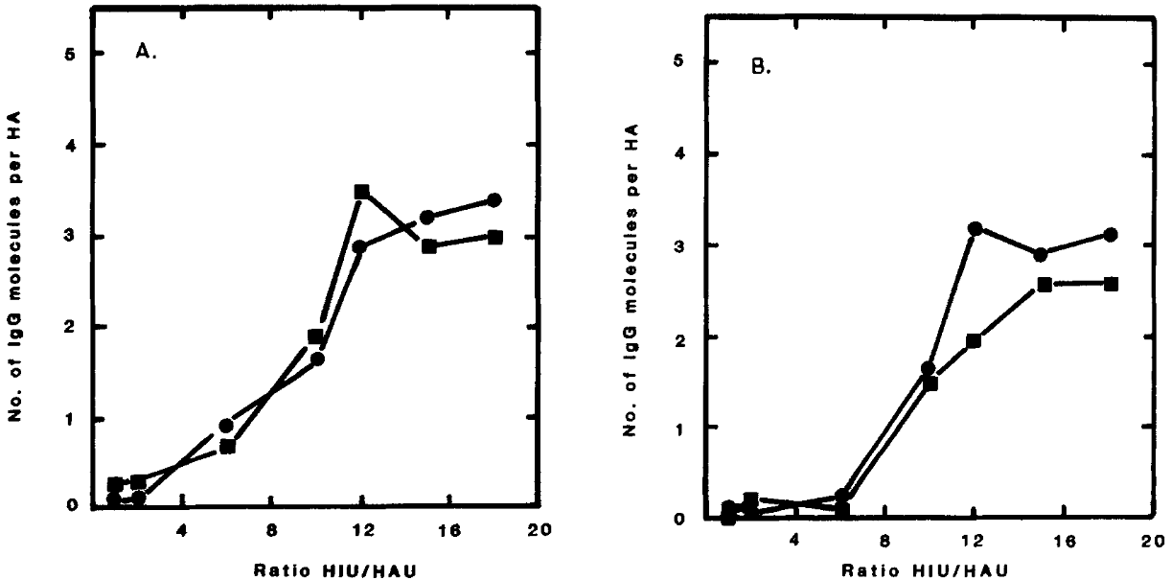

**Figure 4. Number of HC2 (A) and HC10 (B) IgG molecules binding to FPV/R particles (5 HAU/well) (⬤) or equivalent isolated BHA spikes (◻️) in solid phase RIA.** 5 HAU intact FPV/R or isolated BHA were adsorbed onto the surface of microtitre plate wells. Increasing amounts of 125I-labelled IgG (5-90 HIU) were added to virus-coated microtitre wells for 1 hr at 25°C and then 18 hr at 4°C. The wells were then washed thoroughly with cold PBS and the radioactivity associated with the wells and hence the number of IgG molecules binding was determined. The specific activity of 125I-labelled HC2 IgG was 4.95·104 cpm/μg and of HC10 was 4.28·104 cpm/μg.

* [Wrigley 1983](https://doi.org/10.1016/0042-6822(83)90499-3) (Virology): Electron microscopy of influenza haemagglutinin-monoclonal antibody complexes
  + Analyzed the viral strain X31 (a recombinant strain expressing A/PR/8/34 (H1N1) internal proteins and A/Aichi/2/68 (H3N2) glycoproteins)
  + Electron microscopy of four monoclonal antibodies in complex with the X31 virus were taken.
    - For three of the four antibodies considered (HC3, HC19, and HC45), complexes containing multiple antibodies bound to a single HA were seen. [Two antibodies bound to a single HA trimer were directly observed, but whether three antibodies could bind to a single trimer was not discussed.]
    - The fourth antibody (HC31) bound at the top of HA near the axis of symmetry (see Figure 6 below), and in this case complexes containing multiple antibodies bound to a single HA trimer were not seen

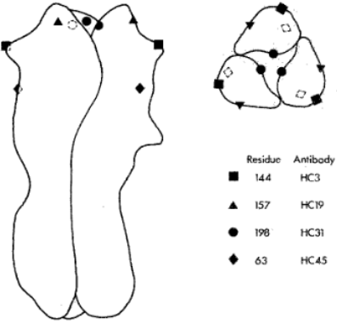

**Figure 6.** **Drawing of the BHA trimer showing the approximate sites of antibody binding and the locations of amino acid substitutions.** Left: long axis vertical, distal end at the top. Right: view of the distal end, note the proximity of the three residues 198 to the trimer axis.

* [Lubeck 1982](https://doi.org/10.1016/0042-6822(82)90313-0) (Virology): Conformational Changes at Topologically Distinct Antigenic Sites on the Influenza A/PR/8/34 Virus HA Molecule are Induced by the Binding of Monoclonal Antibodies
  + Figure 3 shows that the presence of one antibody enhances the binding of another antibody, which almost certainly necessitates that both antibodies bind to the same HA trimer. However, the Gerhard lab almost always used NP40-disrupted virus, and hence according to the discussion of [Taylor 1987](https://doi.org/10.1016/0042-6822(87)90466-1) above, this disruption likely makes multiple antibodies capable of simultaneously binding to the virus (even though whole, intact virus may only allow one antibody to bind per HA trimer)

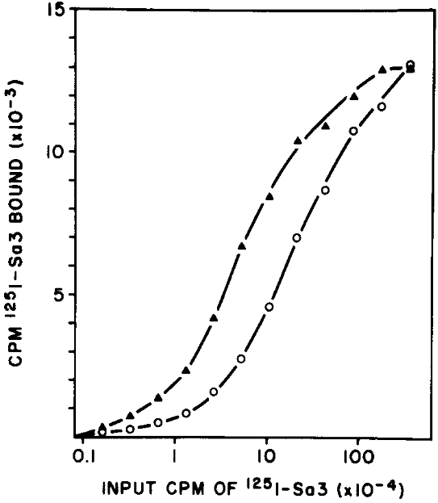

**Figure 3.** **Enhanced binding of [125I]Sa3 at a single concentration of Ca1 antibody.** Various amounts of [I125]Sa3 were incubated with Ca1 antibody (275 ng/well) (▲) or PBS containing 1% bovine serum albumin (𐩒) for 90 min at room temperature in the competitive binding RIA.

### Number of HA Trimers Required to Initiate Fusion

An important but difficult-to-measure quantity is the number of hemagglutinin (HA) spikes required to initiate viral fusion with the acidified endosomal membranes. This answer has implications for how many antibodies are needed to neutralize a virus.

**Sources:**

* [Otterstrom 2014](https://doi.org/10.1073/pnas.1411755111) (PNAS): Relating influenza virus membrane fusion kinetics to stoichiometry of neutralizing antibodies at the single-particle level
  + Analyzed the viral strains A/Puerto Rico/8/34 (H1N1) and A/Aichi/68/X:31 (H3N2)
  + “Our data reveal a need for two to three HA trimers for fusion and strongly support a kinetic model of HA-mediated fusion requiring simultaneous action of multiple, neighboring trimers”
* [Gunther-Ausborn 2000](https://doi.org/10.1128/JVI.74.6.2714-2720.2000) (Journal of Virology): Role of hemagglutinin surface density in the initial stages of influenza virus fusion: lack of evidence for cooperativity
  + Created virosomes containing two different types of HA, one that fuses at a low pH (from the H3N2 strain X-47, which initiates fusion below pH 5.6) and another that fuses at a larger pH (from the H3N2 strain A/Shangdong, which initiates fusion below pH 6.0). The rate of fusion was measured at a pH of 5.7, so that only the A/Shangdong HA could fuse. By creating virosomes with different proportions of the two types of HA, they could determine how fusion varied with the fusion-competent HA surface density
  + "The initial rate of fusion of these virosomes at pH 5.7 increased directly proportional to the surface density of A/Shangdong HA, and a single A/Shangdong trimer per virosome appeared to suffice to induce fusion. The reciprocal of the lag time before the onset of fusion was directly proportional to the surface density of fusion-competent HA"
  + Also discuss earlier work on the number of HA needed to initiate fusion: "Fusion in this system is characterized by two kinetic phases: a lag phase after the shift to low pH and a fusion phase. It was found that cooperative interactions between HA trimers took place during the lag phase, but not during fusion, and the number of HA trimers required for fusion was estimated to be at least 3 [[Jackson 1985](https://doi.org/10.1016/0042-6822(85)90202-8)]. Using one of these same cell lines, but a different experimental and theoretical approach, others came to the conclusion that six trimers were required for fusion [[Daniels 1985](https://doi.org/10.1016/0092-8674(85)90157-6)] or that fusion was not cooperative at the level of the principal rate-determining step, without excluding possible cooperativity at another step [[Huang 1980](https://doi.org/10.1016/0042-6822(80)90334-7)]."
* [Blumenthal 1996](https://doi.org/10.1083/jcb.135.1.63) (Journal of Cell Biology): Dilation of the influenza hemagglutinin fusion pore revealed by the kinetics of individual cell-cell fusion events
  + Analyzed kinetics of an individual red blood cell (RBC) with an HA-expressing mouse fibroblast (serving as a proxy for the virus). The RBC had a fluorescent lipid in its membrane and a fluorescent solute in its aqueous space, allowing the fusion event to be monitored
  + Data was fit to a simple kinetics model where *N* HA trimers must transition to a fusion-competent state to initiate hemifusion, and ***N*=6 HA trimers** were inferred as the number needed to initiate fusion

## 

## Size and Mass of an Influenza Virion (Spherical vs Filamentous)

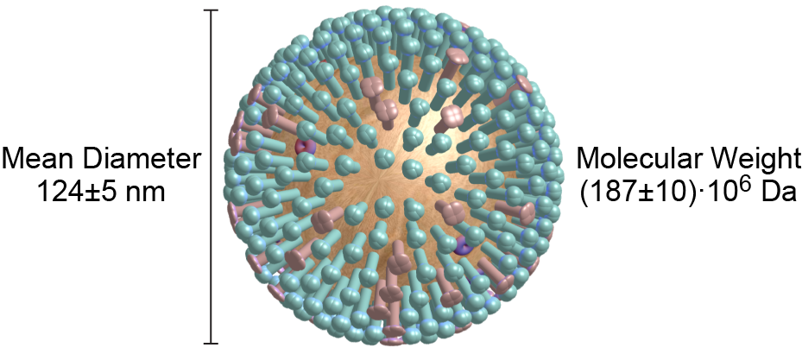

|  |  |  |  |  |
| --- | --- | --- | --- | --- |
| **Mean Diameter of Spherical Virion**  **(Viral Strain)** | **Source** |  | **Mass of Virion**  **(Viral Strain)** | **Source** |
| 142±28 nm  (X31) | [Robb 2019](https://doi.org/10.1038/s41598-019-52759-5) |  | (228±22)·106 Da (A/Switzerland/9715293/2013) | [Parupudi 2017](https://doi.org/10.1016/j.jviromet.2017.06.002) |
| 129.3±0.9 nm  (A/Switzerland/9715293/2013) | [Parupudi 2017](https://doi.org/10.1016/j.jviromet.2017.06.002) |  | (161±17)·106 Da (X49) | [Ruigrok 1984](https://doi.org/10.1099/0022-1317-65-4-799) |
| 106±23 nm (A/Udorn/72) | [Dadonaite 2016](https://doi.org/10.1099/jgv.0.000535)/  [Vijayakrishnan 2013](https://doi.org/10.1371/journal.ppat.1003413) |  | (182±19)·106 Da (B/Singapore/222/79) | [Ruigrok 1984](https://doi.org/10.1099/0022-1317-65-4-799) |
| 130 nm (A/California/7/2009) | [Harris 2013](https://doi.org/10.1073/pnas.1214913110) |  | (178±22)·106 Da (B/Hong Kong/8/73) | [Ruigrok 1984](https://doi.org/10.1099/0022-1317-65-4-799) |
| 104 nm (A/California/07/2009) | [Goldsmith 2011](https://doi.org/10.3201/eid1711.110258) |  | **(187±10)·106 Da** | **Average Value** |
| 137±14 nm (A/California/07/2009) | [Nakajima 2010](http://europepmc.org/article/MED/20093768) |  |  |  |
| 121±19 nm (A/New Caledonia/20/99) | [Yamaguchi 2008](https://doi.org/10.1016/j.jsb.2008.01.009) |  |  |  |
| 120 nm  (X31) | [Harris 2006](https://doi.org/10.1073/pnas.0607614103) |  |  |  |
| 127.0±7.0 nm (B/Hong Kong/8/73) | [Booy 1985](https://doi.org/10.1016/0022-2836%2885%2990312-2) |  |  |  |
| **124.0±5.0 nm** | **Average Value** |  |  |  |

*Note*: Virion diameter represents the *outer* diameter which includes both the viral envelope and the HA/NA spikes. When a virion is not perfectly spherical, the mean diameter represents the average of its major and minor axes.

**Sources:**

* [Robb 2019](https://doi.org/10.1038/s41598-019-52759-5) (Scientific Reports): Rapid functionalisation and detection of viruses via a novel Ca2+-mediated virus-DNA interaction
* Figure S2 measures the average diameter (mean of the major and minor axes) of the X31 virus (a recombinant strain expressing A/PR/8/34 (H1N1) internal proteins and A/Aichi/2/68 (H3N2) glycoproteins) to be 142±28 nm

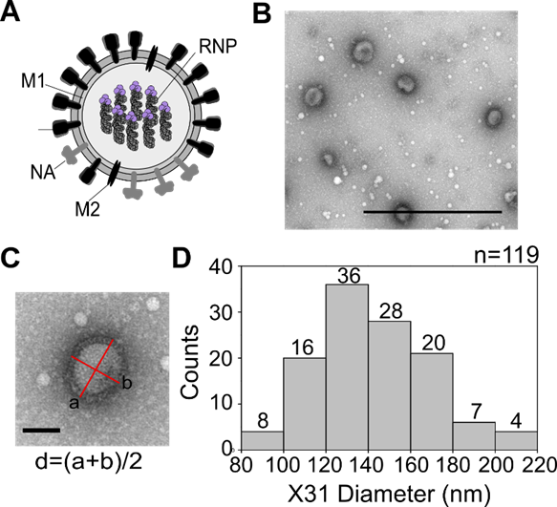

**Supplementary Figure 2.** **Electron microscopy measurement of influenza virus particle size.** A)Schematic representation of an influenza particle. Virus particles have three transmembrane proteins (HA, NA, and M2), beneath which lies a layer of matrix protein (M1), which encloses the eight genomic ribonucleoproteins (RNPs). B) Representative electron micrograph image of negatively stained X31 influenza particles. Scale bar 1 µm. C) The mean diameter of each virus particle was calculated by taking the average between major and minor axes. Scale bar 0.1 µm. D) Histogram of the mean diameter of the X31 virus. Number of virus particles counted (n) = 119.

* [Vahey 2019](https://doi.org/10.1016/j.cell.2018.10.056) (Cell): Low-Fidelity Assembly of Influenza A Virus Promotes Escape from Host Cells
  + Analyzed a viral strain expressing M1 from H3N2 A/Udorn/1972 in an H1N1 A/WSN/1933 background
  + “Virions have a roughly uniform diameter of ~80-100 nm, but lengths can range in size from ~100 nm to several microns ([Badham and Rossman, 2016](https://doi.org/10.1007/s40588-016-0041-7); [Chu et al., 1949](https://doi.org/10.1016/S0140-6736(49)91699-2); [Dadonaite et al., 2016](https://doi.org/10.1099/jgv.0.000535))”
  + Figure 1D shows the length distribution of a population of virions. Note that the *y*-axis is on a log-scale, and that the virions larger than 1000 nm only comprise ~10% of the population

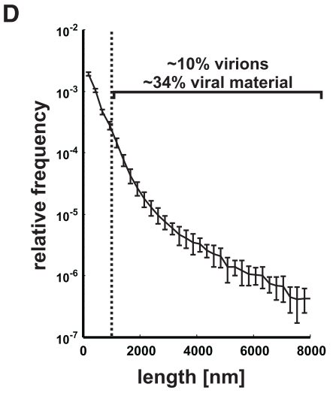

**Figure 1. Multispectral Strains of Influenza A Virus Permit Fluorescence-Based Quantification of Virus Composition and Morphology.** (D) Length distribution of virions containing M1 from A/Udorn/1972 showing significant size variation. Viruses >1 mm in length comprise a minority of ~10% of the population but represent ?34% of the viral material shed during infection (estimated as the product of measured particle size and frequency within the popu- lation). Plot shows mean and SD from six biological replicates with n > 44,000 viruses in each.

* [Parupudi 2017](https://doi.org/10.1016/j.jviromet.2017.06.002) (Journal of Virological Methods): Biophysical characterization of influenza A virions
  + Analyzed H3N2 A/Switzerland/9715293/2013
  + The majority of particles were monomeric and either spherical or slightly oblong
    - “Most particles were spherical or slightly elongated/bean-shaped. The mean value of circularity was 0.9 and about 73% of the virions had a circularity value greater than 0.85. The mean value of the minimum and maximum Feret diameters [the major and minor axes, including both spherical and ovoid particles] of the individual virus particles were 96 nm and 139 nm respectively. Particles elongated by a factor greater than 2 were a minor fraction at about 11%.”
    - Using FFF-MALS, most of their sample “contained about 72.7 ± 2.6% spherical or bean-shaped monomeric virions and 27.3 ± 2.6% elongated particles and/or chains/aggregates on a mass-basis.”
  + Viral aggregates can skew the size and mass calculations, since the average size of a monomer will be less than the average size of the monomers and aggregates in a sample. Since the majority of virions are monomeric, below we show the peak rather than mean size and mass measurements for the various techniques employed
  + Table 1 (shown below) gives the peak of the size distribution using various techniques. While the cryoTEM measurements measured the sizes of individual particles, the remaining techniques are bulk measurements and the size was inferred from the peak of the distribution:
    - 114.0±1.4 nm (cryoTEM, transmission electron cryomicroscopy)
    - 127.6±4.0 nm (NTA, Nanoparticle Tracking Analysis)
    - 135.3±0.9 nm (AUC, analytical ultracentrifugation)
    - 129.5±0.8 nm (FFF-MALS, field flow fractionation with multi-angle laser light scattering)
    - 140.2±1.7 nm (DLS, dynamic light scattering)
    - The average of these techniques is **129.3±0.9 nm**, which is the diameter we report for this source
    - Note that we excluded the DLS peak was not included in Table 1, so we fit the data in Figure 1A to a log-normal distribution and computed its resulting mode

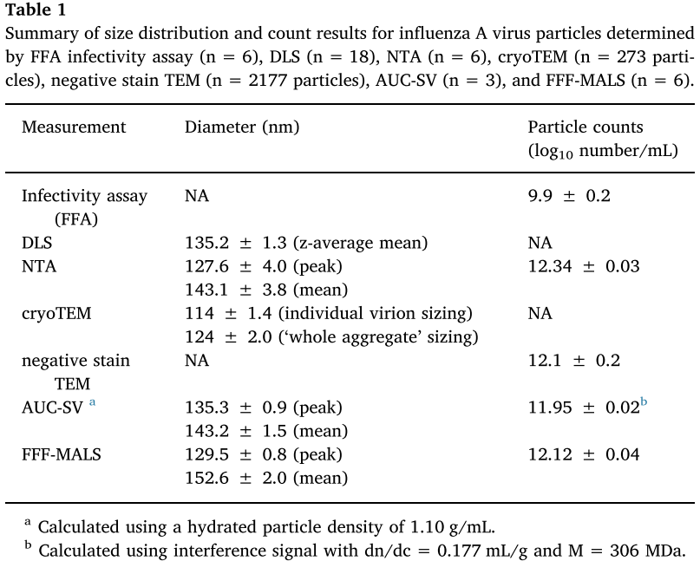

* + Table 2 (shown below) computes the molecular weight of a virion using several different methods. As before, we use the peak (or nominal) value for each method:
    - 229·106 Da (NTA, Nanoparticle Tracking Analysis)
    - 249·106 Da (FFF-MALS, field flow fractionation with multi-angle laser light scattering)
    - 206·106 Da (Virion composition)
    - The average of these techniques is **(228±22)·106 Da**, which is the diameter we report for this source

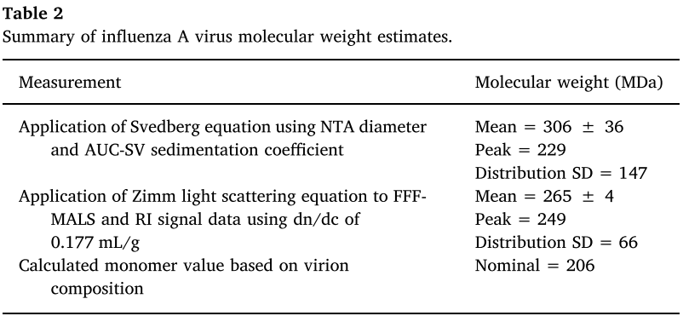

* [Dadonaite 2016](https://doi.org/10.1099/jgv.0.000535) (Journal of General Virology): Filamentous Influenza Viruses
  + "Despite being selected against in egg passage, filament production is selected for during serial intranasal passage of a highly laboratory-adapted spherical strain in guinea pigs. Furthermore, filament formation correlates with transmissibility between co-housed guinea pigs and by respiratory droplets in ferrets"
  + "The majority (typically 65–75 %) are spherical (axial ratio<1.2), with a mean outer diameter of 120nm [[Harris 2006](https://doi.org/10.1073/pnas.0607614103); [Yamaguchi 2008](https://doi.org/10.1016/j.jsb.2008.01.009)]"
  + "[Filamentous viruses] are typically more than 250 nm in length and can reach many microns (Figure 3). Filaments reaching or exceeding 30µm in length have been reported. The proportion of filaments in a given sample varies widely and depends on the virus strain used, tissues infected and the handling of virions."
  + "Filaments can be distinguished from spherical virions not just by their great length, but because their width, which around 80 nm, is less than that of the spherical virions (Figure 3a). Bacilliform virions have an intermediate width of around 95 nm, and show an inverse correlation between length and diameter (Figure 3b)."
  + By digitizing the data in Figure 3B (originally from [Vijayakrishnan 2013](https://doi.org/10.1371/journal.ppat.1003413) Figure 7E), the mean diameter of spherical virions was found to be 106±23 nm

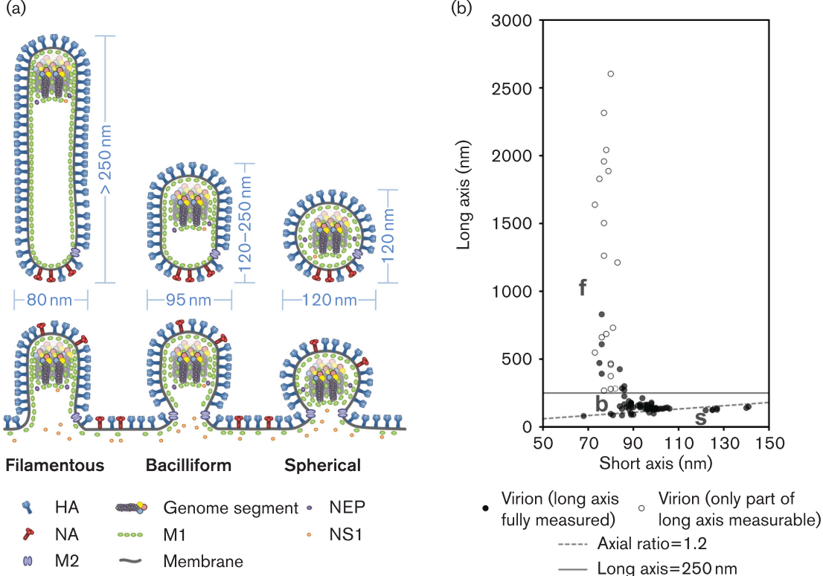

**Figure 3. Dimensions of influenza virions.** The dimensions of influenza virions, shown (a) as a schematic of budding and released virions, with typical sizes indicated, and (b) as measurements of purified influenza A/Udorn/72 virions. For (a) it should be noted that the incorporation of NS1 and NEP has so far only been examined in spherical virions, and their general incorporation is inferred from this. For (b) measurements of 96 virions were taken by cryoelectron microscopy (data replotted from [Vijayakrishnan 2013](https://doi.org/10.1371/journal.ppat.1003413)). Open circles indicate filaments that extended beyond the field of view and so are longer than measured. Spherical virions (s) are distinguished from bacilliform virions (b) by having an axial ratio less than 1.2 (dashed line); filaments (f) are distinguished from bacilliform virions by having a length greater than 250 nm (solid line).

* Although filamentous strains have a selective disadvantage in embryonated chicken eggs, they have a selective advantage in natural influenza infections
* [Bousse 2013](https://doi.org/10.1016/j.jviromet.2013.07.026) (Journal of Virological Methods): Quantitation of influenza virus using field flow fractionation and multi-angle light scattering for quantifying influenza A particles
  + Analyzed the viral strain PR8 (A/Puerto Rico/8/1934) (H1N1)
  + "The average diameter of spherical virions estimated by TEM was 104±30 nm (*n*=100), whereas virions with ovoid morphology had average dimensions of (145±30 nm)×(88±30 nm) with an average geometrical diameter of 116±30 nm (*n*=100)."
* [Harris 2013](https://doi.org/10.1073/pnas.1214913110) (PNAS): Structure and accessibility of HA trimers on intact 2009 H1N1 pandemic influenza virus to stem region-specific neutralizing antibodies
* Analyzed the H1N1 viral strain A/California/7/2009
* "∼75% of HA trimers on the surface of the virus have [at least one] C179 [antibody] bound to the stem domain."
* "Spherically shaped virions had an average diameter of ∼130 nm (n = 46), similar to the longer dimension of oval-shaped virions (length ∼137 nm; *n*=38). Approximately 7% of the virions were filamentous, as defined by an elongated elliptical morphology, with lengths ranging from 170 nm to 1,300 nm and axial ratios ranging from ∼2 to ∼10."
* "[For both spherical and filamentous virions], the ectodomain of trimeric HA was ∼16 nm long and ∼9 nm wide at the region farthest from the viral membrane"
* “HA trimers from both spherical and filamentous virus morphologies showed similar density maps and molecular structures”
* [Goldsmith 2011](https://doi.org/10.3201/eid1711.110258) (Emerging Infectious Diseases): Ultrastructural Characterization of Pandemic (H1N1) 2009 Virus
  + Analyzed the 2009 H1N1 pandemic strain A/California/07/2009 (pdmH1N1)
  + “In negative stain preparations, virions appeared mostly spherical (average diameter 104 nm) with some filamentous particles (up to 3.3 μm in length)“
  + “Extracellular virions, averaging 86 nm in diameter, were mostly ovoid or filamentous (Figure 1, panel B)”
* [Nakajima 2010](http://europepmc.org/article/MED/20093768) (Japanese Journal of Infectious Diseases): The First Autopsy Case of Pandemic Influenza (A/H1N1pdm) Virus Infection in Japan
  + Analyzed the 2009 H1N1 pandemic strain A/California/07/2009 (pdmH1N1)
  + Figure 5A shows negatively-stained electron microscopy images of spherical virions (scale bar represents 100 nm). We computed the average diameter of these virions, which was determined to be 137±14 nm

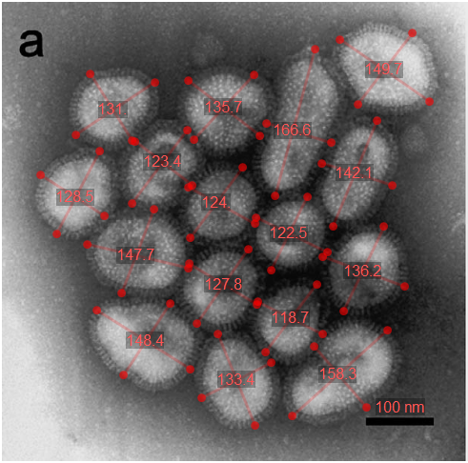

**Figure 5. Electron microscopy.** (a) The negative staining feature of isolated influenza (A/California/07/2009) virus particles in the culture supernatant. Scale bar, 100 nm. We computed the mean diameter of each virion (shown in red text).

* [Moules 2010](https://doi.org/10.1016/j.virol.2010.04.030) (Virology): In vitro characterization of naturally occurring influenza H3NA− viruses lacking the NA gene segment: Toward a new mechanism of viral resistance?
  + Analyzed the H3N2 strain A/California/07/04. Note that they also analyzed two viral strains lacking NA, but here we exclusively focus on the wild type H3N2 strain
  + "Viruses with an axial ratio ranging between 1.0 and 1.2, 1.2 and 1.6, or >1.6 were respectively classified as spherical, spheroidal, or elongated. The three classes of particle shapes were equally represented for the A/California/07/04 H3N2 viruses, with 37.9% (n=22) spherical, 32.8% spheroidal (n=19) and 29.3% elongated (n=17) virions (Table 1)...The spherical A/California/07/04 particles had a mean diameter (88.5± 9.3 nm)"
  + As seen in the [Vijayakrishnan 2013](https://doi.org/10.1371/journal.ppat.1003413) data, when the viruses elongated along their major axis (denoted by *L* in Table 1), their minor axis (denoted by *l* in Table 1) became shorter

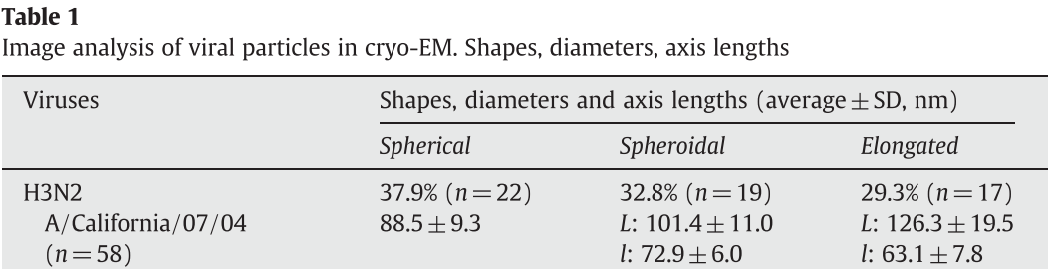

* [Yamaguchi 2008](https://doi.org/10.1016/j.jsb.2008.01.009) (Journal of Structural Biology): Zernike phase contrast electron microscopy of ice-embedded influenza A virus
  + Analyzed H1N1 A/New Caledonia/20/99
  + Table 1 shows the average diameter of spherical virions (121±19 nm) and elongated virions
    - “A series of images of individual virions taken by phase contrast electron microscopy… Ninety-one virions were carefully examined.”
    - Note that the virions classified as *elongated* in this work fall into the *bacilliform* (rather than *filamentous*) category described in [Dadonaite 2016](https://doi.org/10.1099/jgv.0.000535)

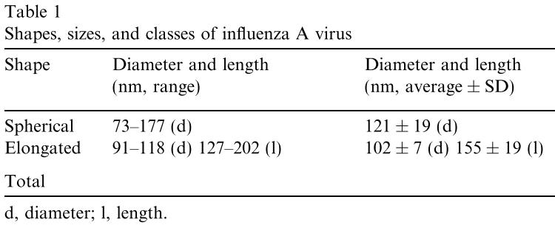

* [Harris 2006](https://doi.org/10.1073/pnas.0607614103) (PNAS): Influenza Virus Pleiomorphy Characterized by Cryoelectron Tomography
  + Analyzed the viral strain X31 (a recombinant strain expressing A/PR/8/34 (H1N1) internal proteins and A/Aichi/2/68 (H3N2) glycoproteins)
  + *n*=78 cells were roughly spherical (eccentricity between 1 and 1.2); *n*=17 were slightly elongated (eccentricity between 1.2 and 1.4); and *n*=15 were filamentous (eccentricity greater than 1.4)
  + The outer diameters of the spherical virions ranged from 84 to 170 nm (mean, 120 nm)
  + The average short diameter of elongated virions was fairly uniform and lower, at ≈100 nm
* [Booy 1985](https://doi.org/10.1016/0022-2836%2885%2990312-2) (Journal of Molecular Biology): Electron microscopy of influenza virus: A comparison of negatively stained and ice-embedded particles
  + Analyzed the influenza B viral strain B/Hong Kong/8/73
  + "The virus is shown to be circular in projection...The diameter of the complete B/Hong Kong virus was estimated from cryo-micrographs as 127.0±7.0 nm"
* [Ruigrok 1984](https://doi.org/10.1099/0022-1317-65-4-799) (Journal of General Virology): Characterization of Three Highly Purified Influenza Virus Strains by Electron Microscopy
  + Analyzed the viral strains X49 (H3N2 recombinant strain of A/England/864/75 (H3N2) and A/PR/8/34 (H1N1))
  + “The measured diameters of X49, negatively stained with uranyl acetate, was 140±12 nm, with similar results obtained for the other two virus strains“
  + “Neutron scattering studies on the virus in solution resulted in diameters of 116 nm; these values agree very well with electron microscopic data on freeze-dried virus (Nermut & Frank, 1971). The diameters determined from negatively stained specimens are somewhat larger, presumably as a result of flattening during specimen preparation”
  + The average mass was (161±17)·106 Da for X49, (182±19)·106 Da for B/Singapore/222/79, and (178±22)·106 Da for B/Hong Kong/8/73. The full mass distributions are shown in Figure 1 below

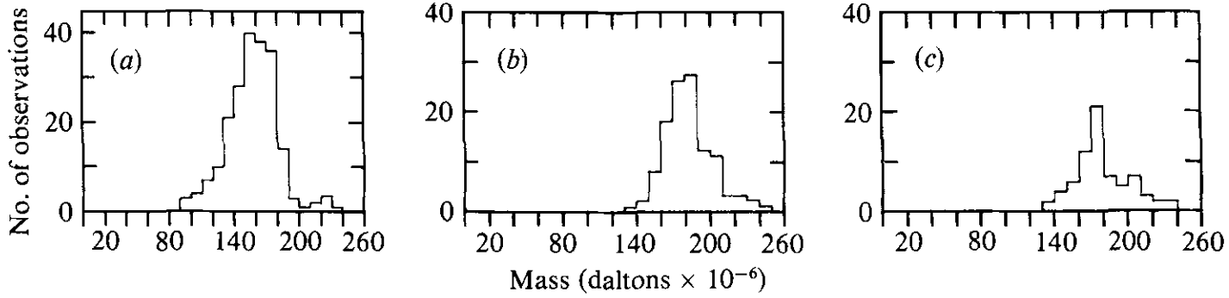

**Figure 1.** The mass distributions of influenza virus particles of strains (a) X49, (b) B/Singapore/222/79 and (c) B/Hong Kong/8/73.

* [Donald 1954a](https://doi.org/10.1099/00221287-11-2-325) (Journal of General Microbiology): Some Properties of Influenza Virus Filaments shown by Electron Microscopic Particle Counts
  + Found that a filamentous strain was more efficient at agglutinating red blood cells (i.e. 1 HA unit for 0.25mL of 1% chicken RBCs consisted of 106.6 virions for a filamentous strain compared to 107.2 virions for a non-filamentous strain)
  + However, both the filamentous and non-filamentous strains had the same infectivity, with 10 virions required for a 50% infectious dose. “The present techniques do not therefore show any differences in the relative infectivity of virus filaments and spheres”
  + Filamentous virions can be broken down by sonication into spherical viruses, which increases the overall HA titer of the mixture (i.e. improves its ability to agglutinate RBCs) but does not change the infectivity of the mixture. This suggests that the viral RNA sticks together during the sonication process (likely held together by [inter-segment interactions](https://doi.org/10.1038/s41564-019-0513-7)) and gets passed down to a single progeny.
    - "If we take into account the fact that the filamentous strains contained on the average about 50% filaments and 50% spherical forms we can conclude that a virus filament is, on average, about 7 or 8 times more efficient than a sphere in producing agglutination in the pattern test."
    - "Thus on ultrasonic treatment 20-40 agglutinating units, on average, appear to have been produced for each filament; this figure is necessary to account for the decrease in the efficiency of agglutination and the rise in agglutinin titre which occurred"

## Size of Epithelial Cells (Target Cells of Influenza)

There is an incredible difference between the size of a virus (~10-7 m) and the epithelial cells that it targets (~10-5 m). Note that there are multiple types of respiratory epithelial cells with different morphologies and different susceptibilities of attack by influenza. For example, human-adapted influenza tends to infect non-ciliated cells, although ciliated cells are also infected once enough virus is produced. The sources below discuss some of these nuances.

**Sources:**

* [Travaglini 2020](https://doi.org/10.1101/742320) (bioRxiv): A molecular cell atlas of the human lung from single cell RNA sequencing
  + Figure 2 shows the myriad cell types that make up the different components of the human lung

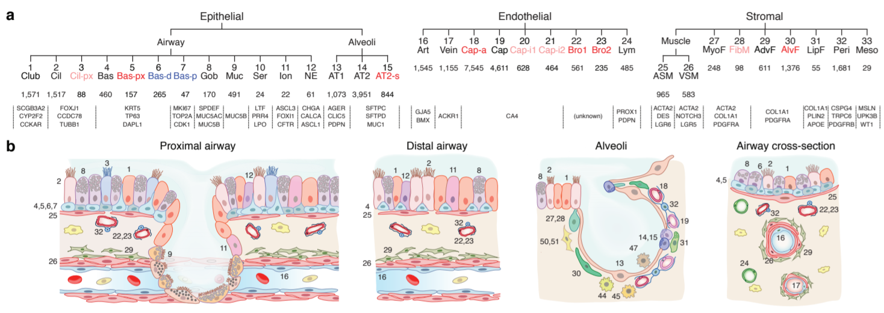

**Figure 2. Identity and location of human lung epithelial, endothelial, and stromal cell types.** a, Hierarchical tree showing human lung molecular cell types and their annotations in the

indicated tissue compartments following iterative clustering (each level of hierarchy is an

iteration) of scRNAseq profiles of cells in each compartment. Black, canonical cell types; blue,

proliferative subpopulations or differentiating states; red, novel populations (light red, found

only in one subject). Number of cells in each cluster and canonical marker genes are shown

below. b, Diagrams showing localization and morphology of each lung cell type (numbering

scheme as in Panel (a)).

* [Maughan 2017](https://doi.org/10.1002/lary.26611) (The Laryngoscope): A comparison of tracheal scaffold strategies for pediatric transplantation in a rabbit model: In vivo Comparison of Tracheal Scaffolds
  + Figure 3A shows the ciliated pseudostratified columnar epithelium found in the human upper respiratory tract. While cell morphology varies considerably, the width of the cells is roughly 5 μm while their height is approximately 30 μm (scale bar 100 μm)

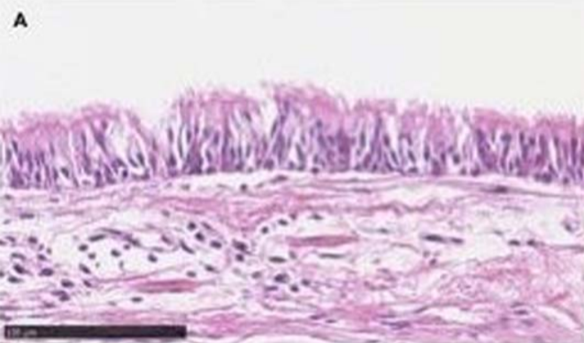

**Figure 3. Hematoxylin and eosin staining of luminal surface at midpoint of graft.** Scale bar=100 μm. (A) Control: largely intact layer of pseudostratified respiratory epithelium.

* [Nerkar 2013](https://doi.org/10.1016/j.jobaz.2013.07.006) (JOBAZ): Ultrastructural features of the Fallopian tube epithelium of bat, *Taphozous longimanus* (Hardwicke)
  + Figure 1 shows an electron micrograph of an epithelial cell (scale bar in bottom-left represents 2μm, as can be seen by zooming in closely). Width of each cilium is 1/3μm. Figure 3 shows a zoomed-in version (scale bar 1μm) that corroborates a width of 1/3μm for each cilium

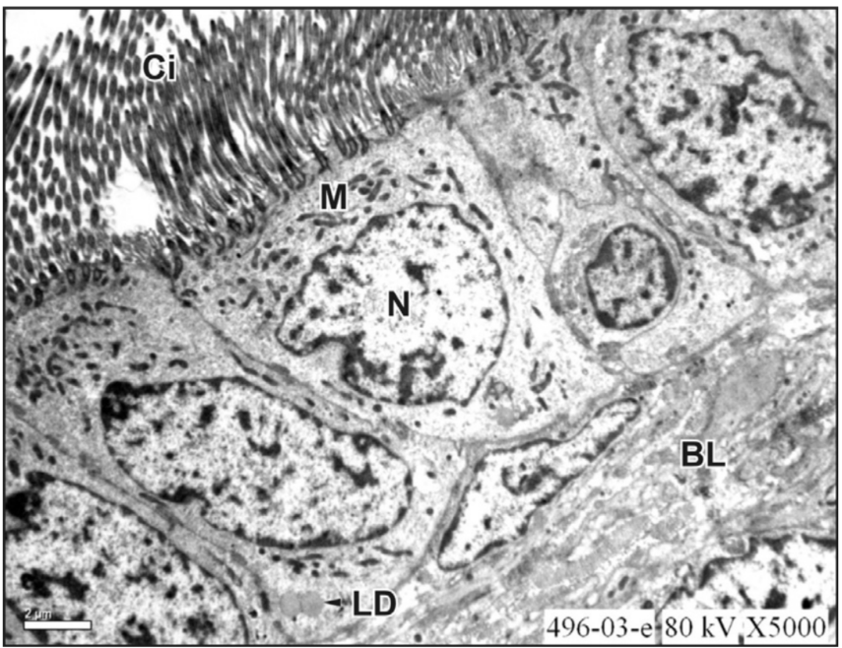

**Figure 1. Electron micrograph of the ciliated epithelial cells showing a broad apex and narrow base.** The ciliated cells show a large number of rod-shaped mitochondria (M), elongated cilia (Ci) at apical end, indented nucleus (N) and lipid droplets (LD) at infranuclear cytoplasm. Basal cells are also seen (X 5000)

* [Matrosovich 2004](https://doi.org/10.1073/pnas.0308001101) (PNAS): Human and avian influenza viruses target different cell types in cultures of human airway epithelium
  + “To identify cell types in human airway epithelium most susceptible to influenza viruses, we infected human tracheobronchial epithelium (HTBE) cultures from the apical side with either the human virus A/Memphis/14/96-M (H1N1) (Mem96-M) or avian virus A/Mallard/Alberta/119/98 (H1N1) (DkH1) and fixed the cells 6–8 h after infection after a single cycle of virus replication. The cultures were then double immunostained for ciliated cells and for the virus antigen.”
  + “The patterns of infection with these two viruses were strikingly different. The human virus infected mainly nonciliated cells (typically 5% of infected cells were ciliated cells), whereas the avian virus infected predominantly ciliated cells (Fig. 1).”

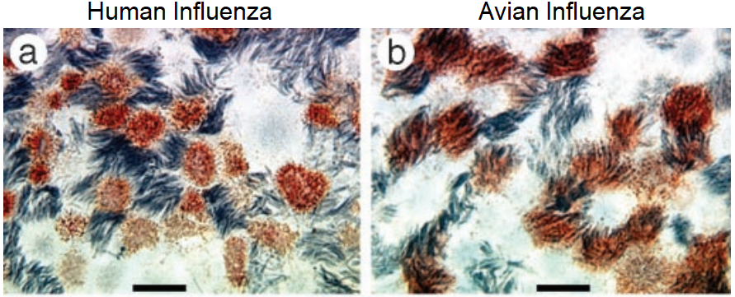

**Figure 1. Differential cellular tropism of human and avian influenza viruses in HTBE cultures.** The cultures were infected with Mem96-M (a) or DkH1 (b) viruses at the moi of 1, fixed 7 h after infection, and double immunostained for virus antigen and for cilia of ciliated cells as described in Materials and Methods. Light microscopy [virus (red), cilia (gray)]. (Bars=10 μm.)

* + “To corroborate the observed differences between the avian and human viruses, we tested several other avian and human virus strains. A/Mallard/Alberta/279/98 (H3N8), A/Duck/Minnesota/1525/81 (H5N1), and A/Chicken/FPV/Rostock/34 (H7N1) preferentially infected ciliated cells, whereas an H1N1, two H3N2, and two type B isolates obtained from human clinical specimens infected mainly nonciliated cells (data not shown). These results confirmed that the tropism for a specific type of airway epithelial cells depends on the virus host species, rather than on virus type, subtype, or strain.“
  + Ciliated cells also get infected later on during an infection. "Although ciliated cells are relatively refractory to infection with the human virus, this can be overcome by high local concentrations of the virus released from neighboring cells."

## Antigenic Sites on HA and NA

### H1N1 HA Epitopes: Sa, Sb, Ca1, Ca2, Cb

The sites where antibodies predominantly bind (the antigenic sites) of hemagglutinin were initially defined in Table 3 of [Caton 1982](https://doi.org/10.1016/0092-8674%2882%2990135-0) by analyzing mutations of H1N1 (PR8).

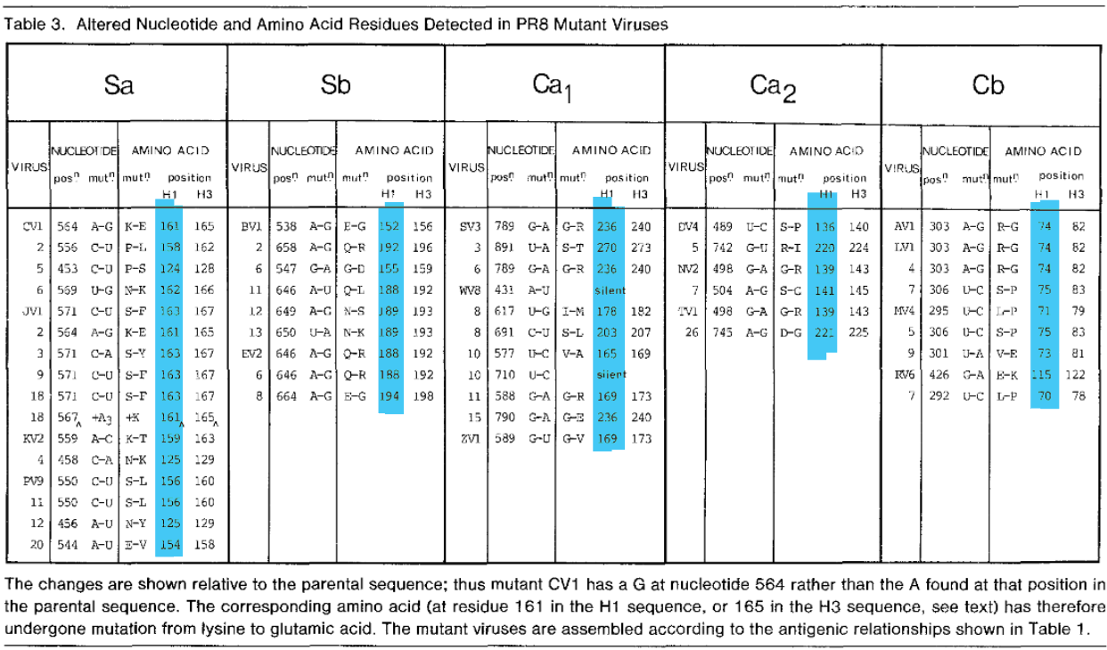

Note that the H1N1 and H3N2 numbering schemes are different. Furthermore, different references may cite slightly different amino acid residues, even after adjusting between numbering schemes (e.g. [Yasugi 2013](https://doi.org/10.1371/journal.pone.0077892) and [Anderson 2018](https://doi.org/10.1186/s12859-018-2042-4)).

The HA epitopes are visually in Figure 1 of [Angeletti 2017](http://www.nature.com/doifinder/10.1038/ni.3680) show below.

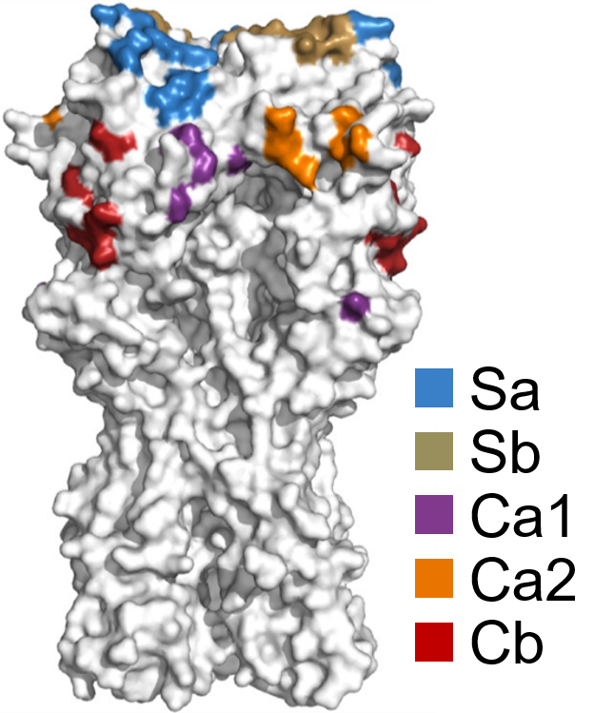

**Figure 1. Characterization of influenza viruses.** (a) Crystal structure of PR8 HA (PDB ID 1RUZ) viewed from the top, with the five major globular-domain antigenic sites in color (Sa, blue; Sb, gold; Ca1, purple; Ca2, orange; Cb, red).

### H3N2 HA Epitopes: A, B, C, D, E

The five epitopes on the head of H3N2 A/Victoria/361/2011 are shown in [Bonomo 2019](https://doi.org/10.1016/j.vaccine.2019.03.068), with the specific residues listed in the figure caption.

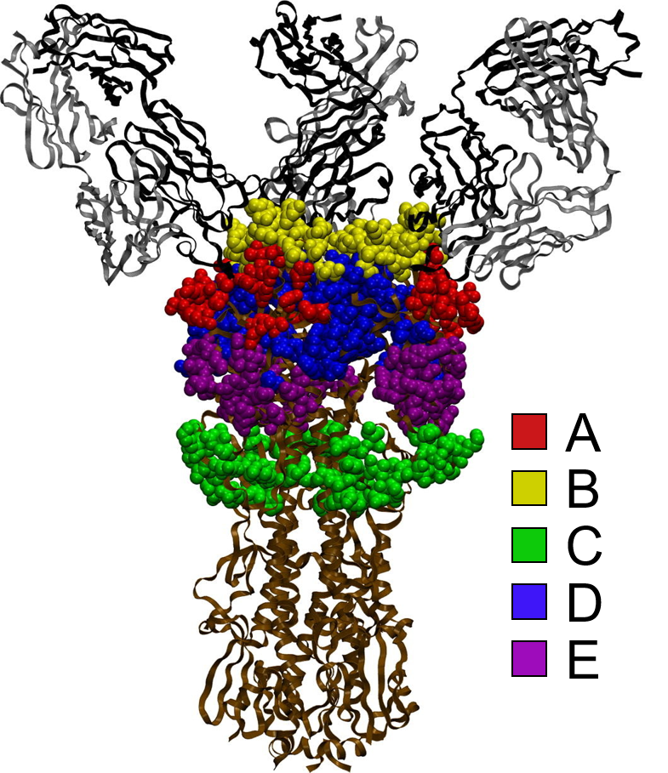

**Figure 1. The HA trimer of A/Victoria/361/2011(H3N2) in complex with three human antibody fragments.** Shown are the epitope regions A (red; amino acid residues 122, 124, 126, 130–133, 135, 137, 138, 140, 142–146, 150, 152, 168), B (yellow; residues 128, 129, 155–160, 163, 165, 186–190, 192–194, 196–198), C (green;residues 44–48, 50, 51, 53, 54, 273, 275, 276, 278–280, 294, 297, 299, 300, 304, 305, 307–312), D (blue; residues 96, 102, 103, 117, 121, 167, 170–177, 179, 182, 201, 203, 207–209, 212–219, 226–230, 238, 240, 242, 244, 246–248), and E (purple; residues 57, 59, 62, 63, 67, 75, 78, 80–83, 86–88, 91, 92, 94, 109, 260–262, 265).

### HA Stem Epitopes

Antibodies can target different sites on the HA stem, as shown in Figure S8 of [Harris 2013](https://doi.org/10.1073/pnas.1214913110) below. It is suspected that due to steric proximity, only a single stem-binding antibody can bind per HA monomer (or equivalently that three stem-binding antibodies can bind per trimer).

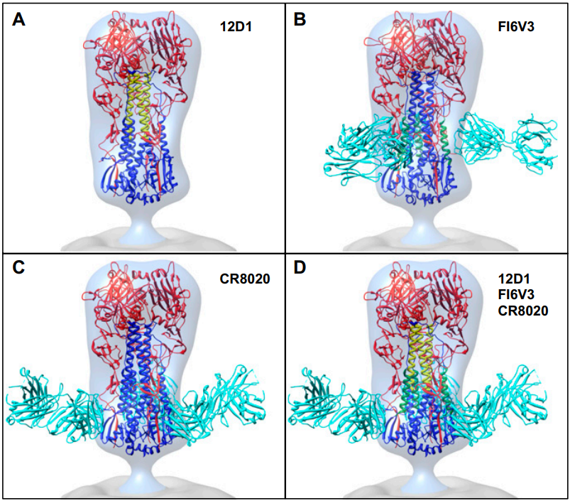

**Figure S8. Comparison of different types of stem epitopes on viral H3 HA**. (A–C) Front views of structures with the 12D1 epitope and complexes of Fab fragments with trimeric HAs placed into the experimentally obtained 3D density map for the H3 HA from H3N2 influenza virus. Structures shown include (A) the HA2 epitope for antibody 12D1, shown in yellow (1) on docked H3 (PDB ID code: 3SDY) (2); (B) H3 HA bound to FI6V3 Fab fragment (PDB ID code: 3ZTJ) (3) with helix A of HA2 within the epitope footprint, in green; and (C) H3 HA bound to CR8020 (PDB ID code: 3SDY). (D) Composite comparison showing the relative location of 12D1, FI6V3, and CR8020 epitopes on H3 HA. HA1 is in red; HA2 is in blue; selected epitope regions for 12D1 and FI6V3 are in yellow and green, respectively; and Fabs are in cyan. The 3D map of H3 is shown as a transparent surface rendering, with the viral membrane region in gray.

### The NA Epitopes

The antigenic sites of NA have not been precisely mapped because NA-targeting antibodies are not neutralizing *in vitro* and because the NA stalk cannot be crystallized, making mapping much harder.

[Colman 1983](https://doi.org/10.1038/303041a0) conducted a mutagenesis analysis and concluded that residues 153, 197-199,

328-336, 339-347, 367-370, 400-403, and 431-434 are likely to be involved in antibody interactions. These residues are shown in Figure 2 reproduced below.

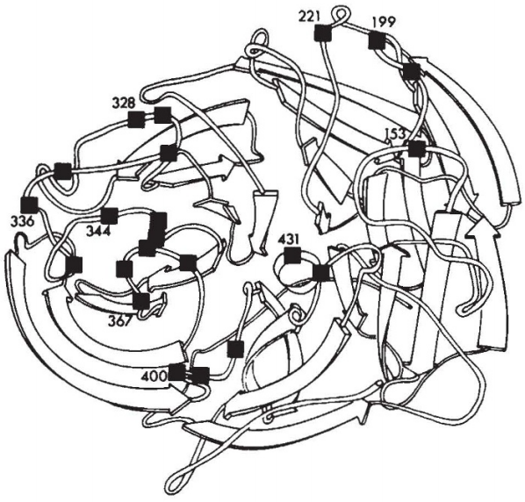

**Figure 2.** Diagram of the neuraminidase subunit structure flagging residues in the seven variable segments referred to in the text: 153, 197,199, 221, 328, 329, 331, 334, 336, 339, 344, 346, 347, 367-370, 400, 401, 403, 431, 434.

Later studies defined NA epitopes using escape mutations from monoclonal antibodies, which is summarized in [Air 2011](https://doi.org/10.1111/j.1750-2659.2011.00304.x) Figure 4 and Table 1 below.

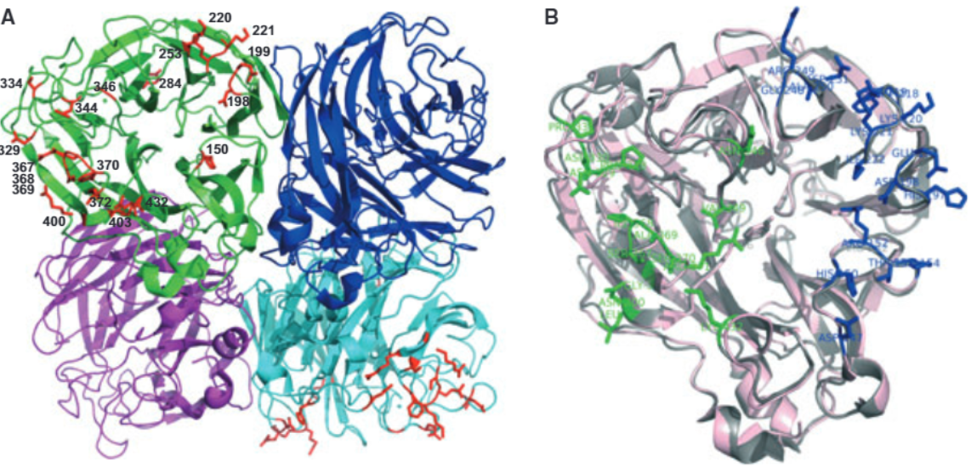

**Figure 4. Neutralizing epitopes on NA.** (A) Escape mutations in NAs surround the active site pocket. All known escape mutations (Table 1) are shown in the green and cyan subunits. The NA tetramer is tilted so that you are looking straight into the active site of the green subunit, while the cyan subunit shows that escape mutations occur on loops on the top surface. (B) A single subunit of N9 (gray) and N2 (pink) showing the amino acids that make up the epitopes of antibodies NC41 (green) and Mem5 (blue). The orientation is similar to the green subunit in A. An epitope is deﬁned as those amino acids of NA that make direct contact with the antibody heavy and light chains. Each antibody covers about one-third of the top surface of the NA subunit. Images were made using Pymol.

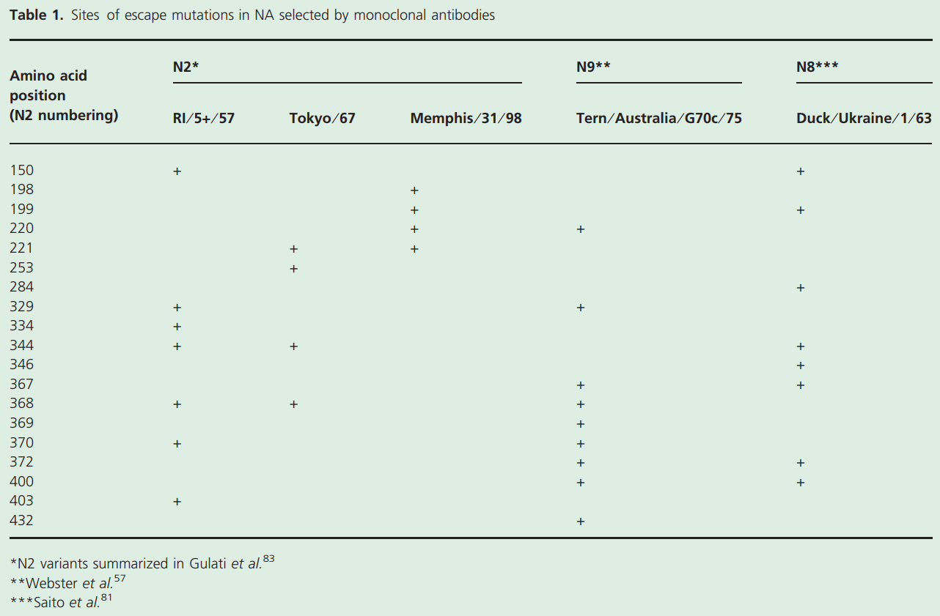

# Antibody Response

## Quantifying the IgG, IgA, and IgM Antibody Response

Much of the complexity of our immune response against influenza arises from the large number of molecular players involved. Protection is likely mediated by a combination of mucosal IgA, serum IgM and IgG, T cells, and the innate immune system. The information below quantifies some of these key players during influenza infection or vaccination.

**Sources:**

* [Horns 2019](https://doi.org/10.1073/pnas.1814213116) (PNAS): Signatures of Selection in the Human Antibody Repertoire: Selective Sweeps, Competing Subclones, and Neutral Drift
  + Figure 1A,B shows that anti-influenza B cells are elicited by Day 7 but not by Day 4 following administration of the 2011-12 trivalent vaccine
    - After vaccination, 36±12 B cell lineages expanded >50-fold between Day 0 (when they received the vaccine) and Day 7 after vaccination. In contrast, across a similar time span in the absence of vaccination (between Day 0 and Day 5), only 6±4 B cell lineages within each subject expanded to this extent
    - Together, these vaccine-responsive lineages accounted for 22±12% of each subject’s repertoire during peak response at Day 7
    - Each subject harbored a distinct set of clonal B cell lineages that exhibited high abundance throughout the study and were unresponsive to vaccination (<2-fold increase from Day 0 to Day 7 and >0.1% fractional abundance at Day 7). Together, these accounted for 22±8% of the repertoire at any time point. Thus, many human antibody repertoires possess a large complement of persistent B cell lineages, which have stable population dynamics on timescales of weeks and do not respond dynamically to influenza vaccination

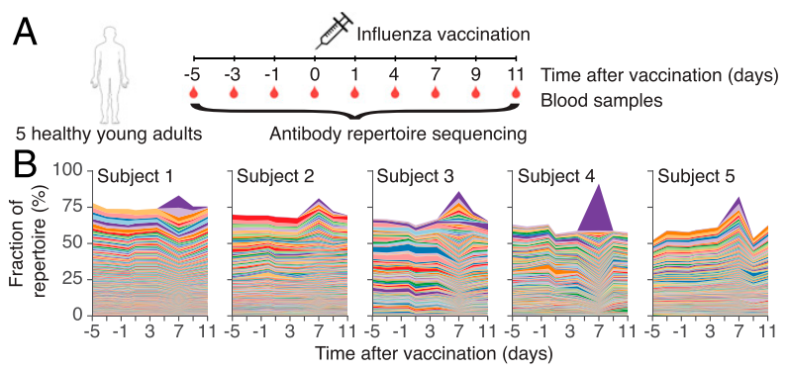

**Figure 1.** **Dynamics and molecular features of antibody repertoires.** (A) Schematic of experiment design. (B) Dynamics of antibody repertoires. Each line represents a clonal B cell lineage, and its width indicates the fractional abundance of that lineage (the number of unique sequences belonging to the lineage divided by the number of unique sequences in the entire repertoire) at a given time. Colors indicate distinct lineages (colors are reused across panels corresponding to different subjects and do not indicate shared sequences across subjects). The most abundant 500 lineages within each subject’s repertoire at D7 are shown.

* + Figure 1F,G shows the anti-influenza B cell response elicited on Day 7 following administration of the 2011-12 trivalent vaccine
    - Class switching goes from IgM or IgD (which in their notation is IgM/IgD) to IgG or IgA. Most B cells that responded to the vaccine class switched into IgG or IgA, while B cells that did not respond to the vaccine stayed as IgM or IgD (i.e. they likely stayed as they were before the vaccination)
    - To help interpret the [triangular plot](https://en.wikipedia.org/wiki/Ternary_plot), we have added a small diagram on the right that shows a repertoire containing 10% IgA (read by following the line going up and to the left), 30% IgG (read by following the horizontal line), and 60% IgM or IgD (read by following the line going down and to the left)

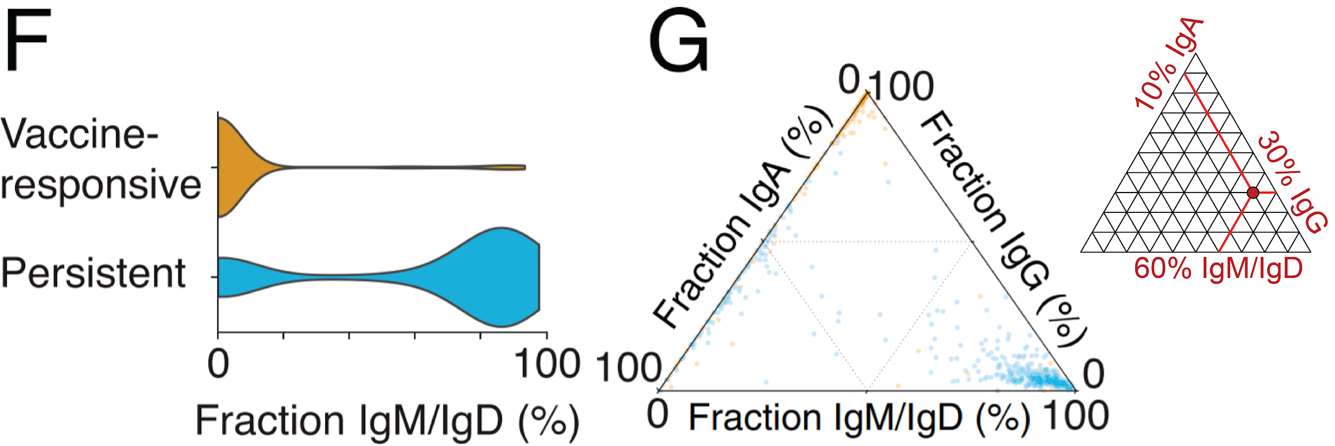

**Figure 1. Dynamics and molecular features of antibody repertoires.** (F) Distributions of the fraction of sequences within each clonal lineage that were the IgM or IgD isotypes among vaccine-responsive and persistent lineages. (G) Fractions of sequences in each clonal lineage that were IgM or IgD, IgG, or IgA. Each dot is a lineage and is positioned according to the isotype composition of that lineage and colored according to identification as vaccine-responsive (yellow) or persistent (blue).

* [Wrammert 2008](https://doi.org/10.1038/nature06890) (Nature): Rapid cloning of high-affinity human monoclonal antibodies against influenza virus
  + “After booster vaccination there was a rapid and robust influenza-specific IgG+ antibody-secreting plasma cell (ASC) response that peaked at approximately day 7 and accounted for up to 6% of peripheral blood B cells. These ASCs could be distinguished from influenza-specific IgG+ memory B cells that peaked 14–21 days after vaccination and averaged 1% of all B cells.”
* [Gould 2017](https://doi.org/10.3389/fmicb.2017.00900) (Frontiers in Microbiology): Nasal IgA Provides Protection against Human Influenza Challenge in Volunteers with Low Serum Influenza Antibody Titre
  + “Volunteers were pre-selected with low haemagglutination inhibition (HAI) titres in order to ensure a higher proportion of infection...H1N1 specific IgG level before challenge did not correlate with protection, probably due to the pre-screening for individuals with low HAI.” “There was a weak but significant correlation between time of virus shedding and serum or local IgA.”
  + Figures 2A and 3A show the change in concentration of serum IgG and IgA 1 day prior to viral infection and 29 days post-infection with H1N1. Figure 3A,D shows the analogous plots for an H3N2 infection
    - “There was a significant increase in the H1N1 specific IgG titre in the serum after infection; the median moved from 2,830 to 21,189 ng/ml (Figure 2A). The majority of volunteers increased in IgG titre after infection (26 out of 29) and there was no difference in the fold increase in antibody titre between individuals infected with different doses of influenza (Figure 2B).“
    - “H1N1 specific IgA in the serum significantly increased after infection (Figure 3A), the average fold change was 24. Interestingly, challenge dose had a significant effect on the increase in IgA titre, with the IgA increasing more in recipients of higher titre virus than those receiving a low dose (Figure 3B).”

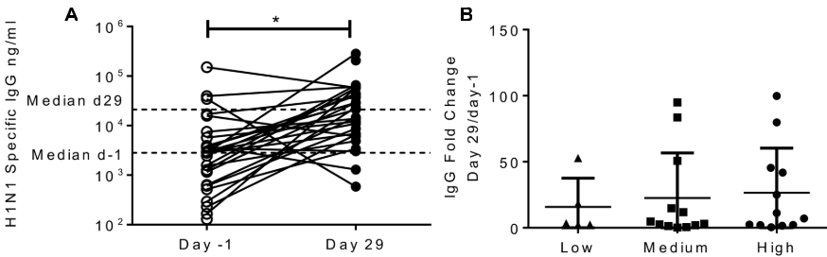

**Figure 2. Infection with influenza increases H1 serum IgG antibody responses, but IgG does not correlate with protection.** Healthy adult human volunteers were infected intranasally with different doses of H1N1 influenza (low dose: 3.5×104 TCID50, Medium dose: 3.5×105 TCID50 and high dose: 3.5×106 TCID50). (A) H1 specific IgG responses were measured by ELISA in serum on Day -1 and Day 29 of infection and presented as absolute values.

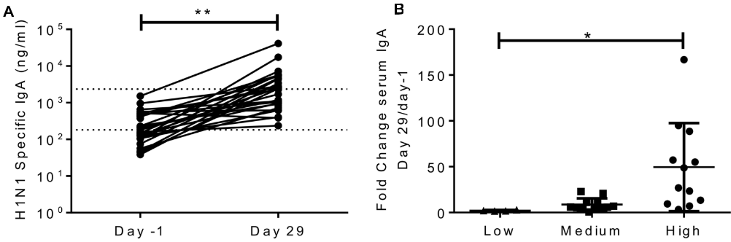

**Figure 3. Infection with influenza increases H1 serum IgA antibody responses.** Healthy adult human volunteers were infected intranasally with different doses of H1N1 influenza. (A) H1 specific IgA responses were measured by ELISA in serum on Day -1 and Day 29 of infection and presented as absolute values.

* Figure 5 shows these measurements repeated for the H3N2 strain A/Texas/50/2012

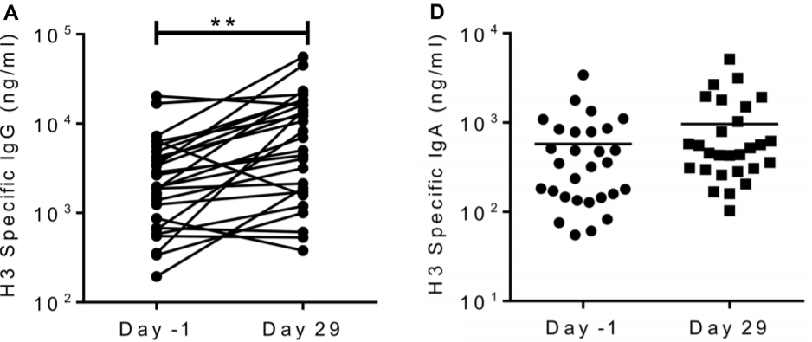

**Figure 5. H3N2 specific antibody does not correlate with protection.** H3N2 specific (A) IgG and (D) IgA measured in serum on Day -1 and Day 29.

* [Memoli 2015](https://doi.org/10.1093/cid/ciu924) (Clinical Infectious Diseases): Validation of the Wild-type Influenza A Human Challenge Model H1N1pdMIST: An A(H1N1)pdm09 Dose-Finding Investigational New Drug Study
  + Human volunteers were administered wild-type A (H1N1)pdm09 virus intranasally
  + Figure 2 shows the antibody response during infection, with appreciable antibodies by Day 6

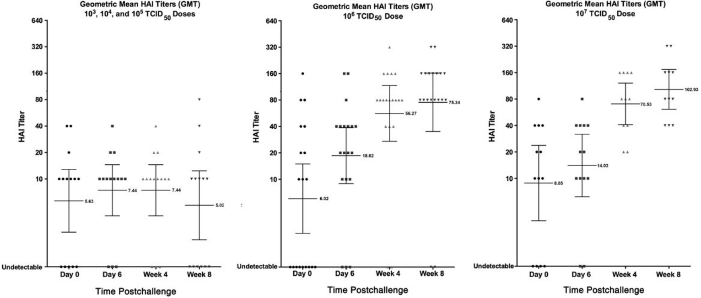

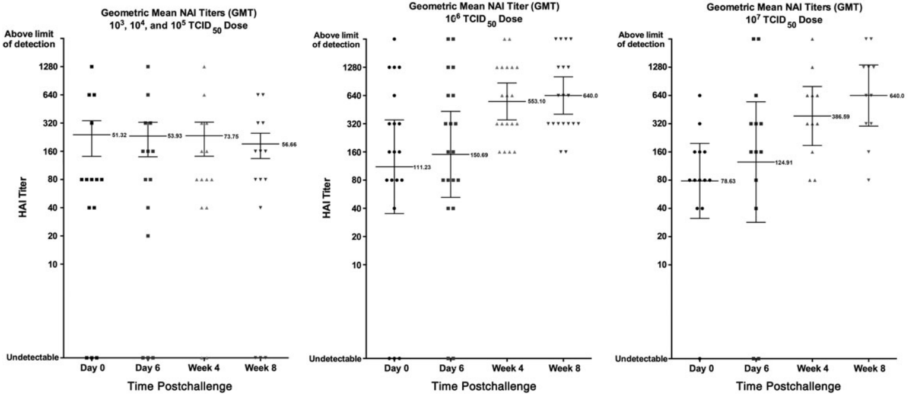

**Figure 2. Antibody response.** Geometric mean titer (GMT) of all challenge participants at different time points of both hemagglutination inhibition (HAI; top) and neuraminidase inhibition titers (NAI; bottom) pre- and postchallenge in the 3 low-dose groups (combined) and each of the 2 high-dose groups (shown separately). Error bars represent 95% confidence intervals. No significant change in GMT was noted for either HAI or NAI at the lowest 3 doses, whereas statistically significant changes were seen at the 2 higher doses. Participants were enrolled if their screening HAI titer was ≤1:40, approximately 8 weeks prior to challenge. For 4 participants in the 106 and 107 tissue culture infectious dose 50 (TCID50) groups, day 0 titers were 1:80 or 1:160, suggesting influenza exposure between screening and challenge.

* [Li 2012](https://doi.org/10.1073/pnas.1118979109) (PNAS): Pandemic H1N1 Influenza Vaccine Induces a Recall Response in Humans that Favors Broadly Cross-Reactive Memory B Cells
  + During the 2009-10 season, the H1N1 component of the vaccine was A/Brisbane/59/07, whereas the most prevalent circulating strain was the pandemic H1N1 (pH1N1) strain A/California/04/09
  + Adults given a monovalent pH1N1 subunit vaccine elicited IgG:IgA:IgM plasmablasts against both pH1N1 and the vaccine strain A/Brisbane/59/07 in ratios of 100:10:1 as shown in Figure 1D

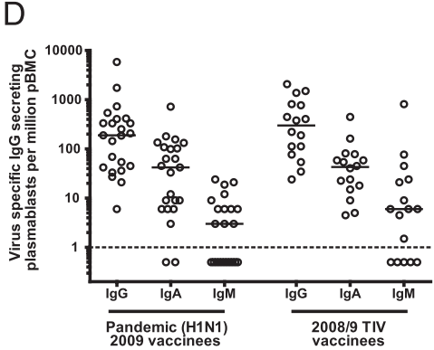

**Figure 1. Rapid and potent plasmablast and serological responses after vaccination with the subunit pH1N1 2009 vaccine.** Healthy adult volunteers were vaccinated with the subunit pH1N1 2009 monovalent vaccine. (D) The numbers of influenza-specific IgG-, IgA-, and IgM-producing plasmablasts at day 7 as determined by ELISPOT after immunization with the monovalent pH1N1 2009 vaccine compared with the response elicited by the seasonal 2008/2009 TIV. These TIV data are from a cohort vaccinated in 2008. Dotted lines indicate limit of detection.

* [Wolf 2011](https://doi.org/10.1172/JCI57362) (Journal of Clinical Investigation): Protective antiviral antibody responses in a mouse model of influenza virus infection require TACI
  + The control group in Figure 2 shows IgG levels in mice post-infection with PR8

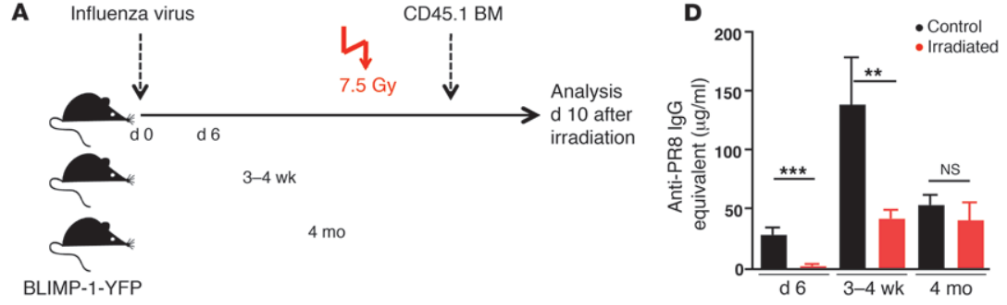

**Figure 2. ASCs in lungs of influenza virus–infected BLIMP-1–YFP mice are sensitive to irradiation.** (A) Influenza virus PR8–infected BLIMP-1–YFP mice (*n*=3-9 mice/group) were subjected to whole-body irradiation (7.5 Gy) at 6 days, 3-4 weeks, or 4 months p.i. and analyzed 10 days later together with non-irradiated controls. (D) PR8-specific IgG Ab titers in sera from control and irradiated mice were measured by ELISA. All data with mean ± SEM represent at least 2 independent experiments. *P < 0.05, **P < 0.01, ***P < 0.001.

* + The WT group in Figure 4 shows IgM and IgG levels in the serum, along with the IgM, IgG, and IgA levels in the bronchus-associated lymphoid (BAL)

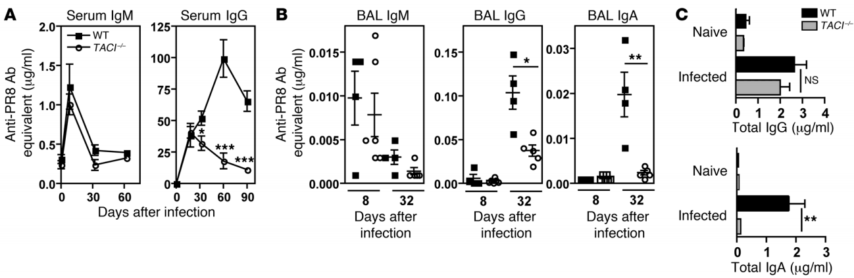

**Figure 4. Maintenance of virus-specific Abs to influenza virus requires TACI.** (A) Sera from WT and TACI–/– mice were assayed for PR8-specific IgM and IgG by ELISA. Blood samples were collected from naive mice (*n*=3 mice) and on days 8, 18, 33, and 60 p.i. (*n*=3-12 mice per time point). (B) PR8-specific IgM, IgG, and IgA Ab titers in bronchus-associated lymphoid (BAL) were measured at days 8 and 32-34 p.i. (C) Total IgG and IgA in BAL from WT and TACI–/– mice (*n*=8-11 mice/group) were determined (days 32-34 p.i.). Data with mean ± SEM are representative of at least 2 independent experiments. *P < 0.05, **P < 0.01, ***P < 0.001.

* [Miao 2010](https://doi.org/10.1128/JVI.00266-10) (Journal of Virology): Quantifying the Early Immune Response and Adaptive Immune Response Kinetics in Mice Infected with Influenza A Virus
  + Obtained a large data set for the immune response from primary H3N2 infection in 340 mice. Used statistical modeling to infer many of the kinetic parameters of viral replication
  + In mice, virus-specific antibodies begin increasing around 5 days after inoculation, which is followed by a peak in IgM level around 8-10 days and in IgG levels around 25 days and eventual decay.

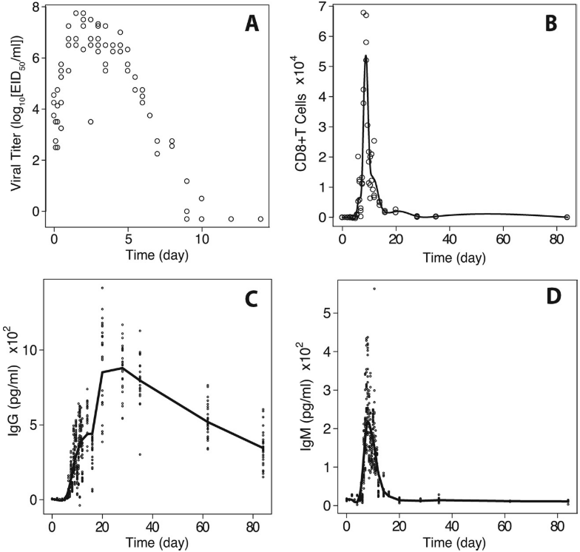

**Figure 2. Experimental data.** (A) Viral titer; (B) antigen-specific CD8+ T-cell data and the smoothed curve; (C) IgG data and the smoothed curve; (D) IgM data and the smoothed curve.

* “Prior to a detectable virus-specific immune response (before day 5), the estimated half-life of infected epithelial cells is ~1.2 days, and the half-life of free infectious IAV is ~4h. During the adaptive immune response (after day 5), the average half-life of infected epithelial cells is ~0.5 days, and the average half-life of free infectious virus is ~1.8 min. During the adaptive phase, model fitting confirms that CD8+ CTLs are crucial for limiting infected cells, while virus-specific IgM regulates free IAV levels.”
* “Our results suggest that IgM is crucial for IAV clearance in a primary infection, whereas the contribution of IgG is less important, despite the eventual presence of higher and more sustained levels of IAV-specific IgG.”
* [Perelson 1980](http://link.springer.com/10.1007/BF00276984) (Journal of Mathematical Biology): Optimal strategies in immunology
  + Figure 1 shows the dynamics of an influenza response following primary and secondary immunizations. While this is a schematic adopted from data, we nevertheless note that the primary IgM and IgG response peaks around 8.5 and 11.5 days, respectively. The secondary IgM and IgG response peaks at 6.5 and 12.5 days post-reinfection, respectively

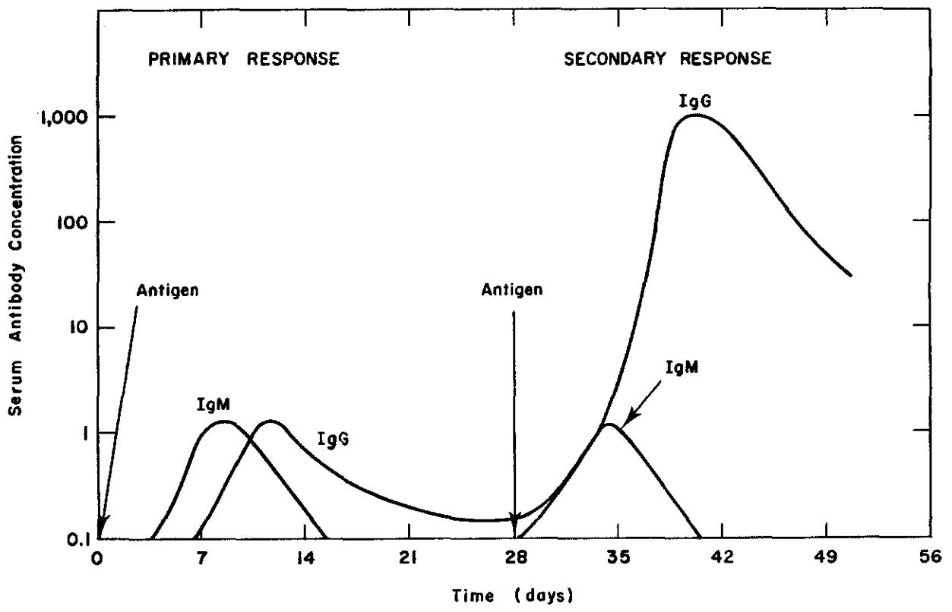

**Figure 1.** Kinetics of IgM and IgG appearance in the serum during the primary and secondary immune responses (adapted from [Hood 1978](https://books.google.com/books/about/Immunology.html?id=iSVrAAAAMAAJ)).

## Targets of Antibody-Secreting B Cells

This section explores which influenza proteins are targeted by our antibody response. A key point that emerged from [Chen 2018](https://doi.org/10.1016/j.cell.2018.03.030) is that the antibody repertoire can be markedly different for vaccination and for infection. Notably, many more antibodies seem to target NA (especially against H3N2 strains) during an infection than during vaccination.

|  |  |  |  |  |
| --- | --- | --- | --- | --- |
| **% Antibodies Targeting HA from Vaccination** | **Source** |  | **% Antibodies Targeting NA from Vaccination** | **Source** |
| 90%  (A/California/07/2009 monovalent vaccine, Young Cohort) | [Henry 2019](https://doi.org/10.1016/j.chom.2019.01.002) |  | 2% (A/California/07/2009 monovalent vaccine, Young Cohort) | [Henry 2019](https://doi.org/10.1016/j.chom.2019.01.002) |
| 50%  (A/California/07/2009 monovalent vaccine, Elderly Cohort) | [Henry 2019](https://doi.org/10.1016/j.chom.2019.01.002) |  | 10% (A/California/07/2009 monovalent vaccine, Elderly Cohort) | [Henry 2019](https://doi.org/10.1016/j.chom.2019.01.002) |
| 87%  (TIV Subunit Vaccine) | [Chen 2018](https://doi.org/10.1016/j.cell.2018.03.030) |  | 2%  (TIV Subunit Vaccine) | [Chen 2018](https://doi.org/10.1016/j.cell.2018.03.030) |
| 81%  (QIV Split Vaccine) | [Chen 2018](https://doi.org/10.1016/j.cell.2018.03.030) |  | 0%  (QIV Split Vaccine) | [Chen 2018](https://doi.org/10.1016/j.cell.2018.03.030) |
| 90%  (Monovalent Vaccine) | [Chen 2018](https://doi.org/10.1016/j.cell.2018.03.030) |  | 1%  (Monovalent Vaccine) | [Chen 2018](https://doi.org/10.1016/j.cell.2018.03.030) |
| 40% (A/New Caledonia/20/99, A/Wisconsin/67/2005, B/Malaysia/2506/2004 Trivalent Vaccine) | [Wrammert 2008](https://doi.org/10.1038/nature06890) |  | **3±4%** | **Average Value** |
| **73±22%** | **Average Value** |  |  |  |

|  |  |  |  |  |
| --- | --- | --- | --- | --- |
| **% Antibodies Targeting HA from Infection** | **Source** |  | **% Antibodies Targeting NA from Infection** | **Source** |
| 33%  (H1N1 Infection in 2009-10) | [Chen 2018](https://doi.org/10.1016/j.cell.2018.03.030) |  | 14%  (H1N1 Infection in 2009-10) | [Chen 2018](https://doi.org/10.1016/j.cell.2018.03.030) |
| 52%  (H1N1 Infection in 2015-16) | [Chen 2018](https://doi.org/10.1016/j.cell.2018.03.030) |  | 24%  (H1N1 Infection in 2015-16) | [Chen 2018](https://doi.org/10.1016/j.cell.2018.03.030) |
| 25%  (H3N2 Infection in 2014-15) | [Chen 2018](https://doi.org/10.1016/j.cell.2018.03.030) |  | 35%  (H3N2 Infection in 2014-15) | [Chen 2018](https://doi.org/10.1016/j.cell.2018.03.030) |
| **37±14%** | **Average Value** |  | **24±11%** | **Average Value** |

**Sources:**

* [Henry 2019](https://doi.org/10.1016/j.chom.2019.01.002) (Cell Host and Microbe): Influenza Virus Vaccination Elicits Poorly Adapted B Cell Responses in Elderly Individuals
  + Analyzed the response to the A/California/07/2009 monovalent vaccine in the young and elderly
  + Figure 3G shows the antigens targeted by sera taken from the young (less than 70 years old) and the elderly (70+ years old). The young cohort had 90% of their antibodies targeting HA and 2% targeting NA, whereas the elderly cohort had 50% of their antibodies targeting HA and 10% targeting NA

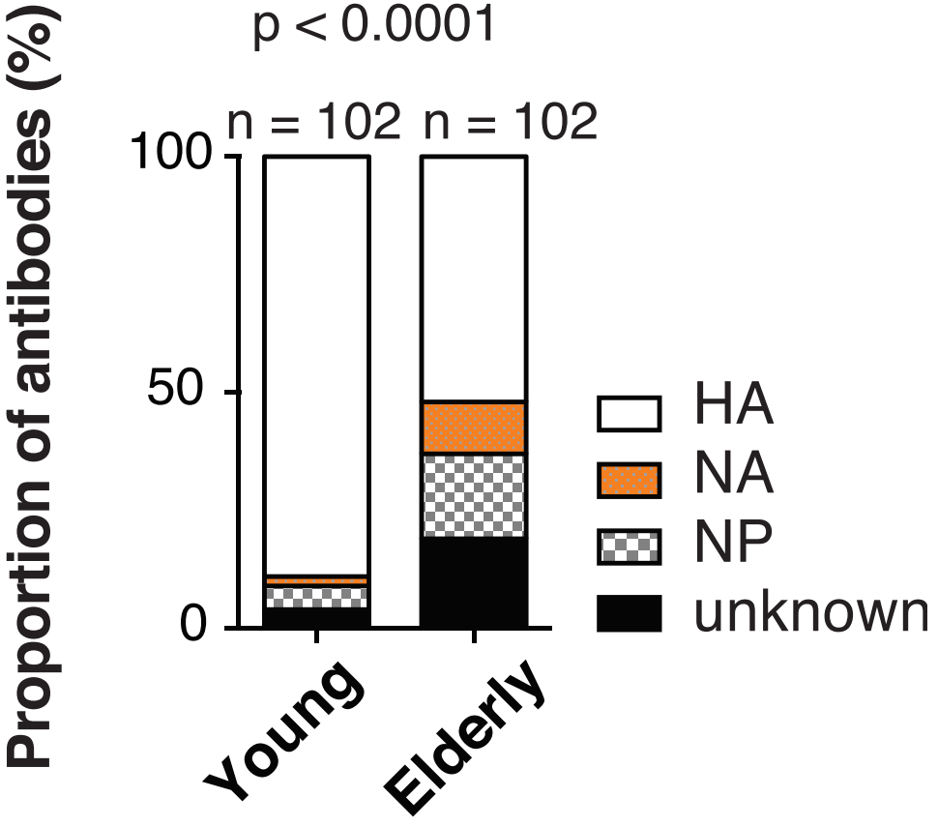

**Figure 3. Most Influenza Virus-Reactive Antibodies from Elderly Individuals Are Low Potency and Target Conserved Epitopes on HA and on Other Viral Proteins.** Proportion of HA-, NA-, and NP-reactive antibodies considering all mAbs in each group (n = 102 for each group).

* [Chen 2018](https://doi.org/10.1016/j.cell.2018.03.030) (Cell): Influenza Infection in Humans Induces Broadly Cross-Reactive and Protective Neuraminidase-Reactive Antibodies
  + Compared the antibody response from influenza infection and from influenza vaccination
  + Figure 1D,E shows the response in humans. The NA response is much larger in the case of influenza infection and becomes slightly larger than the HA response for H3N2
    - In Panel D, the 2009-10 and 2015-16 H1N1 strains were likely A/California/07/2009 (the predominant H1N1 strain in both seasons). Note that in 2014-15, the circulating H3N2 strain had drifted from the vaccine component
    - In Panel E, the subunit vaccine was administered in 2006-07, 2007-08, and 2010-11; the split vaccine was given in 2008-09 and 2009-10, and the monovalent vaccine included the A/California/07/2009 pandemic strain was administered in 2009-10
    - Note that this work did not measure the antibody response directly, but instead characterized the fractions of antibody-secreting B cells (plasmablasts). The exact relationship between the number of plasmablasts and the concentration of antibodies is not currently known

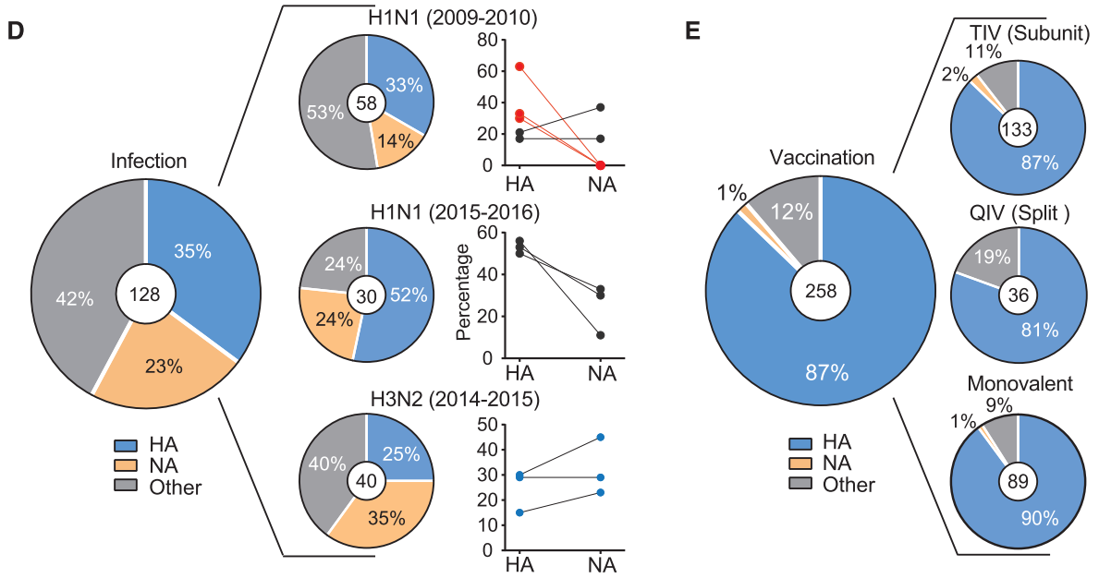

**Figure 1. Influenza Virus Infection Induces a Greater Prevalence of NA-Reactive Antibodies Than Vaccination.** PAPie charts show the percentages of mAbs that bind a given antigen (HA, NA, or other) of the total, indicated in the center circle. Graphed on the right are the percentages of HA- and NA-reactive antibodies per individual. Each dot represents one individual (n = 11). Red indicates patients with no NA B cells detected on first exposure to the pandemic H1N1 strain in 2009 (E). The frequency of NA-reactive mAbs induced by vaccination (the vaccinated cohorts are detailed in the STAR Methods) is shown. As in (D), pie charts show the percentages of mAbs that bind a given antigen (HA, NA, or other) in individuals vaccinated with influenza virus subunit vaccine (seasons 2006–2008 and 2010–2011), influenza virus split vaccine (2008–2010), or monovalent pandemic H1N1 vaccine (2009–2010). In Panel (D), the blue dots indicate patients infected with an H3N2 virus.

* [Wrammert 2008](https://doi.org/10.1038/nature06890) (Nature): Rapid cloning of high-affinity human monoclonal antibodies against influenza virus
  + Analyzed the antibody response to the 2006-07 trivalent influenza vaccine containing A/New Caledonia/20/99, A/Wisconsin/67/2005, B/Malaysia/2506/2004
  + Figure 3C shown below breaks down the human influenza-specific antibody-secreting plasma cell (ASCs) 7 days post-vaccination. Overall, 40% of the antibodies targeted HA. It is unclear exactly how many bound NA (although it is bounded above by 12%), so we exclude it from our summary measurements above

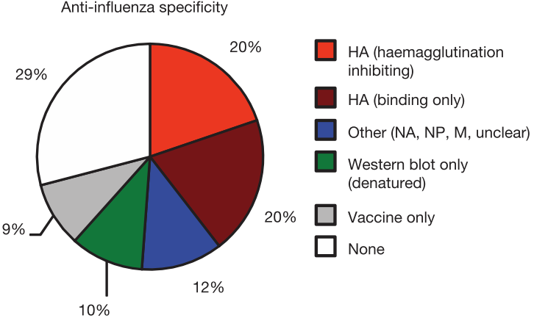

**Figure 3. High-affinity mAbs generated from single influenza-specific ASCs.** Analysis by immunoprecipitation and western blot (Supplementary Fig. 3) on Recombinant mAbs from day-7 IgG anti-influenza ASCs. Haemagglutination assays identified those antibodies that were inhibiting (Table 1 and Methods). HA, Haemagglutinin; NA, neuraminidase; NP, nuclear protein; M, matrix protein.

[Tamminen 1987](https://doi.org/10.1002/eji.1830170716) (European Journal of Immunology): Searching for MHC-restricted anti-viral antibodies: antibodies recognizing the nucleoprotein of influenza virus dominate the serological response of C57BL/6 mice to syngeneic influenza-infected cells

* Analyzed the mouse response to the viral strain X31 (a recombinant strain expressing A/PR/8/34 (H1N1) internal proteins and A/Aichi/2/68 (H3N2) glycoproteins). Note that we exclude these results from our summary table which only considers the human response
* Found that in mice, a large portion of antibodies generated by immunizing with infected cells targeted NP. "Spleen cells from mice challenged 2-4 times with viable, influenza A-type virus-infected syngeneic cells were used to produce antibody-secreting hybridoma clones." "Of the 10 hybridoma antibodies which were identified as being reactive with X-31-infected EL4...7 of the 10 monoclonal antibodies were found to react specifically with the purified influenza virus nucleoprotein (NP)"

## The Binding EC50 and Neutralization IC50 of Potent Antibodies

Antibody statistics were pooled from a variety of sources ([Henry 2019](https://doi.org/10.1016/j.chom.2019.01.002), [Lee 2019](https://doi.org/10.1016/j.chom.2019.01.010), [Thornburg 2016](https://doi.org/10.1172/JCI85317), [Lee 2016](https://doi.org/10.1038/nm.4224), [Wu 2015](https://doi.org/10.1038/ncomms8708), [Whittle 2014](https://doi.org/10.1128/JVI.03422-13), [Tan 2014](https://doi.org/10.1128/JVI.02289-14), [Lee 2012](https://doi.org/10.1073/pnas.1212371109), [Krause 2011](https://doi.org/10.1128/JVI.00700-11), [Wrammert 2011](https://doi.org/10.1084/jem.20101352), [Wrammert 2008](https://doi.org/10.1038/nature06890), [Kostolansky 2000](https://doi.org/10.1099/0022-1317-81-7-1727)), and the concentration at which 50% of them are bound (EC50) or at which virus is neutralized to 50% infectivity (IC50) are shown.

* Antibodies rarely reach EC50 values below 10-10 M because selection is likely unable to differentiate between values below this “affinity ceiling” [[Foote 1995](https://doi.org/10.1073/pnas.92.5.1254)]. Note that having an EC50 value ≥10-10 M necessarily implies an IC50 value ≥10-10 M, since an antibody cannot neutralize without first binding
* That said, a few antibodies antibodies exhibited both binding and neutralization at ~10-11 M, and hence this is the lower bound that we present on the front of the SnapShot

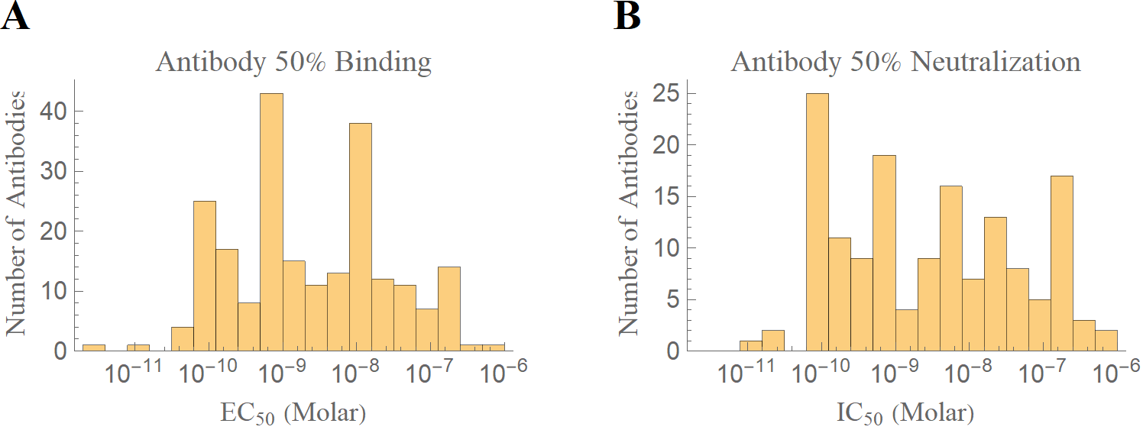

**Pooled statistics on antibody binding (*n*=218) and neutralization (*n*=146).** (A) EC50 represents the concentration at which 50% of antibodies are bound to the virus. (B) IC50 denotes the concentration of antibodies at which 50% of the virus is neutralized.

### 

### Binding (ELISA)

The enzyme-linked immunosorbent assay (ELISA) immobilizes an antigen on a surface and quantifies how many antibodies are in complex with this antigen. Repeating this assay with multiple antibody concentrations provides a dose-response curve from which the EC50 (effector concentration that gives 50% of the maximal response) and the maximum binding signal can be inferred.

Notes:

* The EC50 is an important parameter that characterizes the effective dissociation constant KD between the antibody and antigen. Ideally, KD is reported in absolute units (e.g. μg/mL or Molar) rather than relative units (e.g. titer dilution or area under the curve) which depend on the experimental setup. Moreover, including the annotated raw data helps other groups build off this work
* The maximum binding signal may be of interest when comparing how multiple antibodies bind to a viral strain (e.g. some antibodies may bind three per trimer whereas fewer antibodies of another type may fit on a single trimer due to steric hindrance or allostery [[Lee 2016](https://doi.org/10.1126/science.aad2450)]). However, the magnitude of the maximum signal depends on the experimental setup (i.e. on the amount of immobilized antigen)
* The area under the curve (AUC) metric, where the ELISA response is integrated over a range of antibody concentrations, is sometimes used as a way of reporting both the midpoint and the height of a response as a single number, attempting to convey both properties simultaneously. Unfortunately, this metric convolute the two characteristics together in a way that neither the KD nor the height of the response can be extracted
  + If the AUC is reported, then in addition: (1) the range of antibody concentrations integrated over (and whether this integration was done on a log or linear scale) must be reported; (2) the KD for each antibody/antigen pair should be specified separately; and (3) the full ELISA binding data should be included
* Two different schemes to measure the dissociation constant are through ELISA or through surface plasmon resonance (SPR). Below, we show measurements from several papers where antibody binding to influenza was measured with both methods to quantify how much they agree with one another. The sources used were:
  + [Lee 2016](https://doi.org/10.1038/nm.4224): ELISA measurements (Figure 3A) and SPR measurements (Figure S5) were available for four antibodies from Donor 1 (H3-11, H1-1/H3-1, H1-3/H3-3, and H1-17/H3-14) and one antibody from Donor 2 (H1-27/H3-42) against the H1 A/California/07/2009 X-181 and H3 A/Perth/16/2009 rHA
  + [Pappas 2014](https://doi.org/10.1038/nature13764): ELISA measurements (Figure S4) and SPR measurements (Table S6) were considered for antibodies FI353, FC41, FE43, FE53, FE54, FI499, FI404, FE25, FB79, CR6261, F10, CR9114, and FB139, while the UCA’s were ignored. The ELISA curves were coarsely digitized and their midpoint was taken to be the KD of each antibody
  + [Schofield 1996](https://doi.org/10.1016/0166-0934(96)02086-1): ELISA and SPR measurements (Table 2) were available for the antibodies HC2, HC3W, HC10, and HC61. The error on the SPR KD values was computed by dividing kd/ka (both of which included error) using the IgG values in Table 1

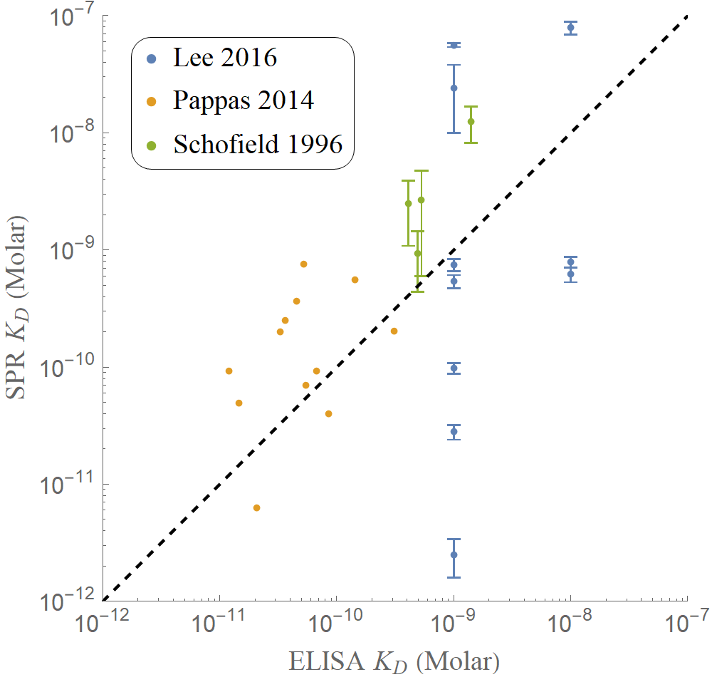

## Evolutionary Rates

Influenza rapidly evolves, so that over the course of several years our antibody repertoire no longer adequately protects us against the current circulating strains. One way to quantify the changes in influenza is to analyze the evolutionary rates, the number of nucleotide substitutions that emerge in circulating strains over time.

To determine these numbers, we utilize [Next Strain](https://nextstrain.org/), an online project that continuously incorporates and curates the publicly available data on influenza and other viruses.

To get up-to-date values of these nucleotide substitution rates, open the [Next Strain influenza database](https://nextstrain.org/flu/seasonal), and in the panel on the left select the following options:

* In the **Dataset** options:
  + Choose the viral subtype (*h3n2*, *h1n1pdm*, *vic*, or *yam*)
  + Choose the viral protein (*ha* or *na*)
  + Change the date range from *2y* to *12y*
  + Note that changing the viral subtype resets the viral protein and date range. Similarly, changing the viral protein resets the date range
* Within **Tree Options**:
  + Select *Clock*
* The evolutionary rate estimate will be shown at the top of the plot in terms of nucleotide substitutions per site per year

On the SnapShot, we present the number of amino acid substitutions per year for HA and NA, since antibodies exert selection on amino acids and not the nucleotide sequences. As of 2020, an amino acid clock feature is not yet available, and hence we asked Trevor Bedford’s lab (who maintains Next Strain) to convert their nucleotide sequence into amino acids, compute the cumulative number of amino acid mutations over time for all strains over the past 12 years, and then fit a linear regression line through the data. As of March 2020, the results were:

* Hemagglutinin (HA)
  + H1N1pdm HA: 1.8 aa subs/year
  + H3N2 HA: 3.1 aa subs/year
  + B Vic HA: 0.7 aa subs/year
  + B Yam HA: 0.7 aa subs/year
* Neuraminidase (NA)
  + H1N1pdm NA: 2.4 aa subs/year
  + H3N2 NA: 1.8 aa subs/year
  + B Vic NA: 0.8 aa subs/year
  + B Yam NA: 1.5 aa subs/year

Note that these numbers fluctuate over time as more sequences are added to Next Strain. In particular, all of these evolutionary rates remained stable in April 2020 except for the H1N1pdm NA rate, which decreased by 10% (hence its range on the front of the SnapShot is larger).

### Evolutionary Rates of HA

The plots below represent the number of substitutions per nucleotide per year.

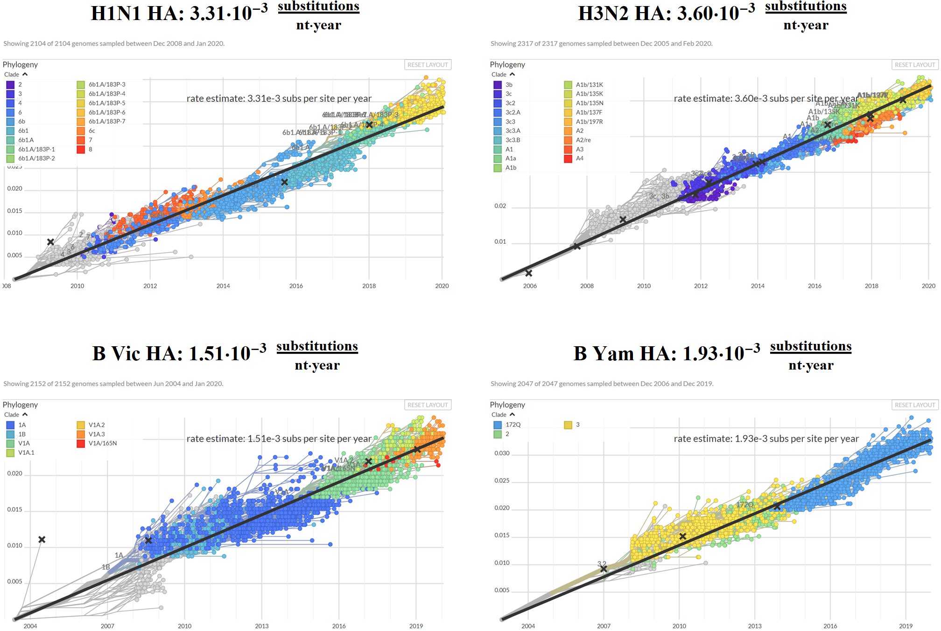

### 

### Evolutionary Rates of NA

The plots below represent the number of substitutions per nucleotide per year.

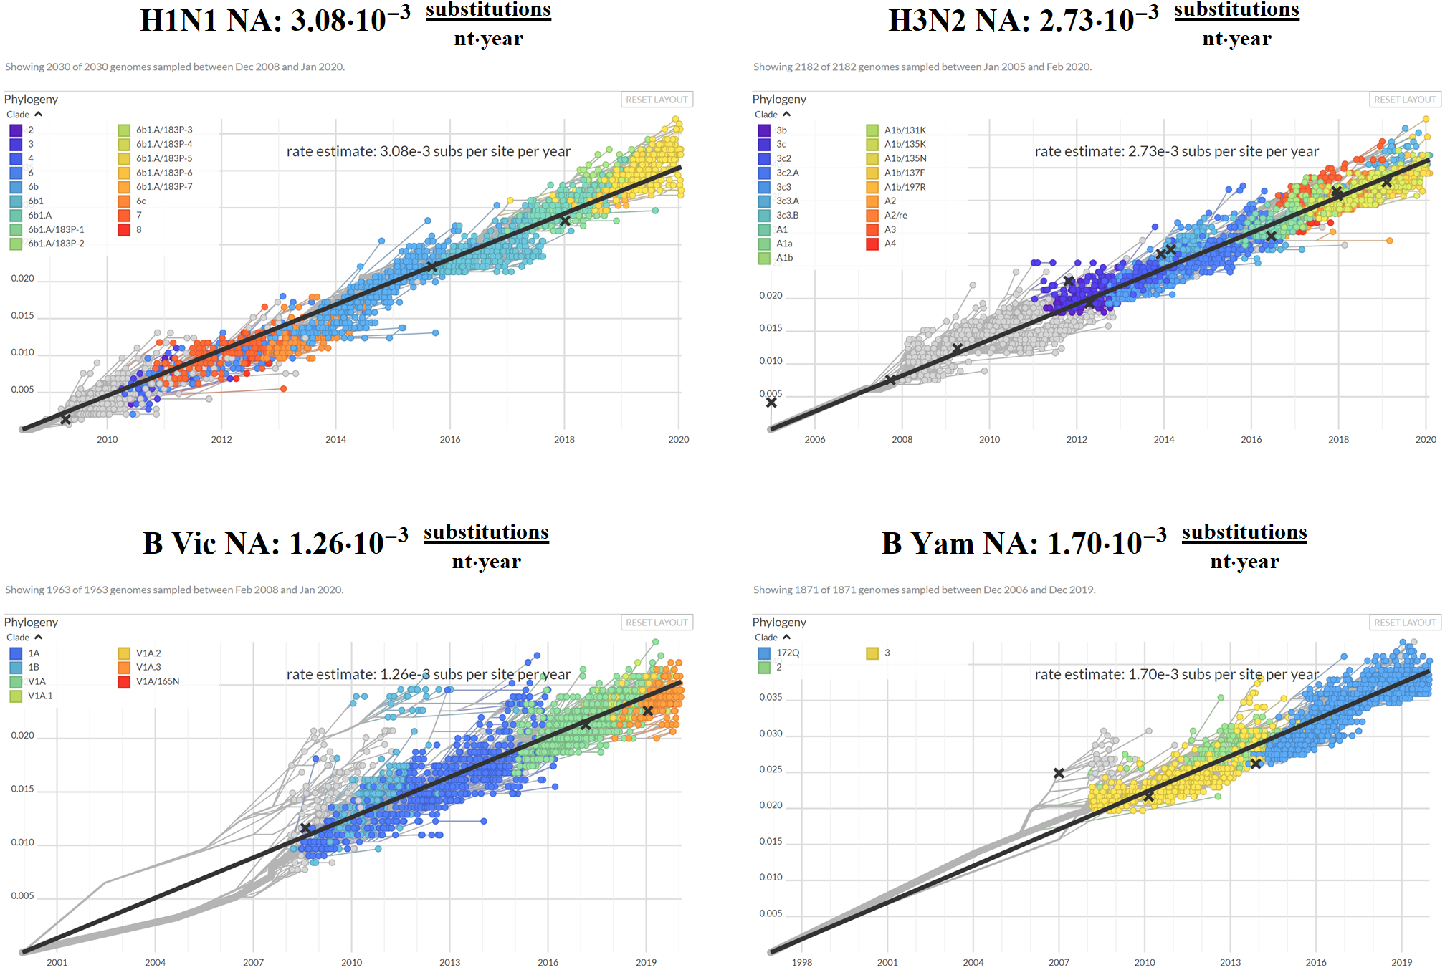

## Genome Mutation Rate per Replication Cycle

The influenza viral RNA is negative-sense, meaning that it must first be copied into positive-sense RNA. The positive-sense RNA can be transported out of the cytoplasm and used to synthesize viral proteins, or it may remain in the nucleus and serve as a template to make more negative-sense RNA. These cycles may happen multiple times within an infected cell, and the genome mutation rate per replication cycle measures the total number of mutations in the RNA of the viral progeny that result from this process.

**Sources:**

* [Pauly 2017](https://doi.org/10.7554/eLife.26437) (eLife): A novel twelve class fluctuation test reveals higher than expected mutation rates for influenza A viruses
  + “We measured an overall mutation rate of 1.8·10-4 substitutions per nucleotide per strand copied for PR8 (H1N1) and 2.5·10-4 substitutions per nucleotide per strand copied for Hong Kong 2014 (H3N2)... Our data suggest that each replicated genome will have an average of 2–3 mutations”
  + We note that these mutation rates are nearly an order of magnitude larger than the values reported by other groups. Hence, we have left this reference out when reporting the range of mutation rates for genome replication
* [Brooke 2014](https://doi.org/10.2217/fvl.13.118) (Future Virology): Biological activities of 'noninfectious' influenza A virus particles
  + “The error-prone IAV RNA polymerase is estimated to have a mutation rate of approximately 10-5 per replication cycle [[Suarez 1992](https://jvi.asm.org/content/66/4/2491.long), [Parvin 1986](https://jvi.asm.org/content/59/2/377.long), [Valcarcel 1989](https://jvi.asm.org/content/63/9/4107.long)].”
* [Sanjuan 2010](https://doi.org/10.1128/JVI.00694-10) (Journal of Virology): Viral Mutation Rates
  + “Here, we critically review original studies and establish criteria to facilitate comparative analyses. The mutation rates of 23 viruses are presented as substitutions per nucleotide per cell infection (s/n/c) and corrected for selection bias where necessary, using a new statistical method.”
  + “A single viral plaque was isolated and replated to isolate new plaques (70).” The mutation rate was determined to be *μ*s/n/c=4.5·10−5. The estimated selection correction factor using the exponential plus lethal class model yields 7.1·10−6
  + “Single plaques were isolated after 3 days of growth in cell cultures and used to infect the allantoic cavities of chicken eggs (84).” The mutation rate was determined to be *μ*s/n/c=1.9·10−5 for H1N1 and *μ*s/n/c=7.9·10−5 for H2N2
* [Nobusawa 2006](https://doi.org/10.1128/JVI.80.7.3675-3678.2006) (Journal of Virology): Comparison of the Mutation Rates of Human Influenza A and B Viruses
  + Analyzed the H1N1 strain A/Aichi/1/87 (A/1/87), the H3N2 strain A/Aichi/12/92 (A/12/92), and the two influenza B strains B/Aichi/29/99 (B/29/99) and B/Aichi/44/01 (B/44/01)
  + Mutation rates (base pairs per replication cycle) are shown in Table 1 for each viral strain. “We have evaluated the mutation rate of the nonstructural gene as revealed by the genetic diversity observed during the growth of individual plaques in MDCK cells. Six plaques were studied, representing two strains each of type A and B viruses. A total of 813,663 nucleotides were sequenced, giving rates of 2·10-6 and 0.6·10-6 mutations per site per infectious cycle”
    - H1N1 A/Aichi/1/87: 2.6·10-6
    - H3N2 A/Aichi/12/92: 1.2·10-6
    - B/Aichi/29/99: 1.0·10-6
    - B/Aichi/44/01: 0.45·10-6

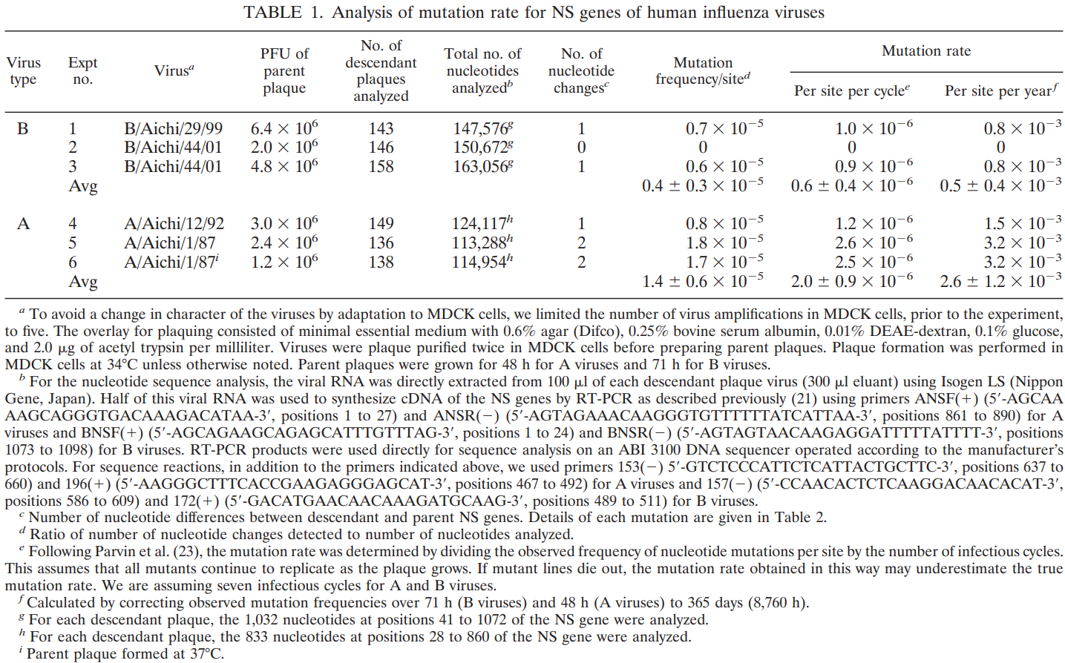

* [Suarez-Lopez 1994](https://doi.org/10.1099/0022-1317-75-2-389) (Journal of General Virology): An estimation of the nucleotide substitution rate at defined positions in the influenza virus haemagglutinin gene
  + Analyzed the H3N2 influenza strain A/Victoria/3/75
  + “Maximal mutation rates could be estimated at approximately 3·10-5 and 2.7·10-6 mutations per nucleotide and replication round for epitopes 2G10 and p7, respectively, for the VIC strain”
* [Drake 1993](https://doi.org/10.1073/pnas.90.9.4171) (PNAS): Rates of spontaneous mutation among RNA viruses
  + Analyzed the H1N1 influenza strain A/WSN/33, using data from [Parvin 1986](https://www.ncbi.nlm.nih.gov/pmc/articles/PMC253087/)
  + RNA viruses display rates of spontaneous mutation of ≈1 bp mutation per genome per replication cycle. Notably, “The maximum tolerable deleterious mutation rate cannot be substantially greater than 1 per genome per replication (4) with or without mitigating factors such as high fecundity, large populations, and recombination."
  + Table 1 shows the rate of bp mutated per replication cycle at any given base (μb) or across the whole genome (μg)

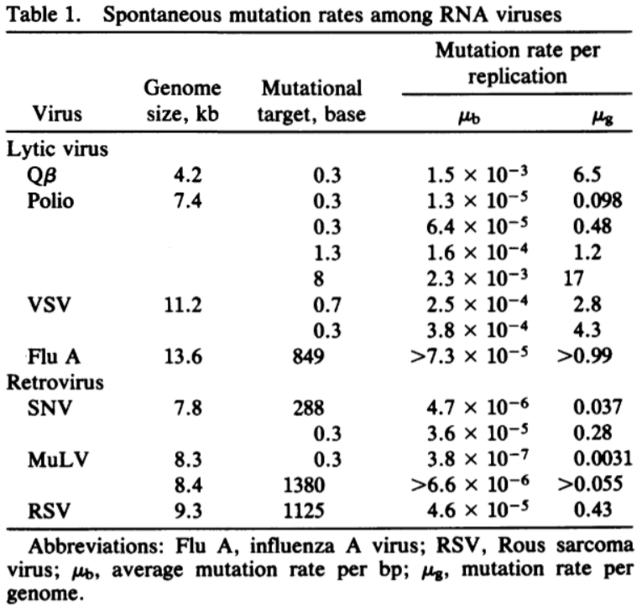

* [Parvin 1986](https://www.ncbi.nlm.nih.gov/pmc/articles/PMC253087/) (Journal of Virology): Measurement of the mutation rates of animal viruses: influenza A virus and poliovirus type 1
  + Analyzed the H1N1 influenza strain A/WSN/33
  + “We then calculated mutation rates of 1.5·10-5 mutations per nucleotide per infectious cycle for influenza virus“

## Virus Escape Frequencies

When a virus is grown in the presence of a monoclonal antibody, the frequency of escape mutations has been found to be approximately 10-5, regardless of whether the antibodies target HA or NA. These results corroborate the genome mutation rate per replication cycle in the section above.

**Sources:**

* [Perelson 2012](https://doi.org/10.1093/infdis/jis265) (The Journal of Infectious Diseases): Combination antiviral therapy for influenza: predictions from modeling of human infections
  + During a typical infection within 1 human host, “all possible single mutants, about 35% of all possible double mutants, and about 2×10−5% of all possible triple mutants are generated.” Thus, they suggest that triple-combination therapies would be most effective at controlling influenza infections
* [Colman 1983](https://doi.org/10.1038/303041a0) (Nature): Structure of the catalytic and antigenic sites in influenza virus neuraminidase
  + "Sequence changes in the neuraminidase of 'monoclonal variants': Antigenic variants of neuraminidase have been selected with a frequency of ~10-5 after a single passage of A/Tokyo/3/67 influenza virus in the presence of monoclonal antibody to the neuraminidase"
* [Yewdell 1979](https://doi.org/10.1038/279246a0) (Nature): Antigenic Variation in Three Distinct Determinants of an Influenza Type A Haemagglutinin Molecule
  + Table 3 shows the virus escape frequency when grown in the presence of monoclonal antibodies (10-5.06 and 10-5.11 for two antibodies) and the escape frequency for virus grown with both antibodies (<10-9.3). It would be interesting to see if measuring down to 10-10.2 would result in the expected escape double mutant

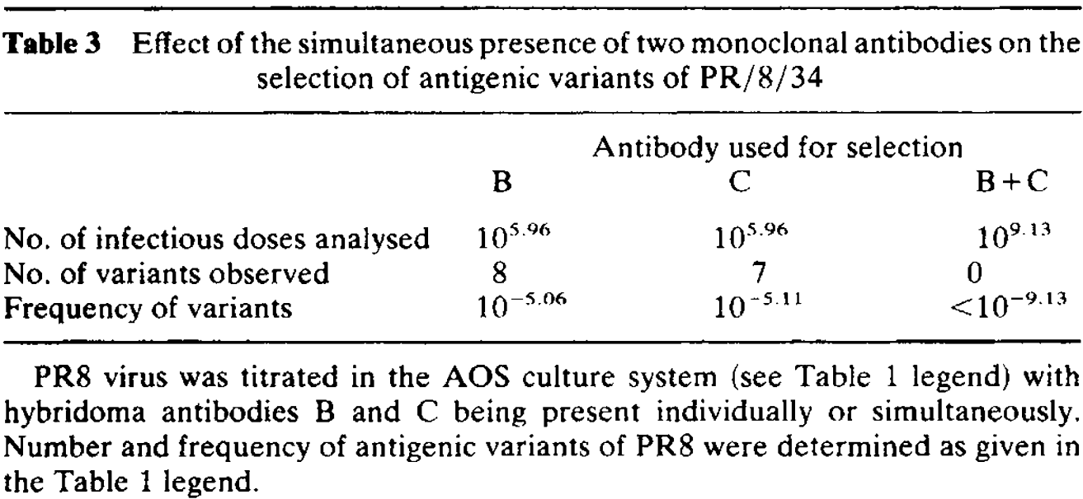

# Infection Dynamics

## Typical Infection Time Course

The duration and severity of an influenza infection depends upon multiple factors (e.g. age, infection and vaccination history, immunodeficiency status, etc.), and it is impossible to definitively state how any single infection will proceed. Yet several human challenge studies, mostly targeted at healthy young adults, allow us to gain a foothold and quantify the time course of an “average” infection.

A typical influenza infection lasts for less than 10 days due to the immune system (e.g. T cells and antibodies). Noteable, immunocompromised patients can experience chronic influenza that can last months [[Xue 2018](https://doi.org/10.1016/j.tim.2018.02.007)], but the numbers presented below represent an acute infection.

We define *peak viral shedding* as the duration during which participants exhibited ≥10% of the maximum shedding and we define *peak symptoms* as the range of time during which the symptom score is ≥80% the maximum value. Altering these (admittedly arbitrary) thresholds will alter their inferred ranges.

|  |  |  |  |  |
| --- | --- | --- | --- | --- |
| **Peak Viral Shedding**  **(Viral Strain)** | **Source** |  | **Peak Symptoms**  **(Viral Strain)** | **Source** |
| Days 2-7 (A(H1N1)pdm09) | [Memoli 2015](https://doi.org/10.1093/cid/ciu924) |  | Days 4-6 (A(H1N1)pdm09) | [Memoli 2015](https://doi.org/10.1093/cid/ciu924) |
| Days 1-4 (H1N1) | [Carrat 2008](https://doi.org/10.1093/aje/kwm375) |  | Days 2-4 (H1N1) | [Carrat 2008](https://doi.org/10.1093/aje/kwm375) |
| Days 1-6  (H3N2) | [Carrat 2008](https://doi.org/10.1093/aje/kwm375) |  | Days 2-5  (H3N2) | [Carrat 2008](https://doi.org/10.1093/aje/kwm375) |
| Days 1-5  (Influenza B) | [Carrat 2008](https://doi.org/10.1093/aje/kwm375) |  | Days 2-4  (Influenza B) | [Carrat 2008](https://doi.org/10.1093/aje/kwm375) |
| Day 3-4 (H3N2) | [Richman 1975](https://www.ncbi.nlm.nih.gov/pmc/articles/PMC274274/) |  | **Days 3-5** | **Average Value** |
| **Days 2-5** | **Average Value** |  |  |  |

Note: The intervals of peak viral shedding and peak symptoms were determined by averaging all lower bounds and averaging all upper bounds separately.

**Sources:**

* [Gould 2017](https://doi.org/10.3389/fmicb.2017.00900) (Frontiers in Microbiology): Nasal IgA Provides Protection against Human Influenza Challenge in Volunteers with Low Serum Influenza Antibody Titre
  + Human volunteers were challenged intranasally with 3.5·106 TCID50 of H1N1 A/California/2009
  + While they did not show individual responses, they noted that “the number of days infected patients had culture positive samples recovered from the nose was normally distributed with the median being 4 days”
* [Memoli 2015](https://doi.org/10.1093/cid/ciu924) (Clinical Infectious Diseases): Validation of the Wild-type Influenza A Human Challenge Model H1N1pdMIST: An A(H1N1)pdm09 Dose-Finding Investigational New Drug Study
  + Human volunteers were administered wild-type A (H1N1)pdm09 virus intranasally. Escalating doses were given until 69% of volunteers showed both symptoms and viral shedding. Table 1 shows the dose escalation scheme

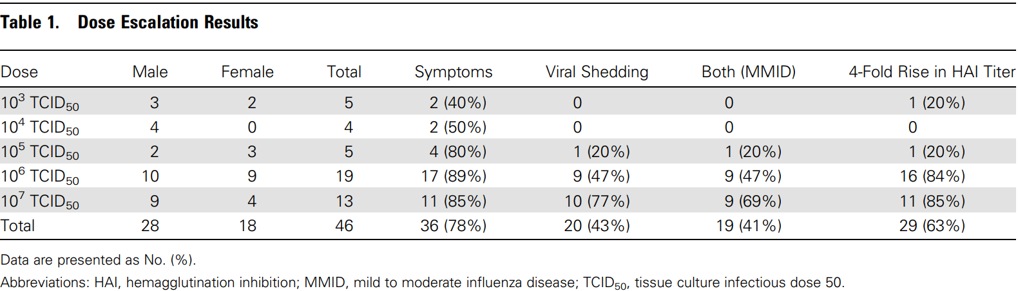

* “Viral shedding was detected typically within 24–48 hours postchallenge, and often 12–24 hours prior to the onset of symptoms. The length of viral shedding was found to be 4–5 days, with some participants shedding virus up to 9 days (Figure 1A and 1D). Quantitation demonstrated that peak shedding occurred for most participants between day 3 and day 6“
  + We roughly categorize “peak shedding” as the time period for which shedding ≥10% of the maximum shedding (which is ~104 when accounting for the large interquartile error intervals). For these data, **peak shedding occurs on Days 2-7,** noting that the large error intervals at the endpoints add to the uncertainty
  + Moreover, as stated in [Carrat 2008](https://doi.org/10.1093/aje/kwm375), the duration of viral shedding may be proportional to the dose of antigen administered, and it is unclear how the doses administered compare to the levels of antigen that would be encountered physiologically
* “Symptoms generally began within 24–72 hours of challenge (Figure 1A and 1E), and lasted about 8 days at the dose of 107 TCID50.”
  + We define “peak symptoms” as the time period for which the symptom score is ≥80% the maximum value (which is 3.5). This translates to **peak symptoms on Days 4-6**

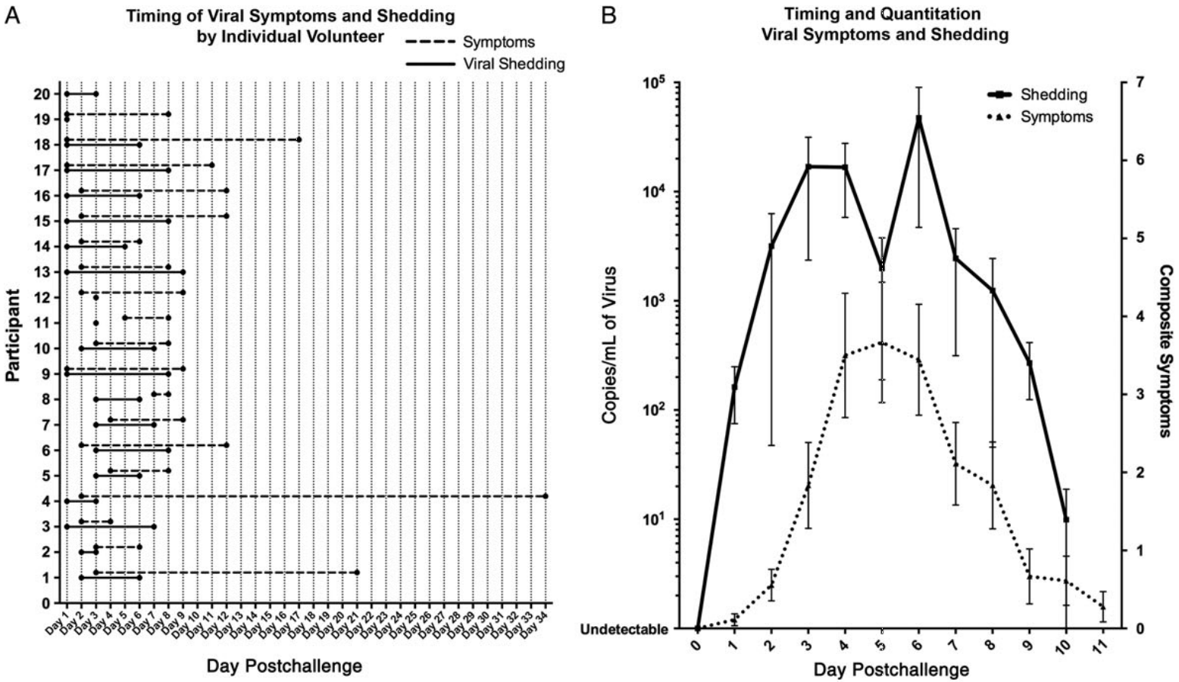

**Figure 1. Viral shedding and clinical illness.** (A) Timing of symptoms and viral shedding for each individual participant who tested positive for influenza A by multiplex respiratory testing during their inpatient stay. Shedding typically began within 24–48 hours of challenge (solid line), and symptoms typically began 24–48 hours after shedding but lasted longer (dashed line). One participant (number 20) shed virus for 3 days without manifestation of symptoms. (B) Aggregate quantitation of viral shedding (solid line) and correlation to number of symptoms each day (dashed line) during the inpatient stay (± standard error of the mean [SEM]).

* [Esposito 2011](https://doi.org/10.1186/1743-422X-8-349) (Virology Journal): Viral shedding in children infected by pandemic A/H1N1/2009 influenza virus
  + "Table 1 shows the mean viral loads (log10 copies/mL) and the number of children shedding virus at different times after the onset of pandemic A/H1N1/2009 influenza."
  + “Unlike what was expected on the basis of data collected in subjects with seasonal influenza, the duration of pandemic A/H1N1/2009 influenza virus shedding was not related to age“

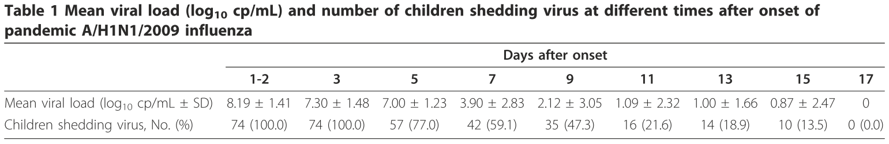

* [Kay 2011](https://doi.org/10.3201/eid1704.100866) (Emerging Infectious Diseases): Shedding of Pandemic (H1N1) 2009 Virus among Health Care Personnel, Seattle, Washington, USA
  + In this study, they analyzed health care personnel who were infected with influenza during the 2009 outbreak. They measured the duration over which any viral load was detected, but they did not quantify the amount of virus and hence are excluded from the summary statistics above. Nevertheless, they provide data on how long virus can be detected in infected patients
    - “From the onset of symptoms, the duration of viral shedding determined by real-time RT-PCR results ranged from 3 to 13 days compared with 3–10 days by rapid culture results”
    - Two notes when interpreting these data. “Viral load was not measured on the day of symptom onset in our study but began on the first day that the participant provided serial nasal wash specimens.” “Furthermore, our findings should be considered in light of the fact that all participants were treated with antiviral medication, which might have affected relationships between symptoms, shedding duration, and viral load.”
  + Also discuss previous reports on the presence of any non-negligible viral load (not peak viral load) during an infection. “A limited number of studies have described the duration of pandemic (H1N1) 2009 virus shedding among healthy persons, as estimated by the presence of viral RNA detected by real-time RT-PCR or viable virus detected by culture. A study by the US Air Force demonstrated that viable virus was present in 24% of nasal wash samples from infected military trainees 7 days after symptom onset (2). To et al. reported that virus was undetectable by culture 5 days after symptom onset or by real-time RT-PCR at 8 days among 21 of 22 hospitalized patients treated with oseltamivir (3). Among household cases, Suess et al. reported mean shedding durations by real-time RT-PCR for treated and untreated patients of 5.7 days and 7.1 days, respectively (4).”
* [Carrat 2008](https://doi.org/10.1093/aje/kwm375) (American Journal of Epidemiology): Time Lines of Infection and Disease in Human Influenza: A Review of Volunteer Challenge Studies
  + Literature review of human challenge studies. "Seventy-one papers describing 56 different studies, 79 different subgroups, and 1,280 different participants were considered...A total of 532 volunteers were challenged with an A/H1N1 virus, 473 with an A/H3N2 virus, 86 with an A/H2N2 virus, and 189 with a type B virus. The routes of challenge were intranasal instillation in most studies. The inoculum ranged between three and 7.2 log10 median tissue-culture infective doses."
  + If infectiousness is proportional to viral shedding, then the average time before transmission (called "mean generation time") can be computed using the viral shedding curves for each viral strain. On average, "The mean generation time calculated from viral shedding curves was 2.3 days (range: 1.5–2.7 days) for type A/H1N1, 3.1 days (range: 2.2–4.0 days) for type A/H3N2, and 3.4 days for type B virus. Across all studies, the mean generation time was 2.5 days"
  + Figure 2 shows the viral shedding for different virus types. As in [Memoli 2015](https://doi.org/10.1093/cid/ciu924), we define "peak viral shedding" during the intervals when shedding is ≥10% of the maximum viral shedding (which is ~103 for all viral strains). Hence, **peak viral shedding** from these challenge studies is roughly:
    - **H1N1: Days 1-4**
    - **H3N2: Days 1-6**
    - **Influenza B: Days 1-5**

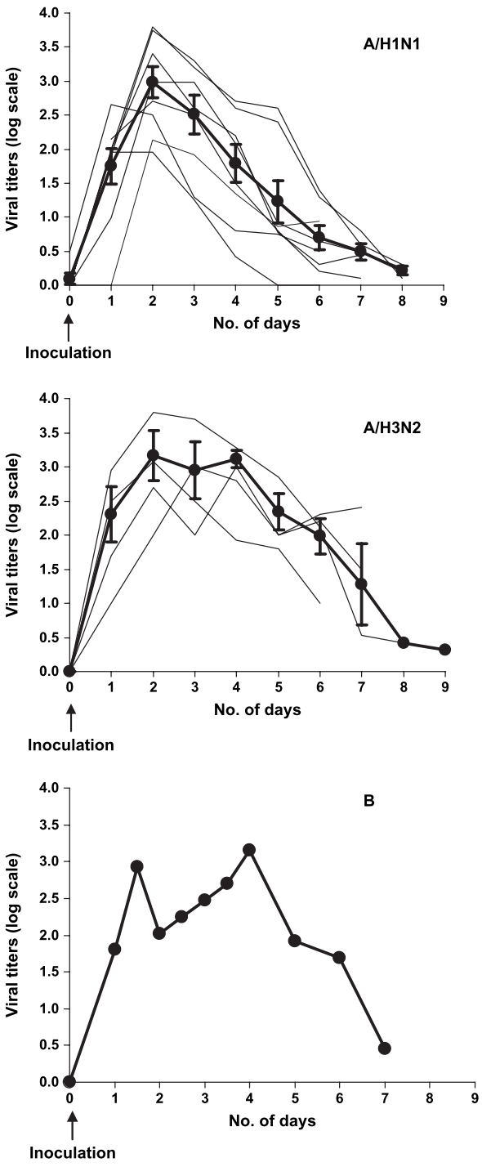

**Figure 2. Summary curves of viral shedding in experimental influenza virus infection, according to the virus type or subtype.** Eight curves (116 participants who shed influenza virus) for A/H1N1 subtype (21, 22, 24, 26, 32, 74–76) and four curves (41 participants) for A/H3N2 subtype (25, 28, 40, 45) were averaged, and one curve (eight participants) was plotted for the B type (24). Bold curves correspond to weighted averages of study curves (standard error)

* Figure 3 shows the time course of symptoms for the different viral strains. As in [Memoli 2015](https://doi.org/10.1093/cid/ciu924), we define "peak symptoms" during the time intervals when the symptom score is ≥80% of the maximum value for each viral strain. Hence, **peak symptoms** from these challenge studies occurs during:
  + **H1N1: Days 2-4**
  + **H3N2: Days 2-5**
  + **Influenza B: Days 2-4**

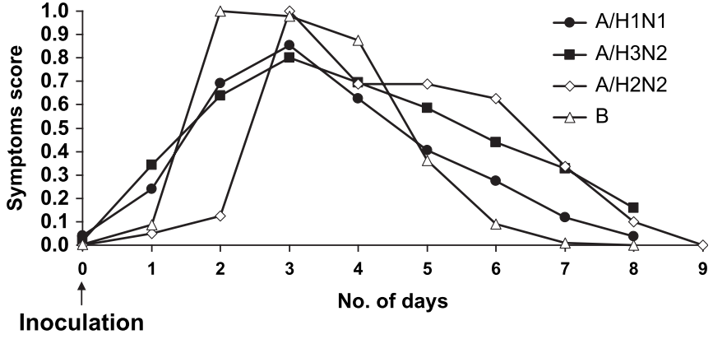

**Figure 3. Summary curves of total symptoms scores in experimental influenza virus infection, according to the virus type or subtype.** Seven curves (134 infected participants) for A/H1N1 subtype (21, 22, 26, 76, 77) and eight curves (68 participants) for A/H3N2 subtype (18, 25, 40, 43, 45, 48, 78) were averaged, and one curve (11 participants) for A/H2N2 subtype (16) and one curve (15 participants) for B type (17) were plotted. A total score of 1 corresponds to the maximum reported score value (refer to Materials and Methods)

* [Stray 2001](https://doi.org/10.1016/S0168-1702%2801%2900260-X) (Virus Research): Apoptosis by influenza viruses correlates with efficiency of viral mRNA synthesis
  + Analyzed the reassorted viruses A/NWS/33HA-Tokyo/67NA (NWS-Tokyo, H1N2), A/NWS/33HA-tern/Australia/G70c/75NA (NWS-G70c, H1N9), and A/NWS/33HA-G70cΔNAMviA [NWS-Mvi, H1N9- (Liu and Air, 1993)]
  + Table 2 shows that viral protein synthesis is seen between 4-8 hours post-infection

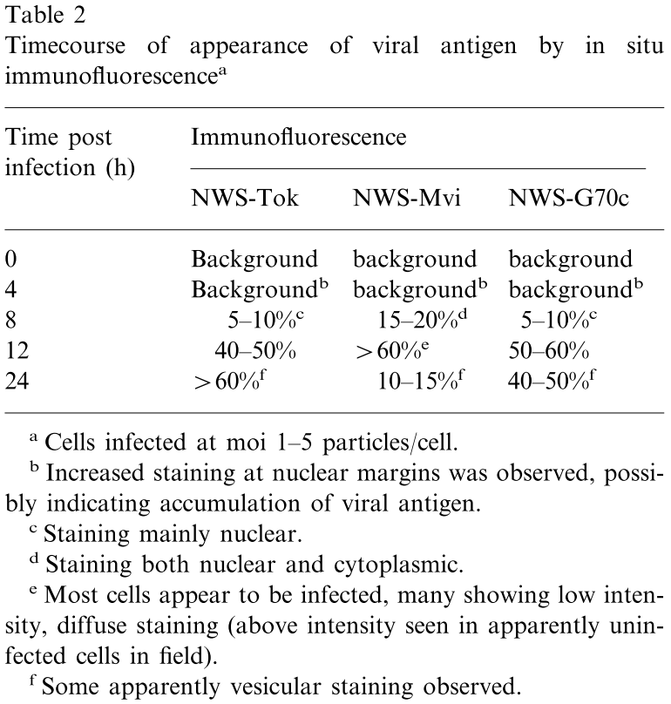

* [Richman 1975](https://www.ncbi.nlm.nih.gov/pmc/articles/PMC274274/) (Journal of Clinical Microbiology): Three strains of influenza A virus (H3N2): interferon sensitivity in vitro and interferon production in volunteers
  + Analyzed the virus kinetics of H3N2 A/Bethesda/1015/1968, H3N2 A/Udorn/307/1972, and H3N2 A/Georgia/101/1974. For each human volunteer, 104.0-104.5 TCID50 of one of these viruses was administered intranasally
  + Figure 1 shows virus titer over time along with the interferon response
    - The peak virus titers occur on Day 2 for A/Bethesda/1015/1968, from Days 1-5 for A/Udorn/307/1972, and on Day 5 for A/Georgia/101/1974. Since these are all H3N2 viruses, we will coarsely combine them by averaging the lower bounds (2, 1, and 5) and the upper bounds (2, 5, and 5) to obtain **peak symptoms between Days 3-4**

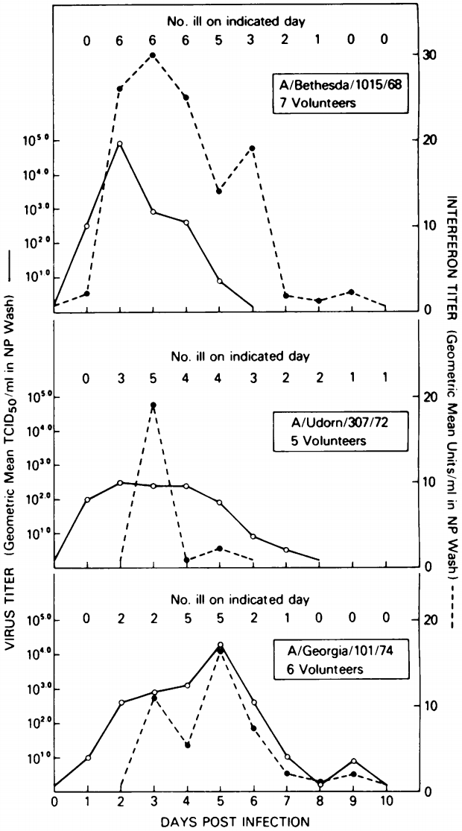

**Figure 1.** Response of volunteers to the intranasal administration of three strains of influenza A (H3N2) virus.

* Table 2 provides another way to average over the response seen for all 14 patients (with the response of each patient weighed equally). This table shows the time after viral challenge when viral shedding and influenza illness symptoms begin, as well as the time of maximum virus titers seen in nasopharyngeal (NP) washes

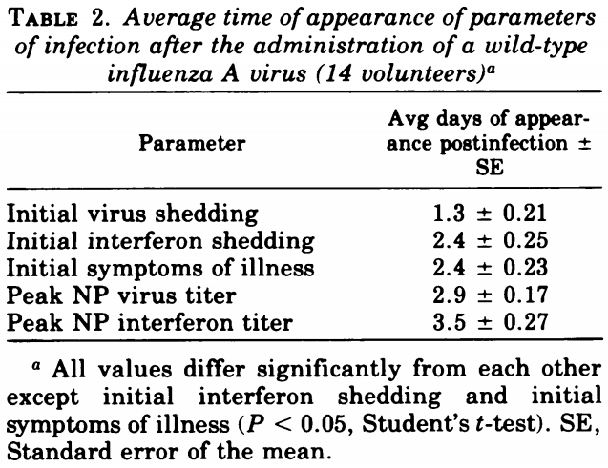

## Number of Epithelial Cells

Influenza primarily targets the sialic acids on the epithelial cells that line the human nose, throat, and lungs. Thus, it is important to estimate the number of potential targets for influenza during the course of an infection.

**Sources:**

* [Baccam 2006](https://doi.org/10.1128/JVI.01623-05) (Journal of Virology): Kinetics of Influenza A Virus Infection in Humans
  + “The initial number of target cells in an adult, *T*0, is approximately 4×108 cells, which was calculated from the area of epithelial cells lining the nasal turbinates of the upper respiratory tract, 160 cm2 ([Menache 1997](https://jvi.asm.org/content/80/15/7590" \l "ref-26)), and the surface area per epithelial cell, 2×10−11 to 4×10−11 *m*2/cell ([Fedoseev 1989](https://jvi.asm.org/content/80/15/7590" \l "ref-11)).”

## Viral Life Cycle

The virus life cycle quantifies the time that it takes between when an infectious virion enters a cell and when that cell starts to release *infectious* viral progeny. (Note that sometimes noninfectious virions are produced within 4 hours of infection, but we disregard these and consider the time required to produce infectious progeny.) Further note that these measurements are made in cell culture.

**Sources:**

* [Frensing 2016](https://doi.org/10.1007%252Fs00253-016-7542-4) (Applied Microbiology and Biotechnology): Influenza virus intracellular replication dynamics, release kinetics, and particle morphology during propagation in MDCK cells
  + Analyzed MDCK cells infected with H1N1 A/Puerto Rico/8/34
  + "Influenza virus RNA synthesis levels out already 4 hours post infection at a time when viral genome segments are exported from the nucleus. Nevertheless, virus release occurred at a constant rate in the following 16 hours. Thereafter, the production of infectious viruses dramatically decreased, but cells continued to produce particles contributing to the hem- agglutination (HA) titer."
  + “When we calculated the cell-specific virus particle production per hour, it became obvious that the rate of virus release for both infectious and total virus particles reached its maximum already in the sampling interval between 4 and 8 hours post infection (hpi) (Fig. 1c)."
    - Note that while some virions are produced between 0-4 hours, they are nearly all noninfectious. Since we are considering the time of the viral life cycle to be the duration required to make the first infectious progeny, the data suggests that it occurs between **4-8 hours** post infection
    - The morphology of the viral progeny differs over the course of an infection. “In the early phase of the infection (between 8 and 12 hpi) most particles were spherical. In addition to these apparently intact virus particles, deformed or broken particles and large membranous structures were present… In contrast, only about 25% of the particles were intact spherical at the later stage between 20 and 24 hours post infection. At this stage, the majority of particles was deformed or broken and the amount of large membranous structures also increased.”
    - Evidence of secondary infections was seen around 12 hours post infection, which corroborates a viral life cycle of around 6 hours. "We found secondary infections at 12 hpi even in the absence of trypsin"

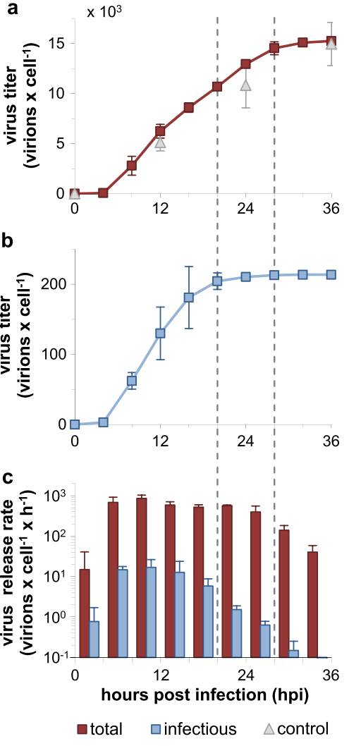

**Figure 1. Virus production kinetics.** MDCK cells were infected with the influenza virus PR8 at an MOI of 10 PFU per cell. The supernatant was harvested every 4 hours and replaced with fresh media. Infections without medium exchange (incubated for 12, 24, and 36 h) served as controls. The number of total virus particles was calculated based on the HA titer and infectious virions were quantified by the TCID50 assay. Depicted are the cumulative titers of total (**a**) and infectious virus particles per cell (**b**) as well as the virus release rates per hour (**c**). The first and the second dashed lines indicate time points when ≥95 % of the final titer of infectious and total particles were released, respectively. Control titers (upper panel) indicate the number of total virions released from infected cells without medium exchange.

* [Baccam 2006](https://doi.org/10.1128/JVI.01623-05) (Journal of Virology): Kinetics of Influenza A Virus Infection in Humans
  + The *virus life cycle* characterizes the time required for a newly infected cell to release viral progeny
  + The time required for newly detached viral progeny to infect another cell and release the next generation of viral particles is called the *virus generation time*. This includes both the time it takes a virion to find and infect a cell as well as the viral life cycle. The generation time is given by (clearance rate of virus in plasma)-1 + (clearance rate of virus-infected cell)-1 [see Table 2 caption of [Perelson 1996](https://doi.org/10.1126/science.271.5255.1582)]
  + From Baccam 2006, (clearance rate of virus in plasma)-1 ≈ 3 hours and (clearance rate of virus-infected cell)-1 ≈ 11 hours, and hence the virus generation time (given by their sum) is 14 hours
* [Sedmak 1973](https://doi.org/10.1099/0022-1317-21-1-1) (Journal of General Virology): Interferon Bioassay: Reduction in Yield of Myxovirus Neuraminidases
  + Analyzed chicken embryo cell culture infected with H3N2 A2/Hong Kong/1/1968
  + Figure 2B shows the PFU of virus produced. Appreciable viruses (above the baseline levels) appear in all conditions around **6-8 hours post infection**

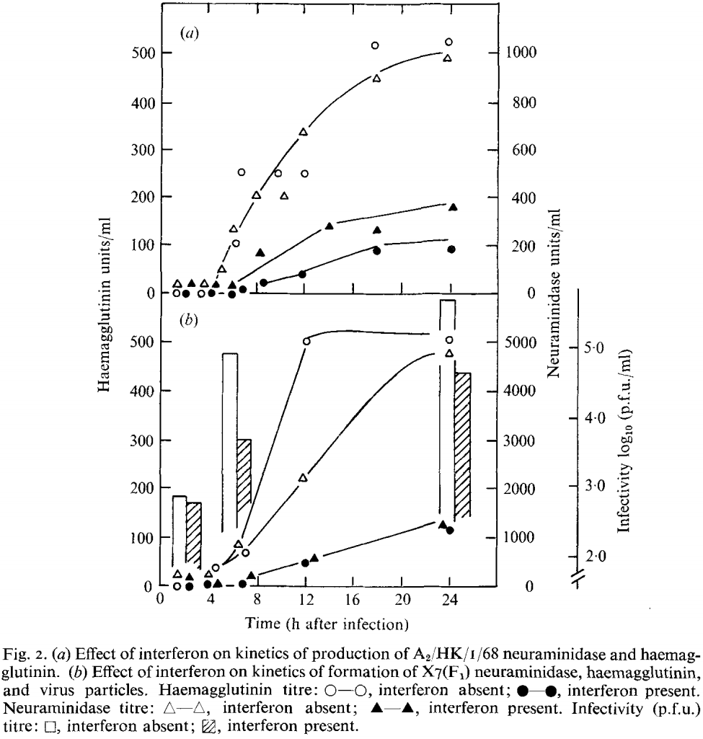

## Viral Burst Size

The viral burst size quantifies the total number of virions that are produced by an infected cell, on average. Note that this quantity is measured in cell culture.

**Sources:**

* [Frensing 2016](https://doi.org/10.1007/s00253-016-7542-4) (Applied Microbiology and Biotechnology): Influenza virus intracellular replication dynamics, release kinetics, and particle morphology during propagation in MDCK cells
  + Analyzed MDCK cells infected with H1N1 A/Puerto Rico/8/34
  + Figure 1A quantifies the total number of physical virions while Figure 1B shows the number of infectious virions produced by an infected cell. "The final HA titer reached corresponded to approximately 15,000 [physical] particles per cell (Fig 1a). In contrast, infectious virus particles reached lower final yields of about 200 virions per cell (Fig. 1b)."



**Figure 1. Virus production kinetics.** MDCK cells were infected with the influenza virus PR8 at an MOI of 10 PFU per cell. The supernatant was harvested every 4 hours and replaced with fresh media. Infections without medium exchange (incubated for 12, 24, and 36 h) served as controls. The number of total virus particles was calculated based on the HA titer and infectious virions were quantified by the TCID50 assay. Depicted are the cumulative titers of total (**a**) and infectious virus particles per cell (**b**) as well as the virus release rates per hour (**c**). The first and the second dashed lines indicate time points when ≥95 % of the final titer of infectious and total particles were released, respectively. Control titers (upper panel) indicate the number of total virions released from infected cells without medium exchange.

* [Heldt 2015](https://doi.org/10.1038/ncomms9938) (Nature Communications): Single-cell analysis and stochastic modelling unveil large cell-to-cell variability in influenza A virus infection
  + Analyzed the viral strain H1N1 A/Puerto Rico/8/34 (PR8) grown in Madin–Darby canine kidney (MDCK) cells
  + Figure 1B shows their experimental measurements of the number of infectious virions (plaque forming units) generated by single cells at 12 hours post infection
    - Note that in [Stray 2001](https://doi.org/10.1016/S0168-1702%2801%2900260-X), they also determined that a single cycle (the time that an infected cell will produce viral progeny) lasts 12 hours
    - “In particular, most productive cells released only 1-75 plaque-forming units (PFUs). However, we also detected cells that yielded several hundred PFUs. Moreover, roughly 40% of the infections did not produce a plaque titre although these cells were tested positive for vRNAs, which confirms their infection (Supplementary Figure 3).”

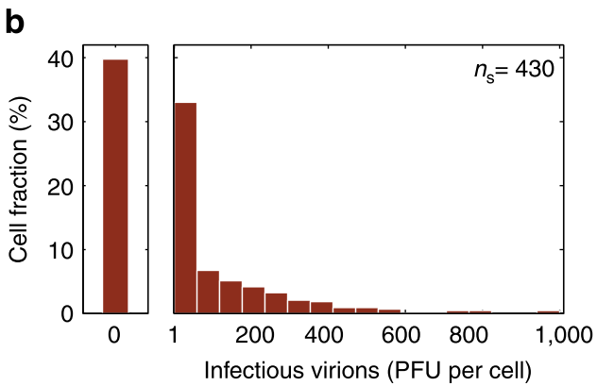

**Figure 1. Single-cell analysis approach and virus yields of IAV-infected cells.** A population of adherent MDCK cells was infected with influenza PR8 virus at an MOI of 10, incubated and afterwards trypsinized to obtain a cell suspension. Subsequently, the diluted cell suspension was transferred to a 384-well plate and wells containing single cells were identified by phase-contrast microscopy. At 12 h.p.i., virus titres in the supernatant were determined by the plaque assay. (b) Distribution of virus yield. The first bar on the left of the histogram indicates the fraction of cells that show no virus release (0 PFU). Illustration includes pooled data of multiple independent experiments (*n*=8).

* Figure 2B shows their computational simulation of the MDCK cell infection by PR8, predicting the *total* number of virions produced per cell (whereas Figure 1B shows the number of *infectious* virions produced per cell). Note that whereas 40% of cells produce no infectious particles, only 4% are predicted to produce no virions at all. In other words, most cells will produce virions, but many of those virions may be uninfectious
  + According to this simulation, most infected cells will produce 102-104 virions

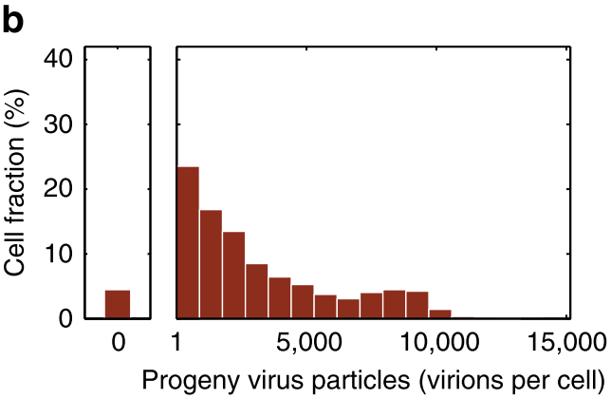

**Figure 2. Stochastic simulation of IAV replication.** (b) Number of progeny virions released by individual infected cells until 12 h.p.i. for an infection at an MOI of 10.

* [Brooke 2014](https://doi.org/10.2217/fvl.13.118) (Future Virology): Biological activities of 'noninfectious' influenza A virus particles
  + "While the in vivo burst size is not known, and will certainly vary based on many different factors, estimates range from 10 to 300 PFUs per producer cell [[Smith 2011](https://doi.org/10.1002/wsbm.129), [Mitchell 2011](https://doi.org/10.1128/JVI.01722-10)]. Even by conservative estimates (10 PFUs ≈ 100 SI particles), this amount of virus restricted to neighboring cells would result in an enormously high MOI."
* [Perelson 2012](https://doi.org/10.1093/infdis/jis265) (The Journal of Infectious Diseases): Combination antiviral therapy for influenza: predictions from modeling of human infections
  + "The estimate of 5,000 virions produced per infected cell is very likely a conservative estimate, as numbers closer to 20,000 virions per cell have been reported [12]. Further, if only 1 in 1,000 virions is infectious, then this implies that only 5 infectious virions are produced per cell, which is also likely an underestimate, since in early infection it has been estimated that each infected cell infects approximately 20 other cells [9]."
* [Stray 2001](https://doi.org/10.1016/S0168-1702%2801%2900260-X) (Virus Research): Apoptosis by influenza viruses correlates with efficiency of viral mRNA synthesis
  + Analyzed the reassorted viruses A/NWS/33HA-Tokyo/67NA (NWS-Tokyo, H1N2), A/NWS/33HA-tern/Australia/G70c/75NA (NWS-G70c, H1N9), and A/NWS/33HA-G70cΔNAMviA [NWS-Mvi, H1N9- (Liu and Air, 1993)] infecting MDCK (Madin Darby canine kidney) cells
  + Table 1 below shows the number of virions needed to infect a cell (Row 1) and viral burst size (Row 3)
    - Row 1 represents the total number of virions (not the number of infectious virions) needed to initiate an infection. In addition, if they used 50μL of 0.5% turkey red blood cells (this was unspecified in the methods), then 1 HAU would represent 0.5·106 virions [see the Number of Virions in 1 HAU section], which would make their particle count a factor of 2 too large
    - Viral burst size varied between 103-104. “Burst size (progeny virus per infected cell) was calculated for each virus infecting untreated MDCK cells and found to be 1 000–10 000 particles per cell for each, similar to the previously reported yield from chicken allantois [[Cairns 1952](https://www.ncbi.nlm.nih.gov/pubmed/14946411)].”

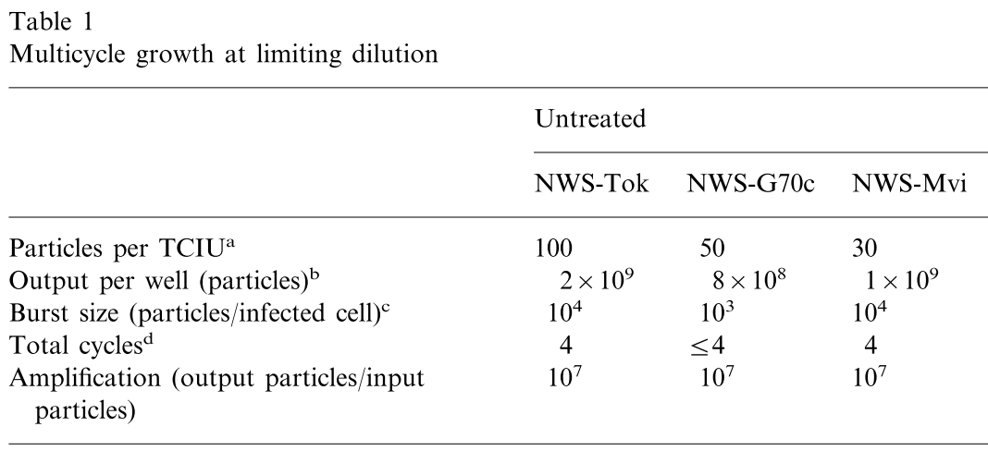

a The minimal number of virus particles required to initiate infection (TCIU) was determined by limiting dilution assay. MDCK cells in 16 mm wells (approximately 2·105 cells) were infected with fivefold serial dilutions of virus, infection was allowed to proceed for up to 96 h, by which time no further increase in virus titer was observed. Virus concentration were determined by hemagglutination, then converted to numbers of particles (1 HAU=1·106 particles).

b Virus particles produced in the last well showing titerable virus production.

c Assuming final yield is output of the total number of cells in the dish [[Cairns 1952](https://www.ncbi.nlm.nih.gov/pubmed/14946411)], burst size is the ratio of particles produced to cells (approximately 2×105 cells/well).

d Obtained from time after infection required for total CPE. Cycle time was approximately 12 h for all viruses, as previously described [[Cairns 1952](https://www.ncbi.nlm.nih.gov/pubmed/14946411)]. Maximal virus yield was obtained by 48 h.

This information represents the left half of Table 1 in the original manuscript

### Fraction of Virus that is Infectious

Two of the most common assays (TCID50 and PFU) to assess the number of infectious virions depict individual virions as either completely infectious or completely noninfectious. While the full picture is clearly more nuanced (e.g. if two virions, each missing a different gene, simultaneously infect the same cell, they can lead to a productive infection) [[Brooke 2014](https://doi.org/10.2217/fvl.13.118)], it is nevertheless helpful to get a sense of what fraction of virions are individually infective.

|  |  |
| --- | --- |
| **Fraction of Virions that are Infectious**  **(Viral Strain)** | **Source** |
| 5.8±1.5% (A/WSN/1933Udorn 1972 M1) | [Vahey 2019](https://doi.org/10.1016/j.cell.2018.10.056) |
| 0.6±0.2% (A/Switzerland/9715293/2013) | [Parupudi 2017](https://doi.org/10.1016/j.jviromet.2017.06.002) |
| 5.9±1.7%  (PR8) | [Bousse 2013](https://doi.org/10.1016/j.jviromet.2013.07.026) |
| 1.5±0.3% (B/Yamanashi/166/98, B/Jilin/20/03) | [Wei 2007](https://doi.org/10.1016/j.jviromet.2007.04.008) |
| **3.4±0.6%** | **Average Value** |

**Sources:**

* [Vahey 2019](https://doi.org/10.1016/j.cell.2018.10.056) (Cell): Low-Fidelity Assembly of Influenza A Virus Promotes Escape from Host Cells
  + Analyzed a viral strain expressing M1 from H3N2 A/Udorn/1972 in an H1N1 A/WSN/1933 background
  + Table S1 shows that a fraction (1.78±0.33)/(30.83±5.66)=0.058±0.015 of virions are infectious, averaged over three replicated

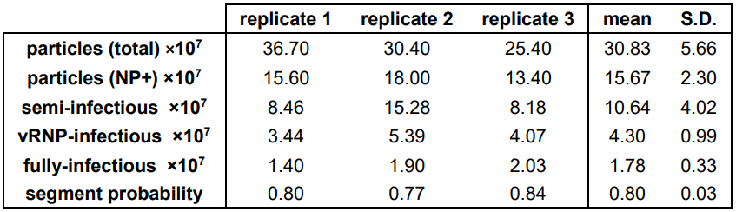

**Table S1. Abundance of different particle types in populations shed from infected cells, Related to Figure 2.** Tabulation of results from three biological replicates: “particles (total)” refers to the total number of particles pulled down onto anti-HA coated coverslips after a 16 hour incubation with periodic mixing; “particles (NP+)” refers to the number of immobilized particles that contain fluorescently-labeled NP above a threshold level; “semi-infectious” refers to the total number of particles that deliver at least one vRNA segment to an infected cell, and is calculated based on the segment probability (p) and the measured number of fully-infectious particles (PFU) as PFU/*p*8; “vRNP-infectious” refers to particles which deliver at least the four segments necessary for secondary transcription (PA, PB1, PB2, and NP); “fully-infectious” refers to particles capable of initiating multiple rounds of replication (PFUs). Finally, “segment probability” is the probability (expressed as a fraction) of any particular vRNA segment being expressed by an infected cell.

* [Parupudi 2017](https://doi.org/10.1016/j.jviromet.2017.06.002) (Journal of Virological Methods): Biophysical characterization of influenza A virions
  + Analyzed H3N2 A/Switzerland/9715293/2013
  + Using Table 1, the fraction of infectious particles to total particles equals:
    - 0.4±0.2% (FFA/NTA; dividing the number of infectious virions measured via FFA by the total number of virions measured by NTA)
    - 0.6±0.4% (FFA/TEM)
    - 0.9±0.4% (FFA/AUC)
    - 0.6±0.3% (FFA/FFF-MALS)
    - The average of these measurements is **0.6±0.2% infectious virions**
  + "Typically, the ratio of total particles (TP) to infective particles (IP) is between about 10:1 and 100:1 for influenza A (Hutchinson 2010; Fonville 2015; Enami 1991; Wei 2007; Donald 1954)."
* [Brooke 2013](https://doi.org/10.1128/JVI.02284-12) (Journal of Virology): Most influenza a virions fail to express at least one essential viral protein
  + "Up to 90% of IAV-infected cells fail to release infectious progeny, indicating that many IAV virions scored as noninfectious by traditional infectivity assays are capable of single-round infection. This fraction was not significantly affected by target or producer cell type but varied widely between different IAV strains"
    - "We were able to determine the expression frequencies of proteins from four of the eight vRNA segments. By averaging expression frequency from a representative experiment (frequency of HA expression [ƒHA], 75.3%; ƒNA, 77.3%; ƒNP, 81.2%; ƒNS1, 78.4%; ƒaverage, 78.1%) and extending it to the four unexamined gene segments, we can estimate the frequency of virions expressing products of all eight vRNA segments (ƒcomplete) as follows: ƒcomplete = (ƒHA)(ƒNA)(ƒNP)(ƒNS1)(ƒaverage4). For the representative experiment, ƒcomplete = (0.753)(0.773)(0.812)(0.784)(0.7814) = 0.138, or 13.8%."
    - "Our finding that the fraction of propagation-competent virions varies nearly 10-fold between different strains indicates that this trait is subject to evolutionary selection and implies that generating replication-incompetent virions may be advantageous in some circumstances. At low MOIs, as would be expected early during natural transmission events, semi-infectious virion production would be detrimental on the basis of non-propagation, although this effect could be mitigated by aggregation-mediated complementation (30). At high MOIs, however, the inability of a virion to express a full complement of gene products should have a minimal negative effect due to complementation. Here, the production of complementation-dependent virions could be advantageous in imposing a step that mandates the mixing of segments from different input viruses, thereby increasing the frequency of genetic reassortment"
  + Figure 5B shows the % of virions that are infectious in MDCK and Vero cells. Figure 5C examines PR8 grown in different sources. "To quantitate virion infectivity, we infected MDCK monolayers on coverslips with PR8 at an MOI of <0.01 and overlaid cells with 0.9% agarose to limit free-virus spread. We incubated cells for 15 h, a period that allowed both virus propagation and visualization of viral protein expression in cells infected in the first round of replication. Staining cells for HA, NP, M1, and M2 allowed us to quantify the number of cells infected in the initial round of viral replication and to determine the fraction of infection events resulting in release of infectious progeny"
    - "Quantitating lone infected cells/pairs versus foci, we determined that only 12.5% of infectious events led to viral propagation (Fig. 5B). Similarly, only 11% of infectious foci in Vero cells demonstrated viral propagation, ruling out a role for type I IFN in limiting viral gene expression"
    - “We expanded PR8 in eggs, MDCK cells, mice, and guinea pigs and compared the percentages of propagation-competent infectious virus. Remarkably, the source of virus had no significant effect on the fraction of propagation competence (Fig. 5C)”

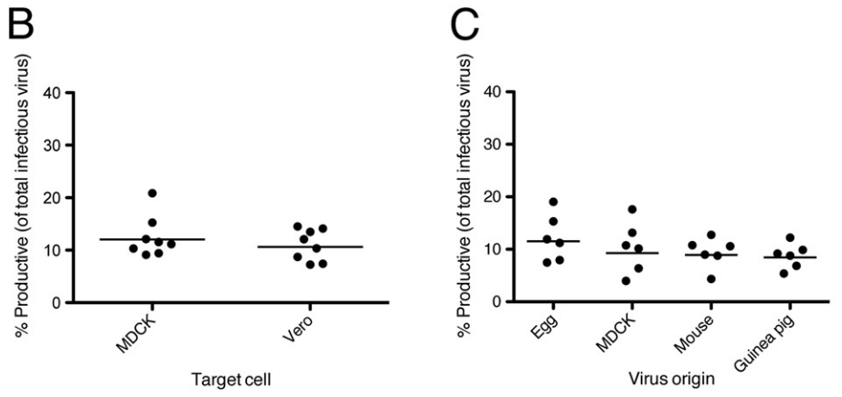

**Fig 5. The majority of infectious IAV virions are incapable of producing infectious progeny.** Confluent monolayers were grown on coverslips, infected with the indicated viruses at an MOI of <0.01, and then overlaid with 0.9% agarose. After 15 h, cells were fixed, permeabilized, and then stained against the indicated viral proteins. (B) MDCK and Vero cells were infected with PR8 and then stained against HA (mouse MAb H36-26) and NP (rabbit pAb). Between 100 and 400 infection events on each coverslip were counted by eye as either abortive (1 to 2 adjacent, lone infected cells) or productive (3 or more adjacent infected cells), and the percentage of infection events that were productive was calculated. Each data point represents the value generated from a single coverslip, and the bars represent the means. (C) MDCK cells were infected with stocks of PR8 grown in eggs and MDCK cells, lung homogenates from PR8-infected mice, and nasal wash from PR8-infected guinea pigs and assessed as described for panel B. Data are representative of two independent experiments

* Figure 6B extends this % infectivity assay to different viral strains. "To generalize our findings [beyond the PR8 strain], we assessed patterns of viral protein expression during low-multiplicity infection with a low-passage-number human isolate from the 2009 H1N1 pandemic, A/California/07/09 (Cal), as well as with the H3N2 strain A/Udorn/307/72 (Udorn).”

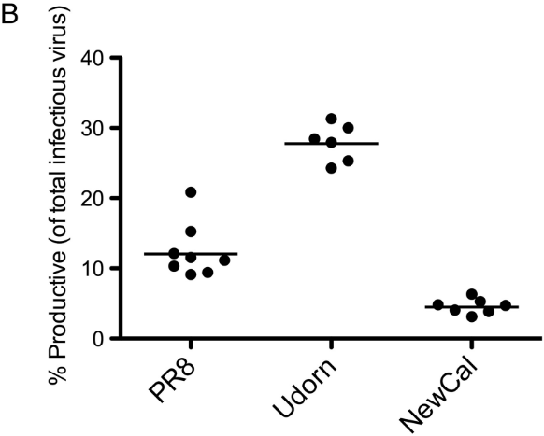

**Fig 6. The efficiency of propagation-competent virus production differs widely between different viral genotypes.** (B) Confluent monolayers of MDCK cells were grown on coverslips, infected with the indicated viruses at an MOI of <0.01, and then overlaid with 0.9% agarose. Fifteen hours later, cells were fixed, permeabilized, and then stained against HA (human mAb 70-1F02) and NP (rabbit pAb). Between 100 and 400 infection events on each coverslip were counted by eye as either abortive (1 to 2 adjacent, lone infected cells) or productive (3 or more adjacent infected cells), and the percentage of infection events that were productive was calculated. Each data point represents the value generated from a single coverslip, and the bars represent the means. Data are representative of four independent experiments, using multiple stocks of each virus grown in eggs and MDCK cells

* [Bousse 2013](https://doi.org/10.1016/j.jviromet.2013.07.026) (Journal of Virological Methods): Quantitation of influenza virus using field flow fractionation and multi-angle light scattering for quantifying influenza A particles
  + Analyzed the viral strain PR8 (A/Puerto Rico/8/1934) (H1N1)
  + Table 4 (shown below) compares the number of infectious virus particles (EID50 and PFU) to the total number of virions (qRT-PCR and FFF-MALS). The fraction of infectious virions averaged over all experiments is given by:
    - 1.2±0.8% (EID50/PCR)
    - 1.4±1.7% (PFU/PCR)
    - 11±4% (EID50/FFF-MALS)
    - 10±6% (PFU/FFF-MALS)
    - The average of these measurements is **5.9±1.7% infectious virions**
  + The EID50 and PFU measurements closely agree with one another, but the qRT-PCR measurements are 10-fold larger than the FFF-MALS measurements. In other work, the total number of virions measured by FFF-MALS was only 2.4-fold larger than the qRT-PCR measurements and 1.6-fold larger than TEM measurements, so it is surprising that the first two methods do not agree in this instance ([Wei 2007](https://doi.org/10.1016/j.jviromet.2007.04.008) Table 3). One possible difference is that the earlier work used PCR on the HA gene, whereas this current work measured the matrix gene

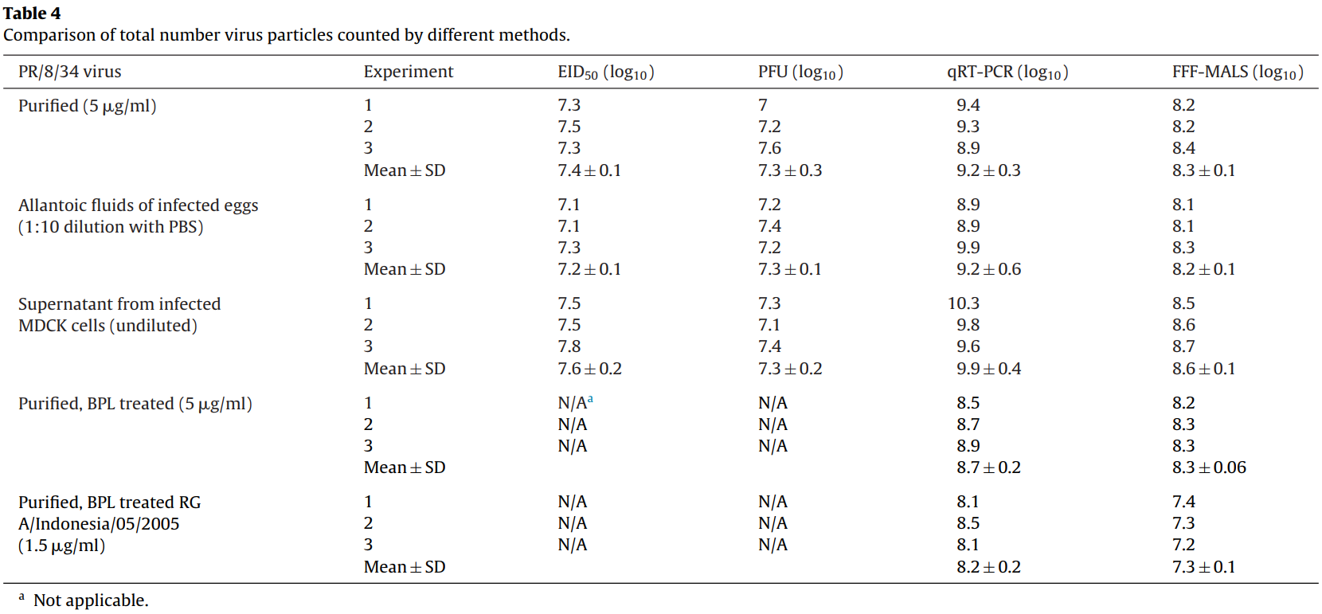

* [Murillo 2013](https://doi.org/10.1016/j.jtbi.2013.03.024) (Journal of Theoretical Biology): Towards multiscale modeling of influenza infection
  + Review article analyzing different aspects of influenza
  + “Most IAV particles are not infectious. At low multiplicities of infection (MOIs) in embryonated eggs, approximately 0.4–4.1% of IAV particles produced are infectious (calculated from Table 1, Marcus et al., 2009); other estimates in eggs and mammalian cells suggest that from 0.2% to 1.0% of particles are infectious (Van Elden et al., 2001; Wei et al., 2007). The percentage of virus particles that is infectious may vary across IAV strains, host cell types, and growth conditions, including in vivo vs. in vitro infection. At high MOIs, an even smaller percentage of IAV particles produced is infectious (von Magnus, 1954; Marcus et al., 2009), and across six strains studied, an average of only about 1 in 150 cells (primary chicken embryonic kidney) produced an infectious virus particle (Marcus et al., 2009).“
* [Wei 2007](https://doi.org/10.1016/j.jviromet.2007.04.008) (Journal of Virological Methods): Biophysical characterization of influenza virus subpopulations using field flow fractionation and multiangle light scattering: Correlation of particle counts, size distribution and infectivity
  + Analyzed the influenza strains B/Yamanashi/166/98 and B/Jilin/20/03
  + Table 2 (shown below) compares the number of infectious virus particles (TCID50 and FFA) to the total number of virions (FFF-MALS, SEC-MALS, TEM, or PCR). The fraction of infectious virions is given by:
    - 0.3±0.1% (TCID50/FFF-MALS)
    - 1.0±0.2% (TCID50/SEC-MALS)
    - 0.5±1.2% (TCID50/TEM)
    - 1.0±0.04% (TCID50/PCR)
    - 0.2±0.1% (FFA/FFF-MALS)
    - 0.6±0.1% (FFA/SEC-MALS)
    - 0.3±0.7% (FFA/TEM)
    - 0.6±0.02% (FFA/PCR)
    - Note that the coefficient of variation given was used to compute the error for each measurement. For example, the log10 total virus count from FFF-MALS was 10.4 with a coefficient of variation of 1.8%, which implies that the standard deviation is the product of the (fraction, not percent) coefficient of variation times the mean (0.018·10.4=0.19). Hence the total virus count is given by 1010.4±0.19
  + Table 3 (shown below) compares the number of infectious virus particles (TCID50) to the total number of virions (FFF-MALS, PCR, or TEM). The fraction of infectious virions averaged over all experiments is given by:
    - 2.8±1.7% (TCID50/FFF-MALS)
    - 5.1±1.3% (TCID50/PCR)
    - 3.7±1.1% (TCID50/TEM)
  + The average over all eleven measurements is **1.5±0.3% infectious virions**

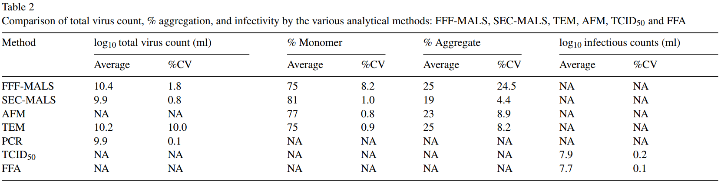

## 

## Minimal Infectious Dose

The minimal number of infectious virions needed to initiate an infection is of great interest, and the consensus in the field is that very few virions (or perhaps even a single infectious virion) are sufficient to pass the disease into a new host.

**Sources:**

* [Heldt 2015](https://doi.org/10.1038/ncomms9938) (Nature Communications): Single-cell analysis and stochastic modelling unveil large cell-to-cell variability in influenza A virus infection
  + They computationally modeled the infection of Madin–Darby canine kidney (MDCK) cells by H1N1 A/Puerto Rico/8/34 (PR8)
  + Figure 6 shows the ways in which they predict that single infectious virions will fail to successfully infect a cell. Their simulations predict that “single-hit infections, where only a single virion enters the cell, predominantly fail to produce progeny virions due to stochastic effects.”
    - "Our model predicts that, once in the nucleus, each IAV vRNP has a chance of 84% to replicate successfully. Considering a cell in which only one viral genome set reaches the nucleus, the probability to replicate all eight vRNPs, which is required to release infectious viruses, is thus only 0.848≈25%." "This is comparable to the results of [Brooke 2013](https://doi.org/10.1128%2FJVI.02284-12), who find that the average expression frequency of a particular protein in an infected cell is 78.1% and the chance to express the products of all eight genome segments 13.8%."
    - "This also implies that even if all parental viruses comprise a complete genome set, many cells would not produce infectious virus progeny during low-MOI infection due to stochastic effects. However, during subsequent rounds of infection, these cells could be infected a second time causing them to contribute to total virus titres."

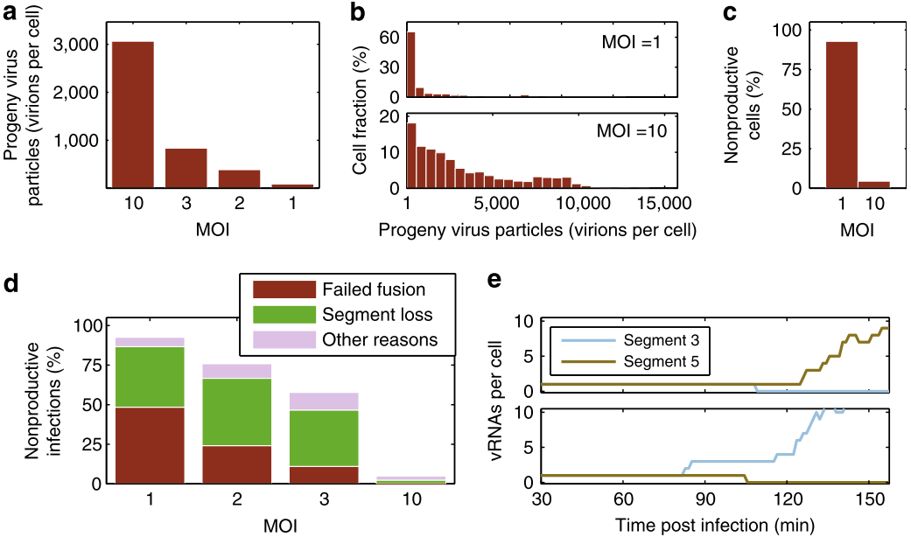

**Figure 6. Increase in noise at low MOI.** Simulation results at 12 h.p.i. for infections at different MOIs are shown. (a) Average number of progeny virions per infected cell after a single round of infection. (b) Histogram of the number of progeny virions at an MOI of 1 (upper panel) and 10 (lower panel), respectively. Only productive cells are shown. (c) Fraction of non-productive cells at an MOI of 1 and 10. (d) Probability that an infected cell does not release infectious virus progeny until 12 h.p.i. for different MOIs. The probabilities that virus fusion fails and that at least one viral genome segment is absent are indicated. (e) Early vRNA dynamics in two exemplary non-productive cells (upper and lower panel, respectively) that were infected at an MOI of 1 and in which virus fusion was successful.

* [Varble 2014](https://doi.org/10.1016/j.chom.2014.09.020) (Cell Host and Microbe): Influenza A Virus Transmission Bottlenecks are Defined by Infection Route and Recipient Host
  + "In addition, aerosol administration to volunteers found the minimal infectious dose to be very low, estimating that fewer than ten virions could account for infection [[Alford 1966](https://doi.org/10.3181%2F00379727-122-31255)]. These numbers have also been found to be comparable in the ferret IAV model [[Gustin 2011](https://doi.org/10.1073/pnas.1100768108)]."
  + In their ferret experiments, “we observed a bottleneck in the virus population that suggested as little as two barcoded viruses can successfully establish a de novo infection.”
* [Brooke 2014](https://doi.org/10.2217/fvl.13.118) (Future Virology): Biological activities of 'noninfectious' influenza A virus particles
  + "Regardless of route, the transmission dose of IAV is thought to generally be low. Studies of aerosol infection in humans have estimated minimal infectious doses of <1–300 TCID50 using different human seasonal strains [[Alford 1966](https://doi.org/10.3181/00379727-122-31255), [Knight 1980](https://doi.org/10.1111/j.1749-6632.1980.tb18917.x)]."
* [Nikitin 2014](https://doi.org/10.1155/2014/859090) (Advances in Virology): Influenza Virus Aerosols in the Air and Their Infectiousness
  + “In studies conducted by Alford and colleagues [[Alford 1966](https://doi.org/10.3181/00379727-122-31255)], volunteers were exposed to carefully titrated aerosolized influenza virus suspensions by inhaling through a face mask...The approximate 50% human infectious dose (HID50 - 50% human infectious dose) of virus per volunteer was from 1 to 126 TCID50 (the tissue culture 50% infectious dose). The dose for half of the volunteers was 5 TCID50. The other half of the men, who had very low or nondetectable preinoculation antibody titers, were infected with 0.6 to 3 TCID50. The study reliably shows that the human infectious dose of the influenza A virus, when administered by aerosol to subjects free of serum neutralizing antibodies, is approximately 3 TCID50. The approaches used in this study allow the precise number of infectious particles in the total number of particles to be determined.”
  + “The human infectious dose of the influenza A virus, when administered by aerosol to subjects free of serum neutralizing antibodies, ranges between 1.95×103 and 3.0×103 viral particles.”
  + “The infectious dose required for inoculation by the aerosol route relative to contact or droplet transmission is unclear, but two reviews of previous studies concluded that the infectious dose by the aerosol route is likely to be considerably lower than the infectious dose by intranasal inoculation [21, 34] and that aerosol inoculation results in more severe symptoms [21], presumably because aerosol particles are able to deposit deeper in the respiratory tract. However, the viability of influenza viruses in particles of different sizes and the persistence of viable airborne viruses in the environment are not yet known.”
  + “Coughing, sneezing, talking, and breathing generate a cloud of airborne particles with diameters that can range from a few millimeters to <1 μm [27–30]. Large droplets (>50 μm in diameter) settle on the ground almost immediately, and intermediate-sized droplets (10–50 μm) settle within several minutes. Small particles (<10 μm), including droplet nuclei from evaporated larger particles, can remain airborne for hours and are easily inhaled deep into the respiratory tract.”
* [Snider 2010](https://www.cdc.gov/influenzatransmissionworkshop2010/) (CDC Meeting Summary): Approaches to better understand human influenza transmission
  + “Previously published human challenge studies [[Alford 1966](https://doi.org/10.3181%2F00379727-122-31255); [Couch 1971](https://doi.org/10.1093/infdis/124.5.473); [Couch 1974](https://doi.org/10.1093/infdis/129.4.411); [Douglas 1975](https://books.google.com/books/about/The_Influenza_Viruses_and_Influenza.html?id=HdprAAAAMAAJ)] indicate that the TCID50 required to establish infection from intranasal instillation (large droplet) is in the range of 127-320 viral particles whereas the TCID50 for aerosol challenge into the lower respiratory tract is in the range of 0.6-3.0”
* [Alford 1966](https://doi.org/10.3181/00379727-122-31255) (Proceedings of the Society for Experimental Biology): Human influenza resulting from aerosol inhalation
  + Human volunteers were administered the viral strain A2/Bethesda/10/63 as aerosolized droplets to determine the human infectious dose through inhalation. Inhalation was through the nose and exhalation was through a mouthpiece. The amount of virus was assessed via throat swabs
  + Table 1 shows the responses of different volunteers given varying amounts of inhaled virus
    - They defined infection as a 4-fold or greater increase in neutralizing antibodies. (A 2-fold increase may just be noise in the assay)
    - While a greater amount of inhaled virus would ordinarily result in a greater probability of infection, the volunteers receiving larger virus doses also had larger pre-inoculation antibody titers, and no volunteer with a pre-inoculation titer of 80 or greater became infected. This is an interesting confounding factor that is often ignored in human challenge studies
    - By only considering the 8 volunteers given 1-5 TCID50 with pre-inoculation titers <5 (i.e. no measurable antibodies), only ⅜ volunteers got infected. This suggests that the 50% human infectious dose (HID50) may be slightly larger than 5 TCID50
    - As an alternate way to analyze the data, of the 8 volunteers given 5 TCID50 pre-inoculation titers below 80 (the level that grants protection), half of the volunteers got sick, suggesting the 50% human infectious dose may be 5 TCID50. Note that these two interpretations are both consistent with the data, but they make different assumptions about the levels of pre-inoculation antibody titers

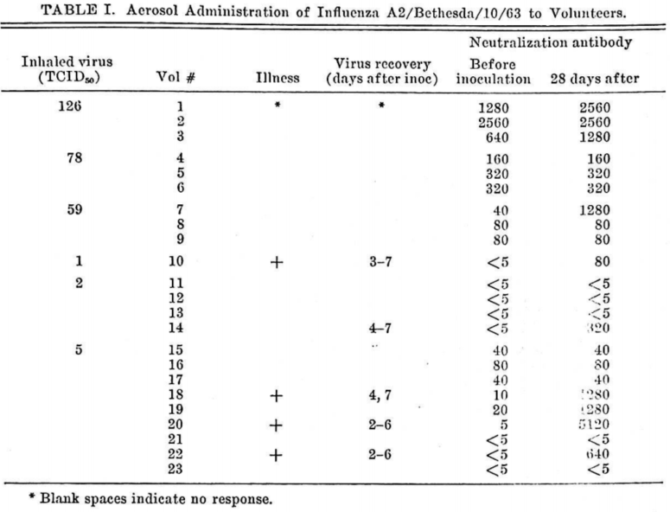

* [Donald 1954](https://doi.org/10.1099/00221287-10-3-457) (Journal of General Microbiology): Counts of Influenza Virus Particles
  + Table 4 shows that there are ~10 virions in a 50% egg infectious dose (ID50) mixture. “With the standard strains the ratios found were all of the order of 10 particles/ID50 dose, and for ‘incomplete’ PR8 the figure was about 1000.”
    - Note that this number convolutes two factors: the minimum dose needed to infect an egg and the fraction of virions that are infective. It is difficult to deconvolute the two without explicit PFU measurements, which were not done in this work
    - The ‘incomplete’ PR8 strain was obtained by making three passages of undiluted allantoic fluid at 24 hour intervals (von Magnus, 1951)

## 

## End of Infection Statistics

The following statistics summarize what happens by the end of a typical human influenza infection.

**Sources:**

* What is the maximum number of epithelial cells destroyed during an influenza infection? Although this quantity has not been measured directly, mathematical models incorporating our knowledge of influenza dynamics and patient data have estimated that 30-50% [[Bocharov 1994](https://doi.org/10.1006/jtbi.1994.1074)] or 37-66% [[Baccam 2006](https://doi.org/10.1128/JVI.01623-05)] of epithelial cells are destroyed during an infection.
* How many total virions are produced throughout an infection? [Perelson 2012](https://doi.org/10.1093/infdis/jis265) combined quantitative modeling with viral titer data from an experimental infection study of H1N1 and inferred that a total of 1010-1012 virions were produced throughout their infections. They noted that the infections of all six patients were restricted to the upper-respiratory tract, and if an infection spreads to the lower-respiratory tract it could generate far a greater number of virions.
  + “Since experimental infections are generally restricted to the upper respiratory tract, this is a minimal estimate of viral production during naturally occurring infections; much higher and more sustained viral loads have been documented in the lower respiratory tract of patients with severe pandemic H1N1 illness [4].”
  + "In Hoopes et al. [10], we assume that of the approximately 4·108 epithelial cells in the upper respiratory tract [9], about 25% are infected during seasonal influenza infection, as observed during equine influenza infection [11]."
* What is the probability that the flu you get is the same as the flu you transmit (in terms of either nucleotide sequence or amino acid composition)? This question is sufficiently interesting to merit an estimation, even if it is overly simplistic:
  + Transmission of influenza in humans typically occurs 2-4 days after infection, during which time the virus is exponentially growing. Assuming an average infection duration of 3 days, an average generation time of 14 hours (this is the time it takes for newly released viral progeny to infect another cell and release the next generation of virus particles), and a mutation rate per replication cycle between 10-6-10-4 errors/(nt·generation), the 14,000 nucleotide genome will accumulate (14,000 nt)(10-6-10-4 errors/(nt·generation))(1 generation/14 hours)(24 hours/1 day)(3 days)≈0.07-7 nucleotide errors in the viral progeny. [Note that this number may be an overestimate, since deleterious mutations may be weeded out at transmission]
  + In the HA gene (~1,600 nucleotides), we would expect 10-fold fewer nucleotides errors. Since ≈75% of nucleotide changes result in nonsynonymous mutations, the HA of a transmitted virus would differ by ~0.05-5 amino acid substitutions, on average. A recent ferret study [[Varble 2014](https://doi.org/10.1016/j.chom.2014.09.020), Figure S3A] found that 10% of ferrets had 1 amino acid substitution, right in the middle of the expected range

## Function of Glycans and Glycan Clock Theory

N-linked glycans added to the HA head domain can increase viral fitness in the presence of antibodies which has lead to the accumulation of glycans overtime in human adapted viruses.

**Sources:**

* [Altman 2019](https://doi.org/10.1128/mBio.00204-19) (mBio): Human Influenza A Virus Hemagglutinin Glycan Evolution Follows a Temporal Pattern to a Glycan Limit
  + Analyze glycan addition over time across different influenza strains. Across seasonal H1 (sH1), pandemic H1 (pH1), and influenza B strains, the virus tends to gain a glycan on hemagglutinin every 5-7 years. This trend continues until the HA reaches a “glycan limit” where the fitness benefit of adding another glycan to shield the virus from immune selection is likely outweighed by the fitness cost of adding additional bulky glycans that can impede the glycoprotein function. When a new pandemic strain arrives from swine or bird origin (which tend to have low glycan levels), the cycle begins again

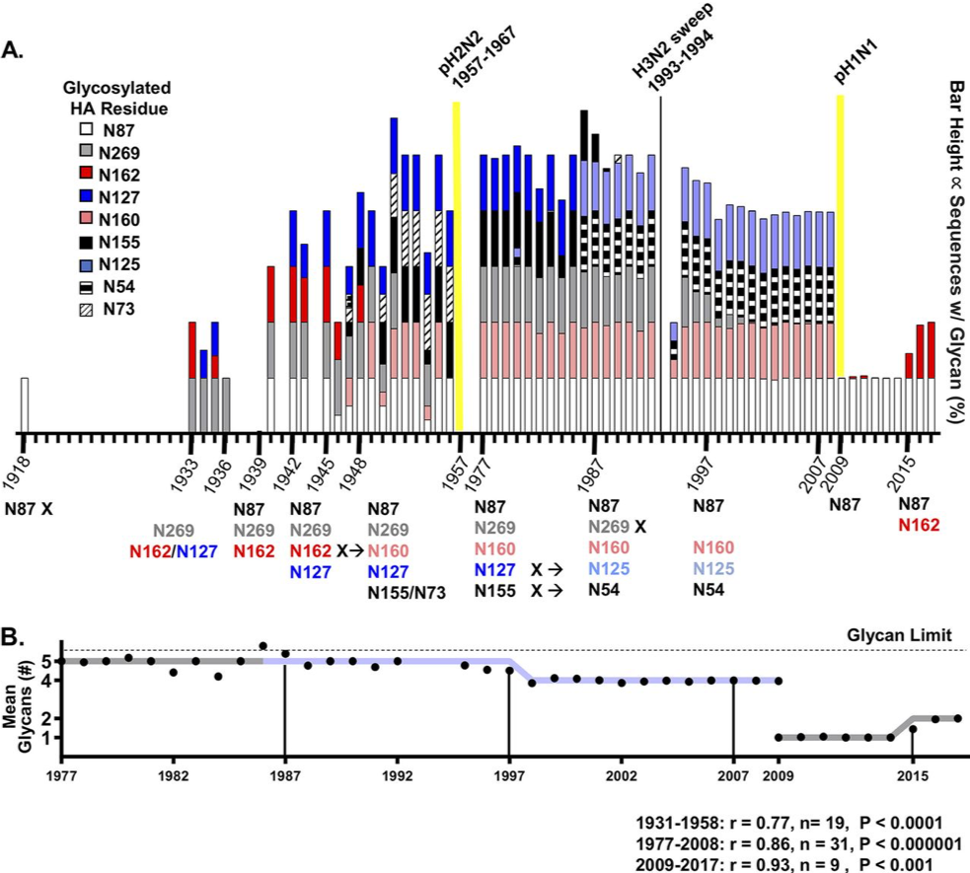

**Figure 2. H1 glycan evolution, 1918 to 2017.** (A) Stacked bars correspond to the percentages of all human H1N1 sequences from a given year containing a glycan listed in the legend. Dates of glycan transition are indicated on the timeline at the bottom, along with the glycosylated residues. Years with no data were left blank. Sequence counts for each year are shown in Figure S4A. Pandemics are denoted by yellow lines. (B) Mean predicted numbers of glycans among all sequences from each year are shown as black circles, which are displayed atop the idealized pattern (gray line; the light blue line indicates glycan swap from sequences containing N127/N155 to sequences containing N125/N54). Black vertical lines denote 11-year intervals after the glycan limit was reached or 6-year intervals during glycan addition. Data representing Pearson’s coefficient of correlation (r) with sample number (n) and P value, from two-tailed Student’s t test comparing the pattern versus the sequence data are shown at the bottom.

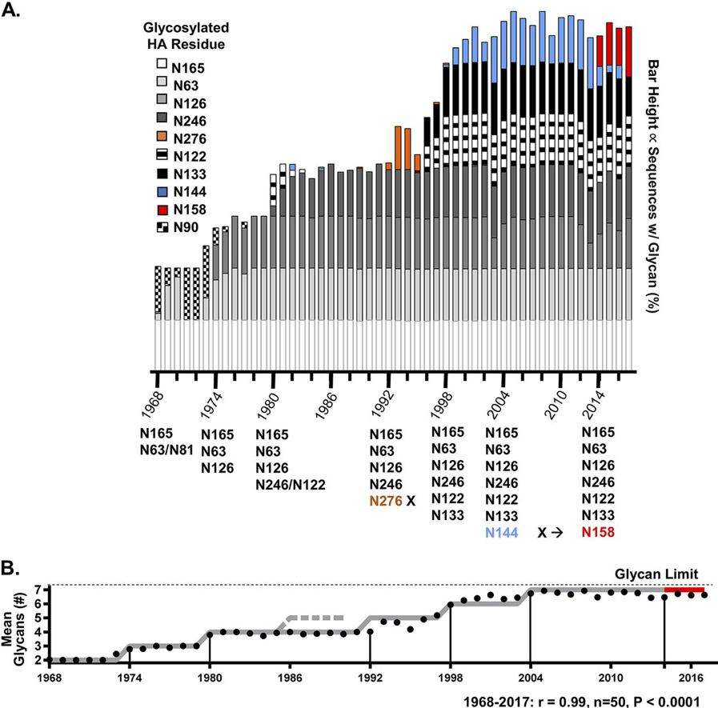

**Figure 3. H3 glycan evolution, 1968 to 2017.** (A) Stacked bars correspond to the percentages of all human H3N2 sequences from a given year containing a glycan listed in the legend. Dates of glycan transition are indicated on the timeline at the bottom along with the glycosylated residues. Sequence counts for each year are shown in Figure S4B. Mean predicted numbers of glycans among all sequences from each year are shown as black circles, which are displayed atop the idealized pattern (gray line; the red line indicates glycan transition from sequences containing N144 to sequences containing N158). The dashed gray line indicates when N276 would have been added if it had followed the pattern. Black vertical lines denote 11-year intervals after glycan limit was reached or 6-year intervals during glycan addition. Data representing Pearson’s coefficient of correlation (r) with sample number (n) and P value from two-tailed Student’s t test comparing the pattern versus the sequence data are shown at the bottom.

* [Murillo 2013](https://doi.org/10.1016/j.jtbi.2013.03.024) (Journal of Theoretical Biology): Towards multiscale modeling of influenza infection
  + Review article analyzing different aspects of influenza
  + “Sialic acid is the primary receptor for influenza viruses. The HA of human- adapted strains preferentially binds α-2,6-linked sialic acids, while avian strains preferentially bind α-2,3-linked sialic acids“
  + “The IAV HA protein is significantly glycosylated, with the degree of glycosylation varying across strains, and these glycans affect HA binding to sialic acid”
  + “In addition to binding carbohydrates, IAV HA also binds to lectins on cells of the immune system. IAV is known to bind to the macrophage mannose receptor (MMR) via sialic acid dependent and independent mechanisms, and binds to the macrophage galactose-type lectin (MGL) via a sialic acid independent mechanism. A human highly pathogenic H5N1 isolate and a human H3N2 strain have been shown to bind dendritic cell-specific intercellular adhesion molecule-3-grabbing non-integrin (DC-SIGN), which is present on dendritic cells only, and H3N2 binds liver/lymph node-specific intracellular adhesion molecules-3 grabbing non-integrin (L-SIGN), which is found in the lung in a subset of alveolar epithelial cells and endothelial cells. More glycosylated strains appear to be more efficient at infecting macrophages in vitro than less glycosylated ones. Finally, it should be noted that influenza viruses bind to sialic acids in mucus”
  + This suggests that drugs (or antibodies) inhibiting NA activity may function by keeping viruses attached to mucus which then sweeps them out of the body. "Mucus does bind human adapted IAV strains as well, and this binding is abrogated by IAV NA activity; an NA inhibitor potently inhibits infection of ALI cultures through mucus, and suggests the importance of the IAV NA protein in initiating infection in vivo"
* [Medina 2013](https://doi.org/10.1126/scitranslmed.3005996) (Science Translational Medicine): Glycosylations in the Globular Head of the Hemagglutinin Protein Modulate the Virulence and Antigenic Properties of the H1N1 Influenza Viruses
  + Figure 2 shows how H1N1 glycosylation changes over time. Additional glycans incur a fitness cost in the absence of antibody pressure since they can impede the ability of the virus to bind to its host receptors

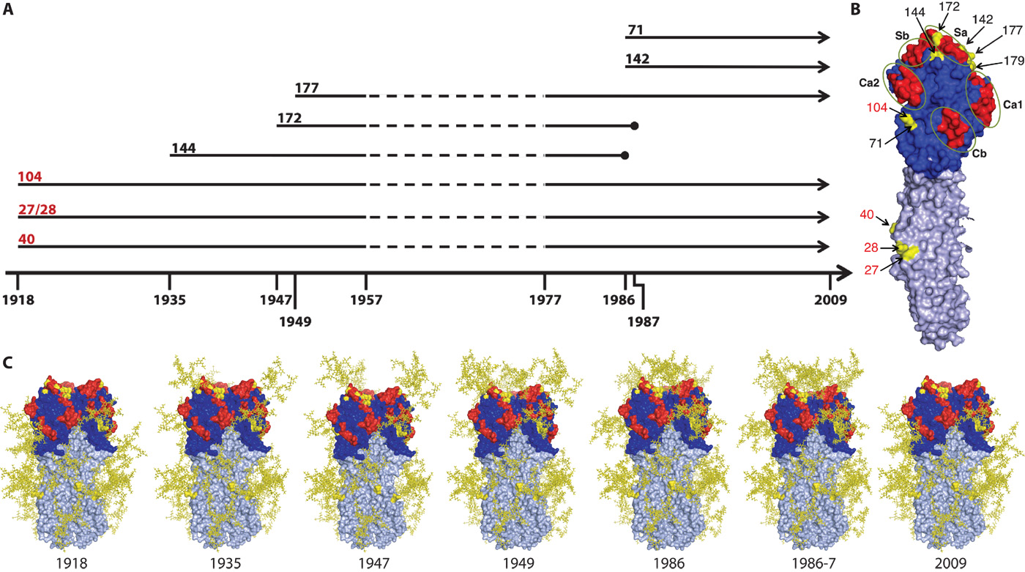

**Figure 2.** **Modeling of H1N1 glycosylations over time.** (A) Timeline illustrating the year of acquisition of glycosylations in the globular head of the HA protein. Numbers in red indicate the amino acid position of the glycosylation sites that are conserved among human H1N1 isolates since their emergence in 1918, and numbers in black indicate the amino acid position of the glycosylation sites that appeared in the specific years shown at the bottom. Arrows denote the persistence of glycosylation sites through time, and circles represent their disappearance. Discontinuous lines indicate the period from 1957 to 1977 when H1N1 viruses did not circulate in humans. (B) Surface representation of an HA monomer with the antigenic sites highlighted in red and the glycosylation sites in yellow. The stem region of HA is denoted in silver. Amino acid positions refer to the H1 nomenclature (sites 71, 142, 144, 172, and 177 correspond to H3 numbering 58, 128, 130, 158, and 163, respectively). Numbers in red indicate conserved glycosylation sites. (C) Structural modeling of the trimeric HA with glycosylations as they appeared over time from 1918 to the emergence of the 2009 pH1N1 virus. The glycan structures for the sites shown in yellow have been modeled onto the Cal/09 HA (Protein Data Bank ID: 3LZG) and are also depicted in yellow. All models were made with MacPyMol.

* [Das 2011](https://doi.org/10.1073/pnas.1108754108) (PNAS): Fitness costs limit influenza A virus hemagglutinin glycosylation as an immune evasion strategy
  + The addition of mutations that create potential N-linked glycans (PNGs) reduce the ability of a virus to bind to human and turkey RBCs treated with increasing amounts of RDE (Figure 3). These glycans reduce the inhibiting effect of polyclonal mouse sera from vaccinated animals in an HAI assay

# Quantification: Experimental Assays

Precisely quantifying the number of virions, as well as the number, binding affinity, and neutralization potential of antibodies underlies every facet of virology. This section examines many of the common assays used to measure these quantities with a focus on the key tools that enable us to fully utilize this quantification.

|  |  |  |
| --- | --- | --- |
| **Assay** | **Measures** | **Absolute Units** |
| Hemagglutination Assay (HA) | Concentration of virus that agglutinates red blood cells | Molar, ng/mL (1 mg/mL virus = 5.9 nM) |
| 50% Tissue culture Infective Dose (TCID50/mL) | Concentration of virus that kills 50% tissue culture cells | Molar, ng/mL (1 mg/mL virus = 5.9 nM) |
| Plaque Forming Unit (PFU/IFU/IVP) | Number of infectious virus particles | Number of particles  (*Dimensionless*) |
| Hemagglutination Inhibition Assay (HI or HAI) | Concentration of antibodies that prevent viral agglutination | Molar, μg/mL (1 μg/mL IgG = 6.6 nM) |
| Neutralization | Concentration of antibodies that neutralizes virus | Molar, μg/mL (1 μg/mL IgG = 6.6 nM) |

Converting an IgG antibody concentration from μg/mL into Molar (using the molar mass 150 kDa for an IgG)



Similar conversions follow for a Fab (1 *μ*g/mL = 20 nM, using the molecular weight 50 kDa) and the heavier influenza virion (1 *μ*g/mL = 5.9·10-3 nM, using the molecular weight 170·103 kDa [[Ruigrok 1984](https://doi.org/10.1099/0022-1317-65-4-799)])

## Total Virus: Hemagglutination Assay (HA)

A hemagglutination assay measures the ability of a virus to agglutinate an amount of red blood cells (RBCs), so that rather than pelleting at the bottom of a test tube the red blood cells are cross-linked by virus and hence more diffuse. As shown in the [image below](https://bioprocessintl.com/wp-content/uploads/2018/09/16-9-Sheppard-F7.jpg), a virus is diluted until it can no longer agglutinate red blood cells, and its concentration in HA units (HAU) is given by the inverse of the maximum dilution that exhibits agglutination.

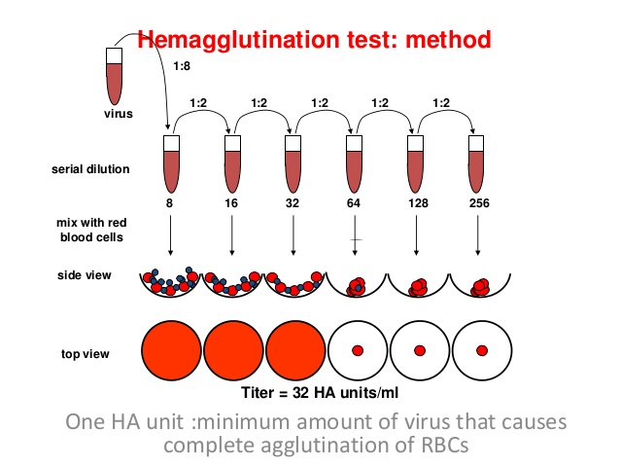

**Notes:**

* *Defining 1 HAU*: 1 hemagglutination unit (HAU) is defined as the maximal viral dilution that can prevent the agglutination of some amount of red blood cells.
  + 2 HAU represents a mixture where there are twice as many virions (compared to red blood cells) as required to prevent agglutination
  + Although the current convention is to measure HAU in 50μL wells, the amount and type of red blood should be stated to enable a conversion from HAU to an absolute number of virions. For example, “Each well contained (25μL of viral dilution)+(25μL of 0.5% turkey red blood cells) which corresponds to 0.3·106 red blood cells per well”
  + The figure below demonstrates that 1 HAU depends on the amount of red blood cells [as shown experimentally in [Magill 1951](https://doi.org/10.1084/jem.94.1.31)], emphasizing the need to explicitly state the volume of red blood cells added. Doubling the volume and the number of red blood cells in a mixture decreases the HAU by a factor of 2. Subsequently doubling the amount of virus and red blood cells would keep the HAU constant. Since the 1st and 2nd mixtures have the same number of virions (but different HAU), and the 1st and 3rd mixtures have the same concentration of virus (but different HAU), this suggests that "1 HAU" cannot be determined solely from the amount of virus and is always defined relative to an amount of red blood cells

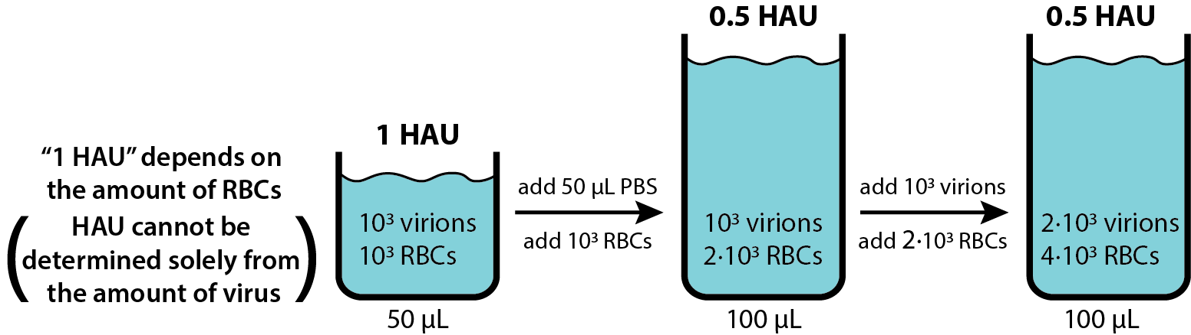

* *How to interpret HAU*: The HAU of a mixture represents the ratio of the concentration of virus to the concentration of red blood cells (or equivalently, the ratio of the number of virions to the number of red blood cells)
  + As has been verified experimentally (see the next section), at 1 HAU there is approximately 1 virion per red blood cell. This assumes that all virions are bound to red blood cells, forming a tree-like structure where each virion joins together two red blood cells. This result is independent of the total volume of a mixture
  + As shown in the figure below, If a mixture starts off at 1 HAU, adding any amount of PBS will keep it at 1 HAU (since there are still just enough virions to agglutinate all red blood cells). Subsequently removing 9/10 of the red blood cells would increase the HAU by 10-fold. This shows that the definition of "1 HAU" is the ratio of virus-to-RBC concentrations (or equivalently on the ratio of their absolute numbers)

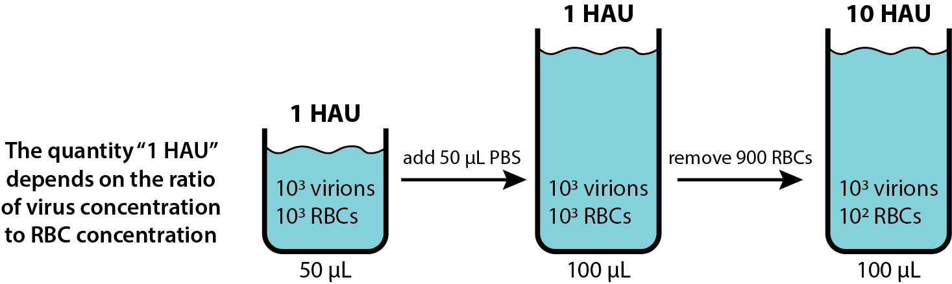

* + An excellent example of quantifying the total number of virions using the HA assay is presented in [Frensing 2016](https://doi.org/10.1007%252Fs00253-016-7542-4): “Total virus particle concentration (cvirus [virions/mL]) was determined, assuming that agglutination occurs up to a dilution in which the amount of virus particles equals the amount of erythrocytes. Thus, the calculation was based on HA titer and cell concentration of the erythrocyte suspension (2·107 cells/mL).”
* *The Ratio of Virions to Red Blood Cells at 1 HAU*: The experimental result that 1 HAU contains an equal number of virions and red blood cells is quite surprising for several reasons. Indeed, simple statistical mechanics arguments would suggest that there must be more virions than red blood cells, yet the experimental results suggest that this correction factor is very small (e.g. the ratio of virions to red blood cells is far closer to 1 than 2). Nevertheless, it is informative to consider the mechanisms that must nudge this factor above 1. To orient this discussion, consider the picture below that depicts two red blood cells and a virus to scale (a virion has a 125 nm diameter while a red blood cell has a 10 µm diameter)

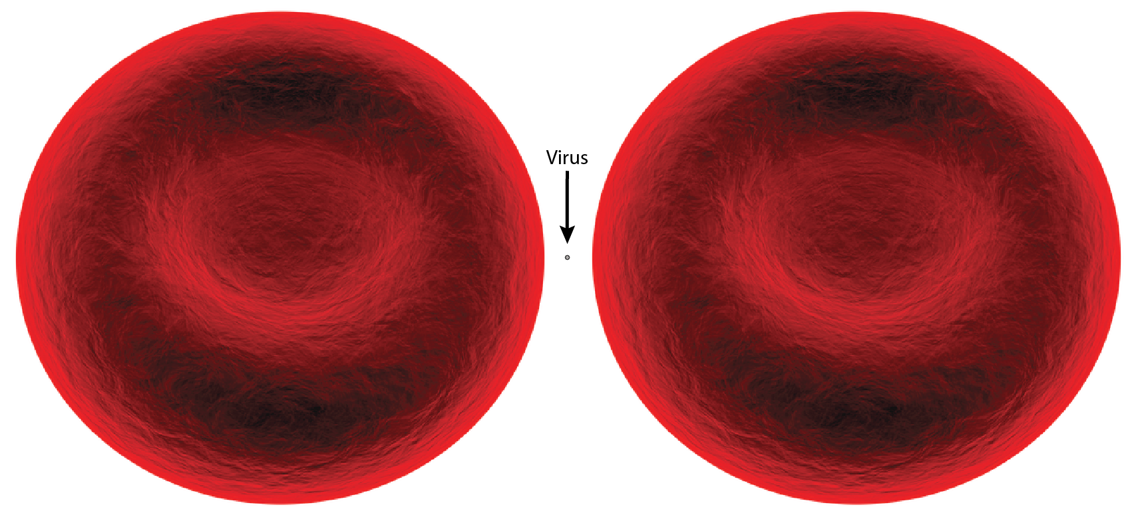

* + Geometry of Binding: Assume that the two red blood cells depicted above are joined together by the virus in a 1 HAU mixture. Suppose another virus binds at a random point on this structure. In order for a third red blood cell to bind to this new virus (to maintain the 1:1 ratio of virions to red blood cells), the second virion cannot bind too closely to the first virion, since this would sterically occlude the new red blood cell from binding to it. Therefore, there will always be some small region of the structure where a bound virus cannot bind to a new red blood cell, increasing the ratio of virions to red blood cells above 1.
    - Note that a different building process could alleviate the need for this correction factor. For example, rather than assuming that a free virion will first bind to the structure and then a free red blood cell will try to bind this virion, we could instead assume that a free virion and free red blood cell first bind together and then bind to the structure (so that the virion can never access the forbidden regions)
  + Avidity of Binding: As shown in the figure above, a virus is 100-fold smaller than a red blood cell. While a virus may bind to multiple sialic acids on a red blood cell, a mutant strain with reduced avidity may bind more weakly. As shown in the figure below, if more than one virion is required to connect two red blood cells, then there would be more than one virion per red blood cell at 1 HAU. For clarity, each virion is drawn 3x larger than its actual scale. The top panel shows a viral strain (dark gray circles) that binds tighter than strain in the bottom panel (light gray circles)

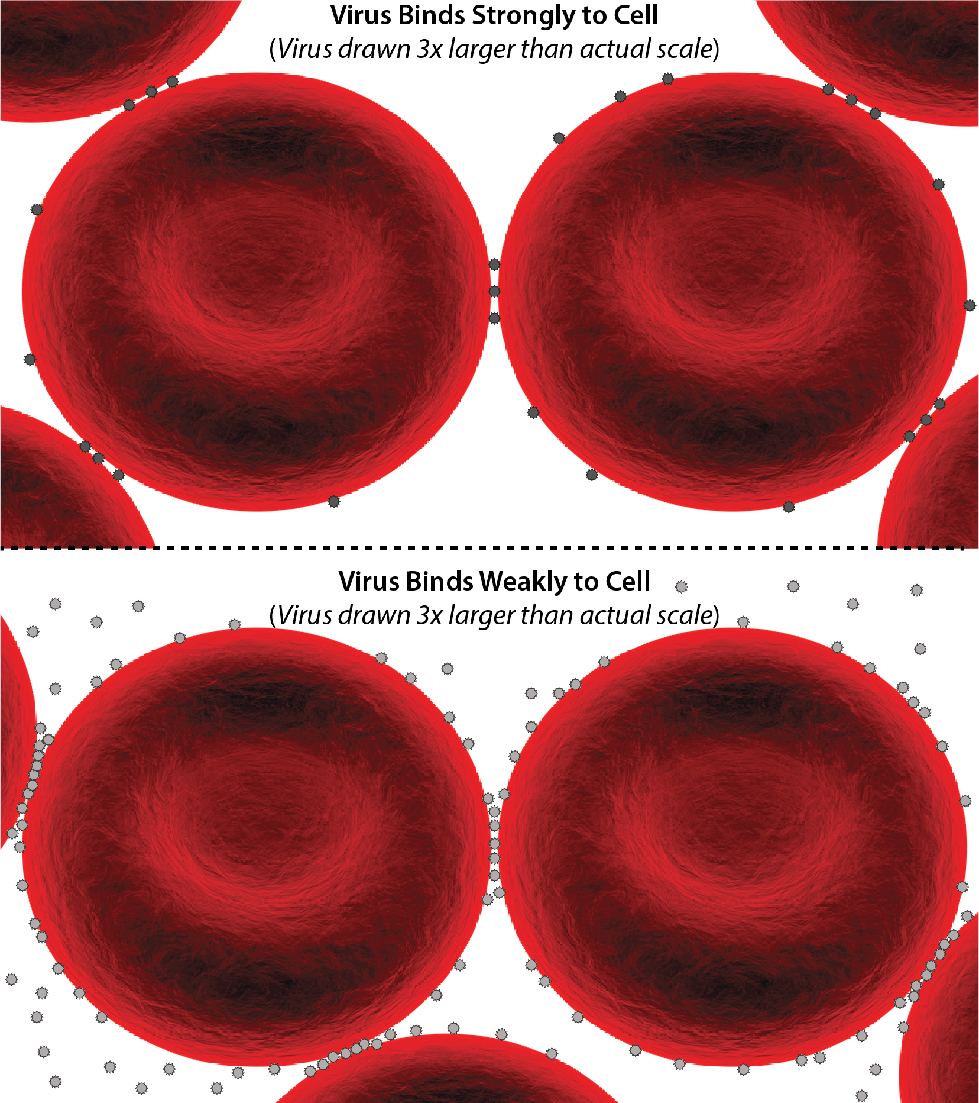

### Number of Virions in 1 HAU

In spite of the various objections noted above, experimental measurements have consistently shown that at 1 HAU, there is very nearly 1 virion per red blood cell. This result is consistent across different viral strains and supports the notion that one virion is able to agglutinate two red blood cells.

|  |  |
| --- | --- |
| **Virions per Red Blood Cell at 1 HAU** | **Source** |
| 1.22±0.13  (PR8) | [Bousse 2013](https://doi.org/10.1016/j.jviromet.2013.07.026) |
| 0.43±0.04  (WS) | [Tyrrell 1957](https://doi.org/10.1099/00221287-16-3-668) |
| 1.1  (NWS) | [Tyrrell 1957](https://doi.org/10.1099/00221287-16-3-668) |
| 0.56  (KUNZ) | [Tyrrell 1957](https://doi.org/10.1099/00221287-16-3-668) |
| 1.8  (N.KUNZ) | [Tyrrell 1957](https://doi.org/10.1099/00221287-16-3-668) |
| 0.57±0.13  (MEL) | [Tyrrell 1957](https://doi.org/10.1099/00221287-16-3-668) |
| 1.4±0.4 (PR8) | [Donald 1954](https://doi.org/10.1099/00221287-10-3-457) |
| 1.06±0.34  (MEL) | [Donald 1954](https://doi.org/10.1099/00221287-10-3-457) |
| 0.9±0.5  (A/England/1/51) | [Donald 1954](https://doi.org/10.1099/00221287-10-3-457) |
| 1.31±0.27  (B Lee) | [Donald 1954](https://doi.org/10.1099/00221287-10-3-457) |
| 1.21±0.26  (Incomplete PR8) | [Donald 1954](https://doi.org/10.1099/00221287-10-3-457) |
| **1.06±0.07** | **Average Value** |

**Sources:**

* [Bousse 2013](https://doi.org/10.1016/j.jviromet.2013.07.026) (Journal of Virological Methods): Quantitation of influenza virus using field flow fractionation and multi-angle light scattering for quantifying influenza A particles
  + Analyzed the laboratory-derived H1N1 strain A/Puerto Rico/8/1934 (PR8)
  + Table 2 (shown below) measures the number of viruses using FFF-MALS (asymmetric field flow fractionation). They assay combines (50μL of virus)+(50μL of 0.5% turkey RBC)
  + They found that (0.67±0.06)·106 virions/HAU
    - Since 50μL of 0.5% turkey RBC has approximately (0.55±0.03)·106 RBCs, there would be **1.22±0.13 virions per red blood cell at 1 HAU**
    - Table 4 of this same paper compares different methods (EID50, PFU, qRT-PCR, and FFF-MALS) of counting virus particles, and they found that qRT-PCR (which measure the number of genes for the matrix protein) estimated 10x more virions than FFF-MALS, although it is difficult to know which method is more accurate
    - Comparing the EID50 and PFU against the FFF-MALS measurements show that 10% of the virions are infective

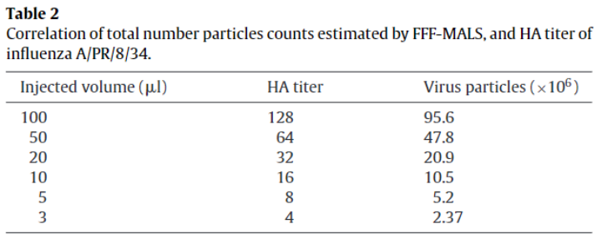

* [Tyrrell 1957](https://doi.org/10.1099/00221287-16-3-668) (Journal of General Microbiology): The Assay of Influenza Virus Particles by Haemagglutination and Electron Microscopy
  + Analyzed the influenza strains WS and NWS (Francis & Moore, 1940); NWS (Stuart-Harris) was a strain passed in eggs and in chick embryo fibroblasts by Professor C. H. Stuart-Harris; MEL and N.MEL (a neurotropic recombinant of NWS and MEL described by Burnet & Edney, 1951); KUNZ was an egg- passaged line of influenza A isolated in Sheffield in 1948 and N-KUNZ was a neurotropic strain prepared with NWS and KUNZ (Appleby 1952)
  + "An experiment was therefore carried out to determine the number of particles at the haemagglutination end-point for 5 different strains by counting the virus particles directly with the electron microscope by two techniques, the red-cell absorption method (Dawson & Elford, 1949; Donald & Isaacs, 1954) and the spray-drop method (Williams & Backus, 1949)."
  + *Note of caution*: The virion counts determined by the "absolute hemagglutination assay" used in [Levine 1953](https://doi.org/10.1084/jem.98.6.521) and [Horsfall 1954](https://doi.org/10.1084/jem.100.2.135) was found to be 10-fold too low
  + As shown in Table 2, "the ratio particles to haemagglutination units range from 1.1·107 to 4.5·107 for the electron microscope counts on the various strains and, since the count of the red-cell suspension used was 2.5·107, the ratio of virus particles to red cells at the partial agglutination end-point was about 1, as previously found with other influenza A strains (Donald & Isaacs, 1954)."
    - For each virus strain in Table 2, we averaged the red-cell and spray methods to determine the average±standard deviation of the number of virions per HA unit. This is identical to the value in their right-most column, but also contains error. The results were (1.10±0.10)·107 for WS, 2.75·107 for NWS, 1.4·107 for KUNZ, 4.5·107 for N.KUNZ, and (1.43±0.32)·107 for MEL
    - We then divided the number of virions in 1 HAU by the number of RBCs (2.5·107) to determine the number of virions per RBC at 1 HAU. The resulting values were 0.43±0.04 for WS, 1.1 for NWS, 0.56 for KUNZ, 1.8 for N.KUNZ, and 0.57±0.13 for MEL
    - The average ratio of virus to red blood cells across these five strains was 0.9±0.03 virions per red blood cell at 1 HAU

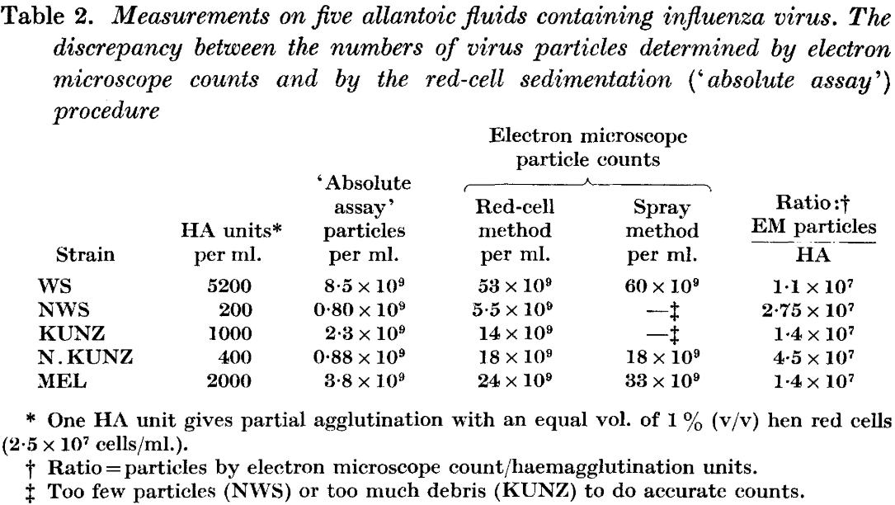

* [Donald 1954](https://doi.org/10.1099/00221287-10-3-457) (Journal of General Microbiology): Counts of Influenza Virus Particles
  + Analyzed the strains PR8 (1934), Melbourne (MEL) (1935), A/England/1/51 strains, and Influenza B-Lee (1940). Also analyzed an ‘incomplete’ PR8 obtained by making three passages of undiluted allantoic fluid at 24 hour intervals (von Magnus, 1951)
  + “Table 2 shows the ratio of the [log10] number of virus particles counted by the spray technique to the number of agglutinating doses/mL of suspensions of four strains of influenza virus. The ratios of virions per agglutinating dose were surprisingly constant and, with two exceptions, varied between 107.1 and 107.3, with an overall mean of 107.21. There was as great a variation between different measurements of a single strain as between different strains of virus. Counts of the number of red cells in 0.25 ml. of a 1% suspension of red cells gave figures of 107.1 to 107.2; hence we conclude that at the agglutination end-point there was about one virus particle/red cell, with the strains we used.”
    - For each virus strain in Table 2, divide 10Table 2 value by the average number of RBCs (107.15±0.05) to determine the number of virions per RBC at 1 HAU. The resulting values were 1.4±0.4 for PR8, 1.06±0.34 for MEL, 0.9±0.5 for A/England/1/51, 1.31±0.27 for Lee, and 1.21±0.26 for Incomplete PR8
    - The average ratio of virus to red blood cells across these five strains was 1.2±0.4 virions per red blood cell at 1 HAU

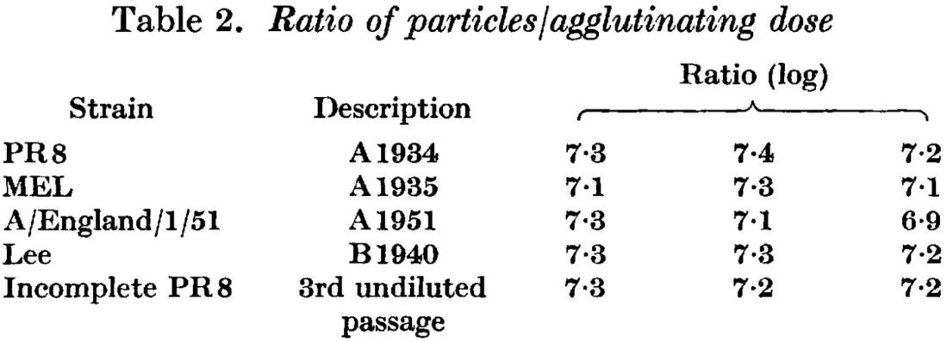

### 

### Number of Red Blood Cells in Turkey (*Meleagris gallopavo*)

Turkey erythrocytes (red blood cells) are commonly used in HA assays. The table below collates the density of these red blood cells to give a sense of the average value and variability of this quantity. Rather than giving the details on each individual source, we state precisely where the information was acquired from within the *Source* column.

|  |  |
| --- | --- |
| **Turkey Erythrocytes**  **(106/μL)** | **Source** |
| 2.13±0.19 | [Saganuwan 2019](https://doi.org/10.5772/intechopen.85865)  (Average of Table 1 Range) |
| 2.83±0.13 | [Ali 2019](http://doi.org/10.5455/ijlr.20180507051502) (Table 1) |
| 2.50±0.44 | [Daniel-Igwe 2017](https://doi.org/10.1515/fv-2017-0002) (Table 1) |
| 2.6±0.5 | [Lazar 2015](http://doi.org/10.1590/1678-4162-7111)  (Average of Table 1 Values) |
| 3.30±0.08 | [Hrabcakova 2014](http://doi.org/10.1155/2014/364602)  (Average of Table 1 Values) |
| 1.07±0.11 | [Schmidt 2014](https://doi.org/10.4102/jsava.v85i1.1006)  (Average of Table 2 Values) |
| 2.10±0.37 | [Strakova 2010](https://doi.org/10.2754/avb201079S9S003) (Table 1) |
| 1.11±0.12 | [Schmidt 2009](http://doi.org/10.3923/ijps.2009.752.754)  (Average of Table 1 Values) |
| **2.20±0.10** | **Average Value** |

*Note*: The above values describe the number of erythrocytes (red blood cells) in 100% turkey blood. The HA assay typically adds virus to (50μL of 0.5% turkey red blood cells), which using the above average value should contain (2.20±0.10)·106·(50μL)·(0.5/100)=(0.55±0.03)·106 red blood cells.

### 

### Number of Red Blood Cells in Chicken (*Gallus gallus domesticus*)

Chicken erythrocytes (red blood cells) are sometimes used in HA assays, although this practice was more common in the past. The table below collates the density of these red blood cells.

|  |  |
| --- | --- |
| **Chicken Erythrocytes**  **(106/μL)** | **Source** |
| 2.47±0.08 | [Dutta 2013](https://doi.org/10.3329/bjz.v41i2.23314)  (Average of Table 1 values) |
| 1.84±0.13 | [Lashari 2018](http://doi.org/10.17582/journal.sja/2018/34.4.973.978)  (Table 3, Negative Chicken) |
| 2.5 | [Tyrrell 1957](https://doi.org/10.1099/00221287-16-3-668) (Caption of Table 2) |
| 5.7±0.9 | [Donald 1954](https://doi.org/10.1099/00221287-10-3-457) (Page 461) |
| 6.4 | [Salk 1944](https://www.jimmunol.org/content/49/2/87) (Page 88) |
| **3.65±0.19** | **Average Value** |

## Infectious Virus

### Infectious Unit (IFU)/Plaque Forming Unit (PFU)/Infectious Virus Particles (IVP)

Many influenza virions produced are not be infectious (e.g. they may have large gene deletions, mutations that perturb the function of the viral polymerase PB1, a membrane containing only HA and no NA, etc.) but may nevertheless still bind to sialic acid and agglutinate red blood cells. Consequently, it is often important to quantify the number of infectious virions.

One common assay that measures the number of infectious virus particles is the plaque assay. A monolayer of cells are inoculated with different dilutions of virus and overlain with a solid medium, which only allows radial cell-to-cell spread of viral progeny. One plaque represents the progeny of one infectious virus particle, permitting you to compute the total number of infectious virions in the undiluted virus stock.

**Notes:**

* The concentration of infectious virus is reported as a concentration, conventionally stated as per milliliter (e.g. 106 IFU/mL)
* Occasionally the IFU (rather than IFU/mL) is reported, representing the number of infectious virions in some volume of a viral preparation. For better reproducibility, the volume used should also be reported so that the concentration of infectious virus (IFU/mL) can be inferred
* The terms infectious unit (IFU), plaque forming unit (PFU), and infectious virus particle (IVP) are interchangable.

## 

### 50% Tissue culture Infective Dose (TCID50)

Another method to quantify the number of infectious virus particles is the 50% tissue culture infective dose assay, which represents the amount of virus necessary to cause cytopathic effects in 50% of tissue culture replicates. Using this assay, the concentration of infectious virus can be quantified in terms of TCID50/mL, where 1 mL of a (1 TCID50/mL mixture) will have no infectious virions 50% of the time and at least one infectious virion 50% of the time.

**Notes:**

* The theoretical relationship between Infectious Units (IFU) and TCID50/mL is obtained by considering some volume of a viral mixture, say 1 mL of a (1 TCID50/mL mixture), which contains λ virions on average. By definition, there is a 50% probability that this 1 mL has no infectious virions, and hence using the Poisson distribution for the probability that this mixture will have no infectious virions we obtain ½=P(0;λ)=λ0·e-λ/0!=e-λ. Therefore, there should be λ=Log[2]≈0.7 infectious virions per mL in a 1 TCID50/mL mixture. Since λ represents the number of IFU in the mixture, we obtain the following results:
  + 1 TCID50/mL ≈ 0.7 IFU/mL
  + 10 TCID50/mL contains fewer infectious virions than 10 IFU/mL
  + This theoretical relationship does not necessarily conform to experimental data. For example, the plot below compares separate IFU/mL and TCID50/mL data from Figure 6 of [Holly 2017](https://doi.org/10.1016/j.jviromet.2017.06.004), showing that the predicted relationship (dashed black line) does not match the data (blue points)

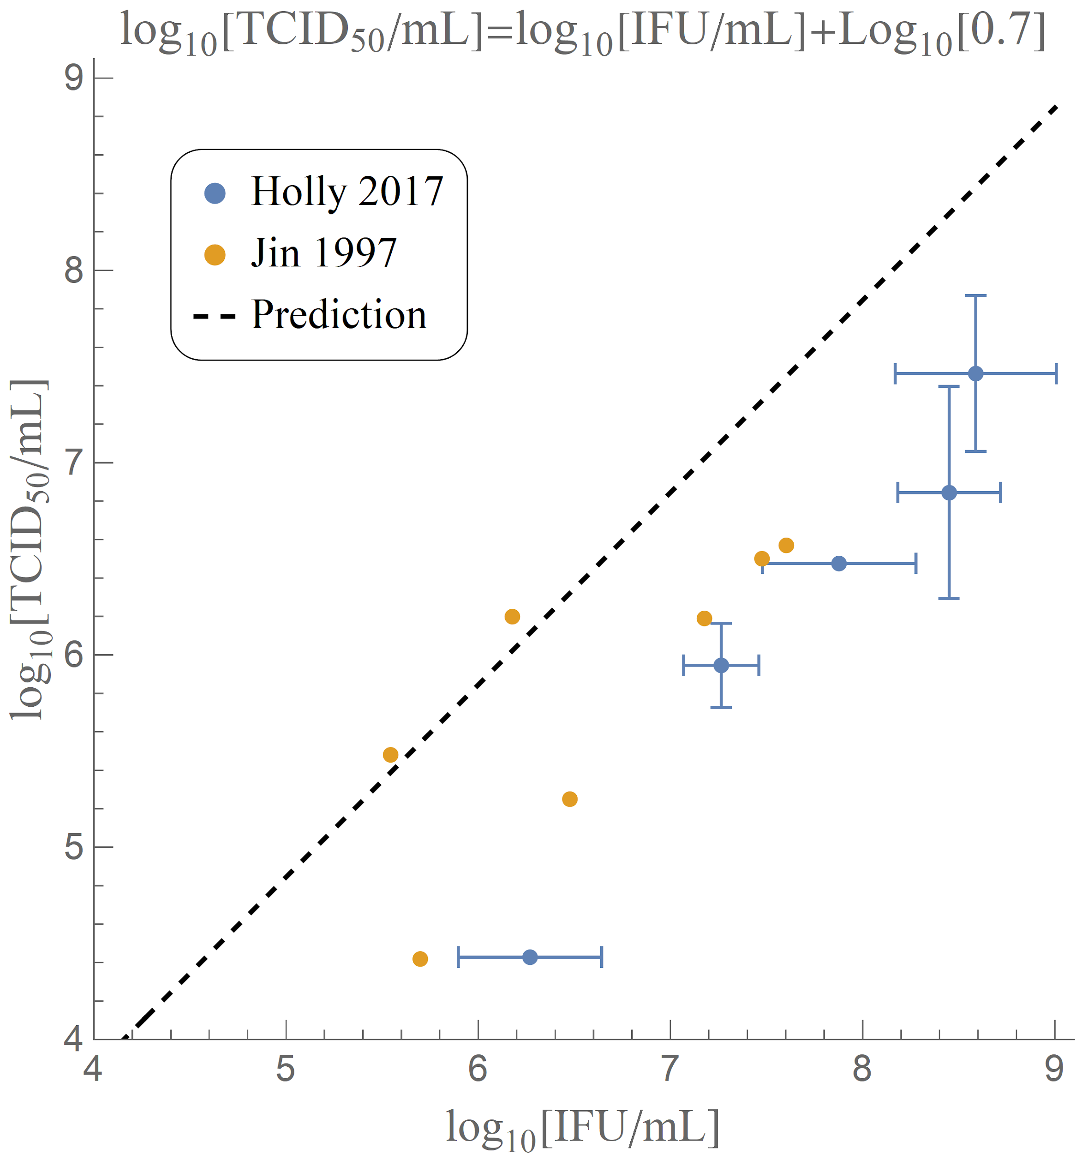

**Adapted from Figure 6 of** [**Holly 2017**](https://doi.org/10.1016/j.jviromet.2017.06.004) **and Tables II and III of** [**Jin 1997**](https://doi.org/10.1093/emboj/16.6.1236)**.** The theoretical relationship between TCID50 and IFU is represented by the dashed black line.

* Note that the above definition for TCID50/mL is a statement about the amount of infectious virions in a viral preparation. On the other hand, TCID50/mL is sometimes confusingly defined as the amount of virus required to kill 50% of infected target cells, which depends both on the amount of infectious virions as well as the amount of target cells used and the specific conditions of the assay. Thus, this latter definition should be avoided
* Occasionally the TCID50 (rather than TCID50/mL) is reported, representing the number of infectious virions in some volume of a viral preparation. For better reproducibility, the volume used should also be reported so that the concentration of infectious virus (TCID50/mL) can be inferred

## Antibody Potency

### Hemagglutination Inhibition (HI or HAI) Assay

The hemagglutination inhibition assay mixes together a fixed amount of virus and red blood with a variable amount of antibody and measures whether the virus is able to agglutinate the red blood cells. The endpoint of the assay is the minimal antibody concentration that inhibits agglutination.

**Notes:**

* There can be many sources of confusion when reading the Methods of an HAI assay [discussed in the following sub-bullet-points], all of which can be alleviated by stating the concentrations (or absolute counts) of the virus, antibody, and red blood cells in the *final* mixture. A precise description might read as follows: “Each HAI mixture contained (100μL of 0.5% turkey red blood cells) + (50μL of virus solution) + (50μL of diluted serum [diluted relative to a 10μg/mL stock]). For example, the 1:20 antibody dilution refers to a well containing the final concentrations of 0.5μg/mL=3.3nM antibodies, 5.5·103 cells/μL=9.1·10-6nM turkey red blood cells, and 10 HAU of virus. In terms of absolute counts, this corresponds to 4·1011 antibodies, 1.1·106 red blood cells, and 1.1·107 virions [assuming a 1:1 ratio of virions to red blood cells at 1 HAU] in the 200μL mixture.”
  + A common problem in current Methods is that a mixture containing (50μL of virus at 4 HAU) + (50μL of red blood cells) may imply that the final 100μL mixture may have 4 HAU of virus, while other groups may interpret this protocol as having 2 HAU in the final mixture (since the 4 HAU of virus was diluted 2-fold). As mentioned above, this problem is solved by unambiguously stating the HAU of the *final* mixture
  + Another issue is that the antibody dilution is often reported before adding the virus solution. For example, combining (5μL of antibody in 45μL diluent containing red blood cells) + (50μL virus solution) may be described as a 1:10 dilution of the serum (instead of the 1:20 dilution of serum in the final mixture). Because the full details of the procedure are often excluded for expediency, such errors are difficult to detect. As such, writing out the details of the final mixture should greatly abet in scientific reproducibility
* Some neutralizing antibodies exhibit no HAI, suggesting that they either bind away from the receptor binding domain on HA or that they bind to another viral protein. An example of these types of antibodies is seen in [Henry 2019](https://doi.org/10.1016/j.chom.2019.01.002) Figure 3B with the antibodies that are HAI- (indicating no ability to inhibit hemagglutination) but MN+ (signifying that they measureable microneutralization capacity)

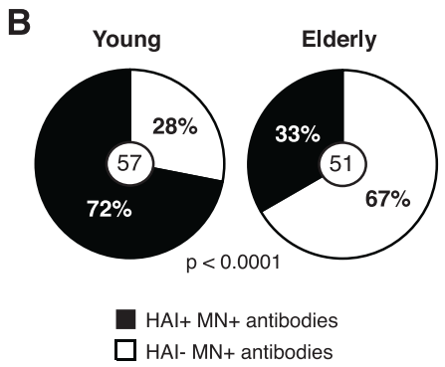

**Figure 3. Most Influenza Virus-Reactive Antibodies from Elderly Individuals Are Low Potency and Target Conserved Epitopes on HA and on Other Viral Proteins.** (B) HAI and in vitro neutralization by plaque reduction neutralization assay (n = 102 mAbs in each group). Statistical significance: Fisher’s exact test. The assays were performed two to three times for each antibody. The number in the middle of the pie charts represents the total number of mAbs tested.

* Large HAI titers have been used as a correlate for protection against influenza infection [[Hobson 1972](https://doi.org/10.1017/S0022172400022610)], although other work has argued against the sole reliance on HAI [[Gould 2017](https://doi.org/10.3389/fmicb.2017.00900), [Ranjeva 2019](https://doi.org/10.1038/s41467-019-09652-6)]. In [Memoli 2015](https://doi.org/10.1093/cid/ciu924) human volunteers were administered wild-type A (H1N1)pdm09 virus intranasally. Figure 3 shows that having larger hemagglutinin inhibition (HAI) or neuraminidase inhibition (NAI) before the virus challenge led to fewer symptoms and less severity of disease. The symptom score equals the number of symptoms exhibited by the patient multiplied by the overall duration of those symptoms

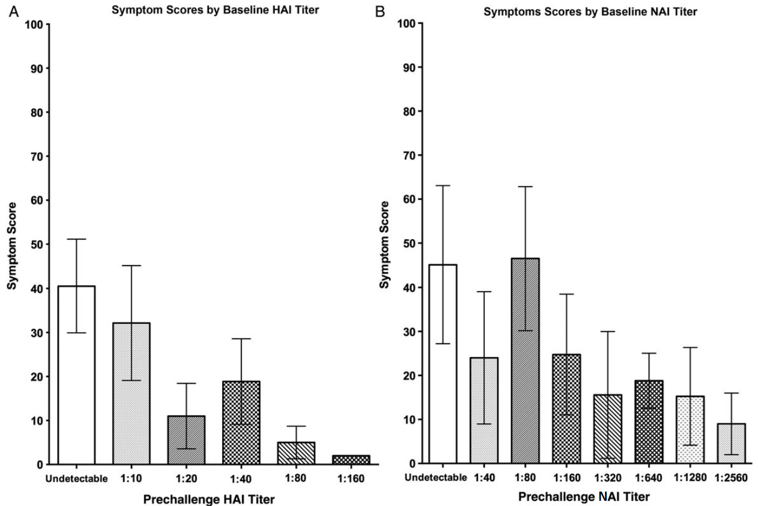

**Figure 3. Clinical score observed by baseline hemagglutination inhibition (HAI) and neuraminidase inhibition (NAI) titers (A and B, respectively).** Mean clinical score (number of symptoms multiplied by overall duration of symptoms in days) of all participants (regardless of presence or absence of viral shedding) at different baseline HAI and NAI titers is shown (± standard error of the mean [SEM]). Overall, there was a trend, for both HAI and NAI independently, that those with a higher baseline titer had a shorter duration and smaller number of clinical symptoms.

* HAI is a measure of how much antibody is needed to prevent virus from agglutinating red blood cells. Thus, the amount of antibody required will depend on the amount of virus used. In [Salk 1944](https://www.jimmunol.org/content/49/2/87), they showed that “serum-inhibition titers vary when different quantities of virus are used in a system in which the concentration of cells is kept constant. The serum-inhibition endpoints were in simple inverse proportion to the amount of virus used. The present experiments (Table 1) have revealed that a simple inverse proportion exists between the highest dilution of a virus-preparation causing complete agglutination and the quantity of cells used as indicator. In antibody-titrations, when the quantities of virus and cells are varied proportionately, the endpoint of inhibition is constant for any given serum.”
  + They carried out HAI assays using different concentrations of RBCs and 1 HAU of virus (defined relative to each RBC concentration, so that a mixture with ½ as much RBC should have ½ as much virus). They found that the same serum dilution endpoint each time

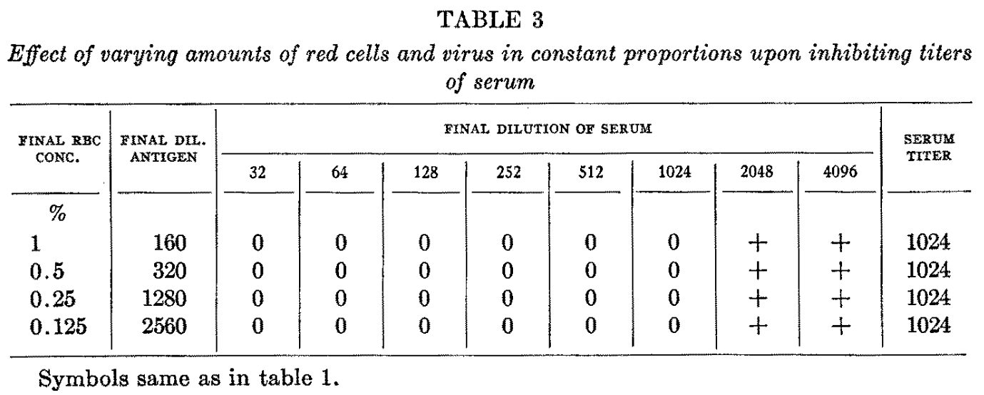

* What is the limit of detection for the HAI assay?
  + As stated above, the hemagglutination inhibition assay measures the minimum concentration of antibody needed to inhibit viral agglutination. Given that a virus is 100-times smaller than a red blood cell, each virion bridges at most two cells in an agglutinated mixture, and hence to suppress agglutination essentially all the viral hemagglutinin must be prevented from binding.
  + An example hemagglutination inhibition assay may combine (50μL of antibody)+(50μL of virus)+(50μL of 0.5% turkey red blood cells), so that the final mixture has 4 HAU of virus. Assuming that one antibody needs to bind per hemagglutinin trimer to inhibit agglutination, what is the minimum antibody concentration (*c*min) that is necessary to block all of the virus sites?
  + Since one antibody must bind to each of the 320 trimeric hemagglutinin, 320 antibodies are required per virion. 50μL of 0.5% turkey red blood cells contains 0.5·106 cells, and hence in a 4 HAU mixture there are 2·106 physical virions. Thus, the 50μL of antibody added must contain (320)·(2·106)=6·108 antibodies. Dividing by Avogadro’s number and this volume, this corresponds to *c*min=(6·108 antibodies)/(6.02·1023 · 50·10-6 L)=2·10-11 M (or 0.003μg/mL for an IgG). Antibodies that bind to hemagglutinin at concentrations below *c*min would incorrectly appear to have *c*min as their minimum effective concentrations in an HAI assay, because below this concentration there would be an insufficient amount of antibody to inhibit hemagglutination to an experimentally observable extent. Fortunately, most potent antibodies have minimum effective concentrations above 10-10 M, indicating that the values are within the limit of detection

#### Influenza Nomenclature

The [naming scheme](https://www.cdc.gov/flu/about/viruses/types.htm) for influenza viruses is shown below and consists of:

* The antigenic type (e.g., A, B, C, D)
* The host of origin (e.g., swine, equine, chicken, etc.). For human-origin viruses, no host of origin designation is given. Note the following examples:
  + (Duck example): avian influenza A(H1N1), A/duck/Alberta/35/76
  + (Human example): seasonal influenza A(H3N2), A/Perth/16/2019
* Geographical origin (e.g., Denver, Taiwan, etc.)
* Strain number (e.g., 7, 15, etc.)
* Year of collection (e.g., 57, 2009, etc.)
* For influenza A viruses, the hemagglutinin and neuraminidase antigen description are provided in parentheses (e.g., influenza A(H1N1) virus, influenza A(H5N1) virus)
* The 2009 pandemic virus was assigned a distinct name: A(H1N1)pdm09 to distinguish it from the seasonal influenza A(H1N1) viruses that circulated prior to the pandemic.
* When humans are infected with influenza viruses that normally circulate in swine (pigs), these viruses are call variant viruses and are designated with a letter ‘v’ (e.g., an A(H3N2)v virus).

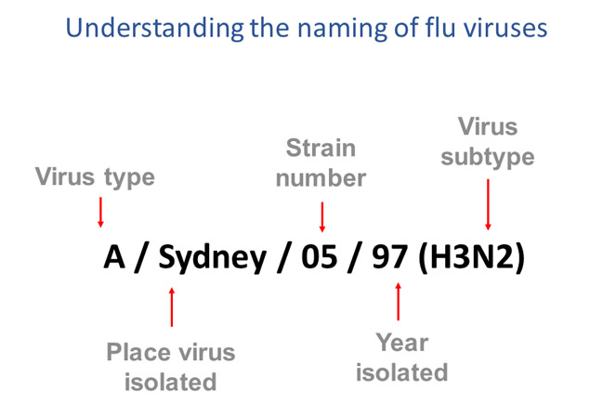

The nomenclature “A/Sydney/05/97-like” represents a virus strain that is antigenically similar to A/Sydney/05/97, with antigenic similarity determined by the HAI assay. In other words, if the antibody response against the A/Victoria/361/2011 strain will protect comparably well against another viral strain, then this latter strain is designated as A/Victoria/361/2011-like. According to the [CDC](https://www.cdc.gov/flu/about/professionals/antigenic.htm), "influenza viruses to be antigenically similar or 'like' each other if their HI titers differ by two dilutions or less. (This is equivalent to a two-well (i.e., a four-fold dilution) or less difference)."

### Neutralization Assay

Neutralization assays combine a virus with its target cells to assess the amount of cytopathic effects, thereby providing a way to visualize viral-induced cell death. Different concentrations of antibody are added to quantify their ability to inhibit cytopathic effects. Neutralization assays are the analog of an HA assay, except that antibodies (rather than virus) are being titrated.

### Mechanisms of Antibody Neutralization

Antibodies use various mechanisms to neutralize viruses including inhibiting fusion, preventing a post-entry step of viral replication, and blocking nascent virions from budding. Even within the specific class of antibodies that inhibit fusion by binding to viral hemagglutinin (HA), multiple mechanisms for neutralization are employed. Antibodies that bind to the top of HA and sterically occlude sialic acid binding may have a maximum neutralization efficiency imposed by their proximity to the receptor binding domain. In contrast, antibodies binding the HA stem are believed to neutralize virus by inhibiting a conformational change required to initiate fusion, and their inherent ability to neutralize may also depend on their specific binding location and orientation.

**Sources:**

* [Reading 2007](https://doi.org/10.1007/s00705-006-0923-8) (Archives of Virology): Neutralization of animal virus infectivity by antibody
  + Figure 1 shows different mechanisms of antibody neutralization, while Table 1 gives some examples and their rough prevalence reported in the literature

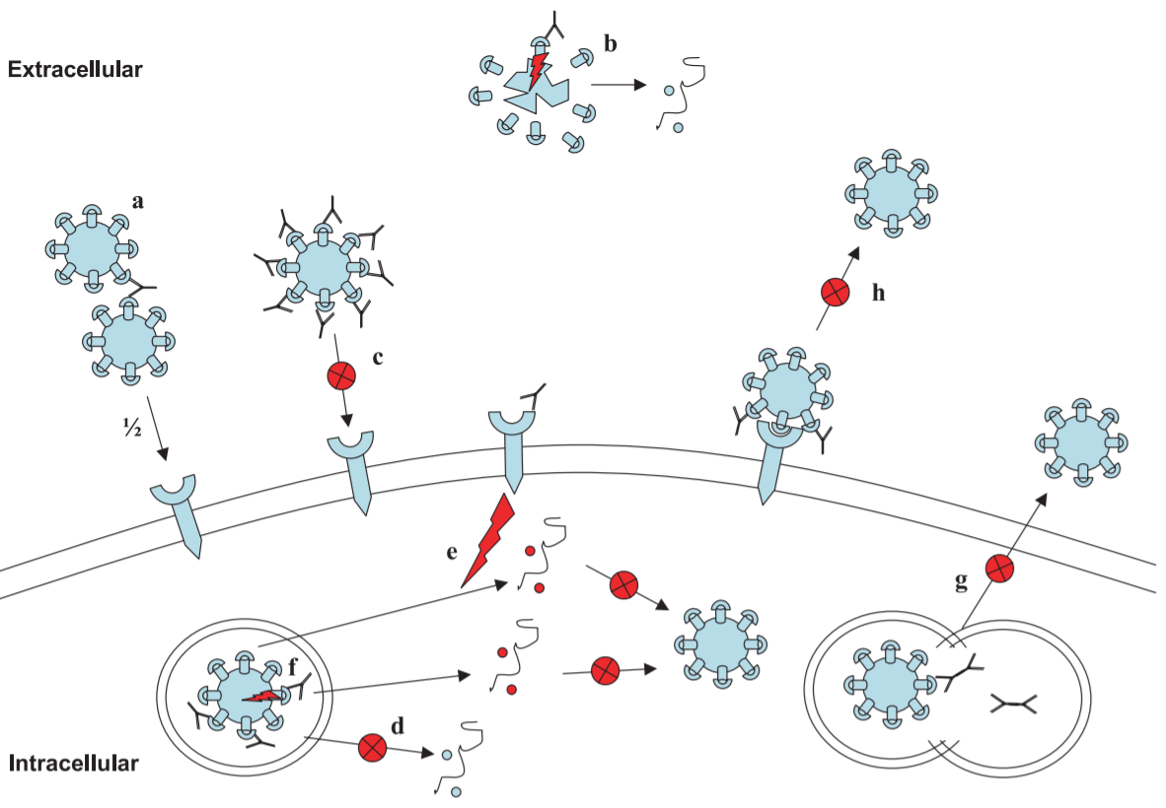

**Figure 1. An overview of the mechanisms through which antibodies neutralize virus infectivity.** Details of processes **a–h** can be found in the text. Virions are represented as spiked circles, cellular receptors as a blue semicircle mounted on an arrow, IgG as a Y, and blocked events as an arrow carrying an X mounted in a red circle. **a** Antibody aggregates virions and reduces the number of infectious centers. The fraction shown (1/2) represents the loss in infectivity. **b** Antibody that mimics cell receptor ligation binds virions and leads to the disruption of the virion capsid (red lightning) and premature release of the genome. **c** Antibody inhibits virion attachment by blocking receptor engagement. **d** Antibody inhibits fusion-entry occurring inside an endocytotic vesicle (illustrated) or at the cell membrane (not shown). **e** Antibody binds to a cell-surface protein and results in the transduction of a signal into the cell (red lightning) that aborts the infection by modification of the replication complex. **f** Post-entry neutralization by transmission of an allosteric signal via the virus surface protein to the virion core (shown as red lightning). The core is released into the cytoplasm but is defective and unable to replicate. As in Panel **e**, this process is poorly understood. **g** Transcytosing IgA antibodies (represented as a double-ended Y) neutralize virus when their respective vesicles fuse. **h** Antibody binds nascent virions and blocks their budding or release from the cell surface

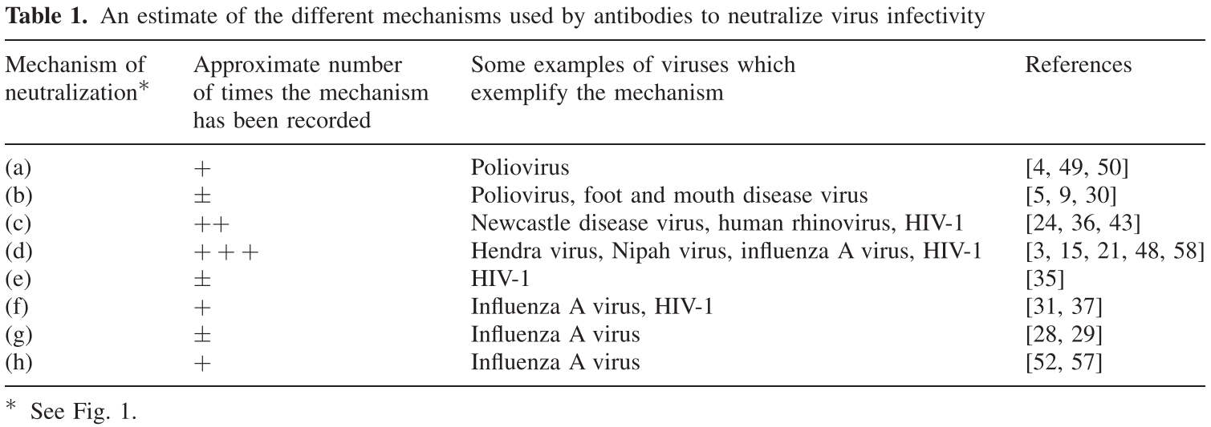

* "Aggregation reduces the number of virions able to initiate an independent infectious event, and reduces overall infectivity [4, 49, 50]. This reduction is directly proportional to the number of particles in the aggregate so that, for example, an aggregate of five virions results in a five-fold drop in infectivity (Fig. 1a). However individual virions within the aggregate are infectious and disaggregation can re- store infectivity"
* "About half of all antibodies tested are obligate bivalent binders, meaning that they are orientated so that both arms of the antibody (Fabs) bind to the same virion and no aggregation can take place. (However, when the antibody concentration is saturating, some Fab arms are forced to point into solution and are available for aggregation.) The other antibodies are obligate monovalent binders, and are orientated with one arm pointing into solution, and have the potential to cause aggregation [20]"
* "Aggregation would presumably contribute to protection from virus infection in vivo and, in addition, would facilitate clearance of virions from circulation as these larger particulates are more readily phagocytosed and degraded. Aggregation is demonstrable in vitro only within a relatively narrow range of antibody:virus ratios and produces a characteristic neutralization curve which peaks at the point of equivalence. As the antibody concentration increases, aggregation and neutralization decrease"
* "A prediction of occupancy theory is that different densities of the antibody-binding sites on the virion surface or changes in particle size impact on the numbers of antibody molecules required for a given level of neutralization. Hence larger virions or those possessing more available epitopes will require more bound antibodies in order to neutralize them. This simple idea has support from a study by Burton and co-workers that showed an almost linear relationship between virus particle size and amount of antibody required for neutralization [7, 34]."
* [Schofield 1997](https://doi.org/10.1099/0022-1317-78-10-2441) (Journal of General Virology): High and low efficiency neutralization epitopes on the haemagglutinin of type A influenza virus
  + Figure 1 (shown below) measures the number of infectious virions over time after a monoclonal antibody is mixed with influenza virus. Notably, the number of infectious virions does not plateau, even after 45 minutes, which has several important implications
    - **Experimental Ramification:** According to the HC2 antibody data, if a serological assay to measure infectious virions is carried out one day 30 minutes after antibody and virus are mixed together, and the next day it is carried out 40 minutes after mixing, there may be a 3x reduction in the number of infectious virions. (If an experiment in another lab starts an hour after mixing, the number of infectious virions may have decreased by over 10x.) This suggests that the time after antibody+virus mixing should be carefully tracked and reported
    - **Antibody-Virus Equilibrium:** When would we expect to see the exponential decay in Figure 1 saturate? When all of the antibodies bind to the virus in equilibrium, we would assume that the virus is maximally inhibited and the number of infectious virions should stabilize. Following [Foote 1995](https://doi.org/10.1073/pnas.92.5.1254), assuming typical antibody values of koff=10-3-10-4 s-1 and the kon=105-106 M-1s-1 (note that these values correctly reproduce the KD=koff/kon values in Table 1), we would expect the curves in Figure 1 to flatten out with a timescale of 𝜏=1/(koff+kon[Ab]) where [Ab] is the concentration of antibody (given as 0.21 μg/mL for HC2 and 0.11 μg/mL for HC3W, both of which are approximately 1 nM using the IgG conversation factor 1 μg/mL=6.6 nM). Substituting these numbers in yields a timescale of 𝜏≈10 minutes which is certainly not seen in the data. This suggests that although these antibodies have reached equilibrium, they continue to decrease the number of infectious virions
    - **Mechanism of Antibody-Virus Neutralization:** The above analysis suggests that these antibodies are not merely sterically occluding HA binding, but are instead *permanently inactivating* the viral HA. For example, these antibodies may be destroying the viral HA by binding, or perhaps they could be binding to the virus and triggering it to release its RNA

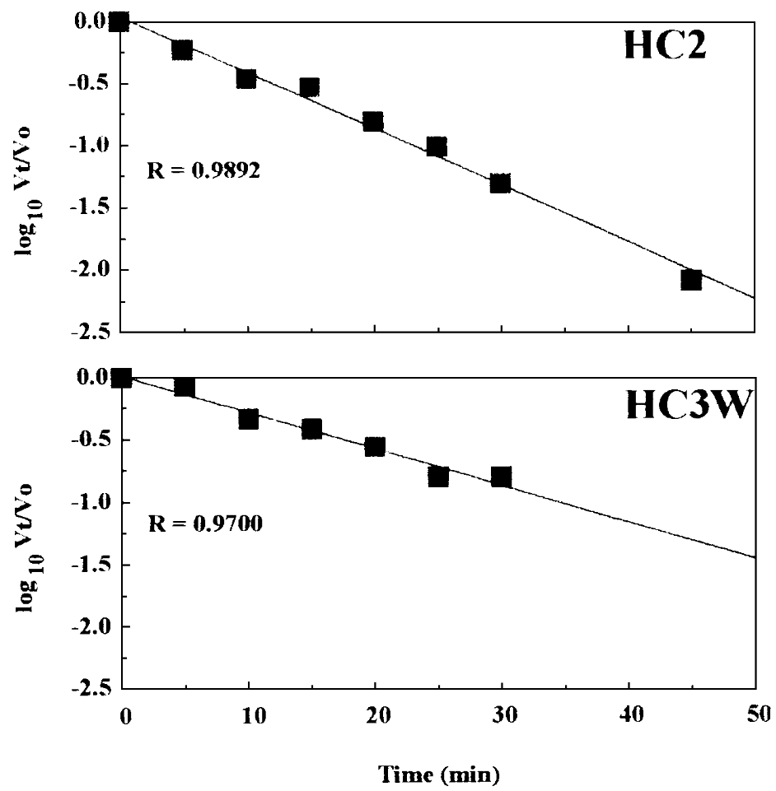

**Figure 1. Kinetics of neutralization of influenza virus A/fowl plague/Rostock/34 by MAbs HC2 and HC3W.** Virus and MAb (HC2: 0.21 µg/ml; HC3W: 0.11 µg/ml) were incubated together at 37°C for the times indicated. *Vt*/*V*0 represents the loss of infectivity, where *V*0 is the titre of virus at time zero, and *Vt* is the titre of virus after incubation for time *t*. R is the correlation coefficient. The SD was within the size of each datum point.

* The mechanism of neutralization appears to be very complicated!
  + "The mechanisms of neutralization of MAbs HC2, HC10 and HC61 have been investigated in some detail. The picture is frustratingly complex and the antibodies do not behave identically. However, as a generalization it appears that, at relatively low levels of neutralization, infectivity is reduced by aggregation of virions, some inhibition of attachment of neutralized virus to the target cell, and some inhibition of fusion of viral and cell membranes."
  + "A clearer picture emerges when HC2 and HC61 were used at concentrations that give high (>99%) levels of neutralization. Under these conditions aggregation no longer takes place, and inhibition of attachment and of fusion are insignificant compared with the loss of infectivity. Thus another mechanism of neutralization must be operating."
  + "Thus it appears that these antibodies all inhibited a post-entry step in infection. It was postulated that these neutralizing antibodies caused a defect in tertiary uncoating, suggested to be the adoption by the viral RNP of a conformation consonant with the needs of transcription (Rigg 1989; Outlaw 1991; Armstrong 1992)."

## 

### Number of Antibodies Required to Neutralize Virus

Several groups have analyzed the stoichiometry of antibody binding needed to neutralize. Even so, there are multiple mechanisms by which antibodies can neutralize viruses, and there remain significant gaps in our understanding of the number of antibodies required to neutralize a virion. The examples summarize a few interesting works on this issue.

**Sources:**

* [Otterstrom 2014](https://doi.org/10.1073/pnas.1411755111) (PNAS): Relating influenza virus membrane fusion kinetics to stoichiometry of neutralizing antibodies at the single-particle level
  + Analyzed H1N1 PR8 and 80 are needed for H3N2 X31
  + Table 1 shows the number of antibodies needed to inhibit hemifusion. "We find hemifusion efficiency is reduced by half with ∼30–80 stem-binding IgG bound to virus particles, and that hemifusion is fully inhibited by ∼140–180 stem-binding IgG. Thus, a significant effect is elicited with quantities of IgG that are substantially lower than the ∼270–300 IgG we and others (30) estimate could sterically fit on the viral surface."

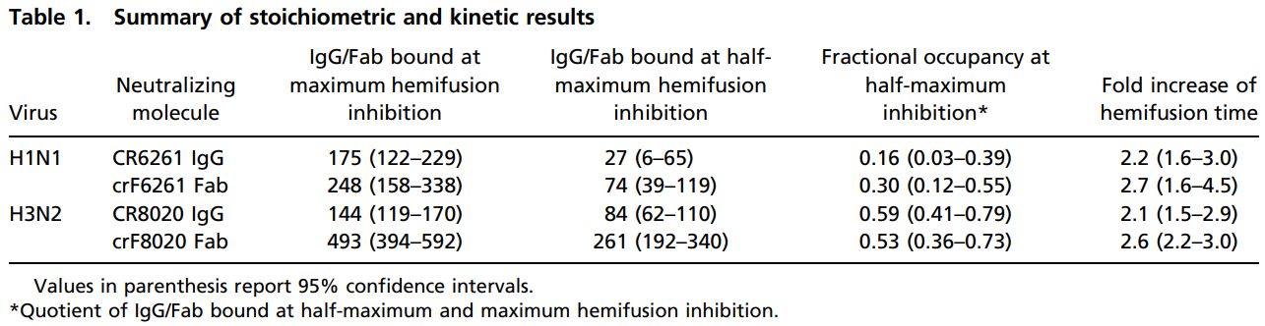

* + "Using radioisotope-labeled IgG, Taylor et al. found that ∼50 HC2 or HC10 monoclonal, head-binding IgG per virion could reduce infectivity in VNAs by half [[Taylor 1987](https://doi.org/10.1016/0042-6822(87)90466-1)], drastically lower than their estimates of 1,000 HA trimers per H7N1 virion."
  + "In comparing the two viral strains, we find that maximum hemifusion inhibition of the H3N2 strain requires ∼3.8-fold more Fab than IgG whereas the H1N1 strain requires only ∼1.6-fold more Fab… Further, large variations in the number of Fab compared with IgG may be common. Using the aforementioned HC2 and HC10, Schofield et al. (42) reported a requirement of 86- and >1,900-fold more Fab than IgG, respectively, to achieve similar levels of viral neutralization"
* [Klasse 2002](https://doi.org/10.1099/0022-1317-83-9-2091) (Journal of General Virology): Occupancy and Mechanism in Antibody-Mediated Neutralization of Animal Viruses
  + Discussing earlier work by [Parren 2001](https://doi.org/10.1016/S0065-2776(01)77018-6). "There is an approximately linear relationship between the number of nAbs required to neutralize the majority of the infectivity and the particle surface area. This supports the coating theory proposed by the authors: neutralization of viruses is due to steric or direct blocking of a proportion of the virion surface such that the requisite interactions between virus and the cellular membrane are prevented."
    - Poliovirus was shown to require an average of nine monoclonal Ab (mAb) molecules per virion for 90% of the infectivity to be neutralized (Icenogle et al., 1983) and a Poisson analysis of those data (Klasse and Moore, 1996) demonstrated a minimum of four or five molecules per virion for neutralization. In contrast, a study of polyclonal IgG neutralization of poliovirus suggested that virions with only one Ab molecule bound were noninfectious (Wetz et al., 1986).
    - Rhinovirus, another picornavirus, requires 5–6 Ab molecules per virion for 50% and 10–20 Ab molecules for 90% neutralization (Smith et al., 1993).
    - One report has suggested that a sucrose gradient-purified fraction of adenovirus with only 1.4 molecules of antihexon polyclonal IgG per virion was noninfectious (Wohlfart, 1988). This is surprising, since, according to a Poisson analysis, 25% of the virions would have no Ab bound.
    - Stoichiometric analyses indicate that 50% of influenza virus infectivity is neutralized when around 50 IgG molecules are bound, while 90% requires over 100 molecules [[Taylor 1987](https://doi.org/10.1016/0042-6822(87)90466-1)].
    - Neutralization of a majority of rabies virus infectivity requires from 130–350 IgG and 40–50 IgM molecules per virion (Flamand et al., 1993): the potential number of epitopes occupied would range from 260 to 700 for the bivalent IgG and from 400 to 500 for IgM.
  + The form of binding (monovalent vs bivalent) can make a large difference on neutralization and aggregation: "A mAb that binds human rhinovirus bivalently with a maximum of 30 molecules per virion neutralizes the virus to a great extent; other nAbs that bind monovalently at a maximum of 60 molecules per virion neutralize and aggregate the virus to highly divergent degrees (Smith et al., 1993; Smith, 2001). These differences are not readily attributable to variable functional affinities since they occur at saturating mAb concentrations."
* [Taylor 1987](https://doi.org/10.1016/0042-6822(87)90466-1) (Virology): Quantitative relationships between an influenza virus and neutralizing antibody
  + Analyzed the H7N1 viral strain A/FPV/Rostock/34
  + “Infectivity is neutralized by 63% (1/e) when about 70 molecules of monoclonal IgGs HC2 and HClO were bound per virus particle, and this is supported by independent evidence from electron microscopy.”
  + "On a semilogarithmic plot, neutralization of 1.3·104 PFU by HC2 has a linear relationship with the number of IgG molecule bands (Fig. 5). If all antibody binding sites were critical for neutralization an average of one antibody molecule bound per particle would be sufficient to reduce infectivity by 63% (1/e). However, Fig. 5 shows clearly that this value is around 67 HC2 molecules per particle and therefore that only a minority of the sites are critical. At 50% neutralization (N50) about 52 molecules per particle are bound"

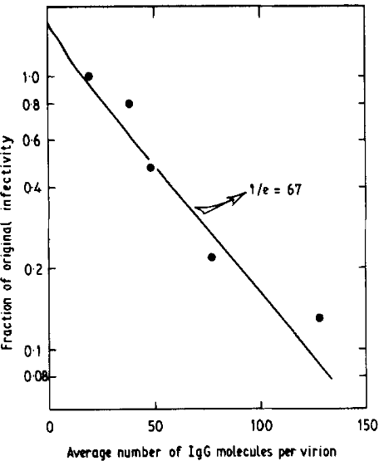

**Figure 5. The relationship between neutralization of 1.3·104 PFU and the number of monoclonal (HC2) IgG molecules binding to FPV/R particles.** The number of IgG molecules was calculated as described in Table 1 and the line was fitted by regression analysis.

* + "Figure 6 shows a similar experiment, with another monoclonal antibody HC10, in which a higher concentration of virus and up to saturating amounts of antibody are used. With this monoclonal antibody the relation- ship between virus and bound antibody was again linear giving a value of 1/e of about 76 and an *N*50 of 47 molecules per virion. However, when neutralization approaches 2 log10 the slope decreased, although it remained linear until the amount of bound antibody approached saturation values of around one IgG molecule per HA spike."

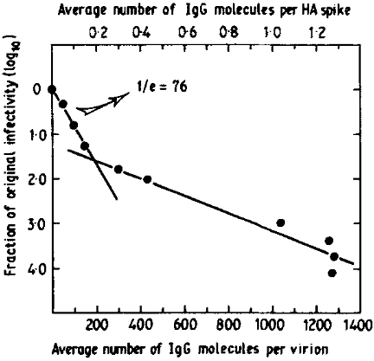

**Figure 6. Reduction in the infectivity of 2·107 PFU FPV/R by HC10 IgG correlated with the number of IgG molecules binding per FPV/R particle and per HA spike.**